Free and Reduced Application Download

To download a file of Free and Reduced Priced Meal Applications submitted on-line by households in your District, go to ODE’s secure file transfer website: https://district.ode.state.or.us
Only authorized NSLP District staffs are allowed to access confidential Free and Reduced Price Meal Application information. National School Lunch Program (NSLP) administrators and District eligibility officials should contact their District Security Administrator for permission to access the ODE district secure website.

File Download Instructions:
- Go to website: https://district.ode.state.or.us/home/
- Enter your User Name and Password and click “login”

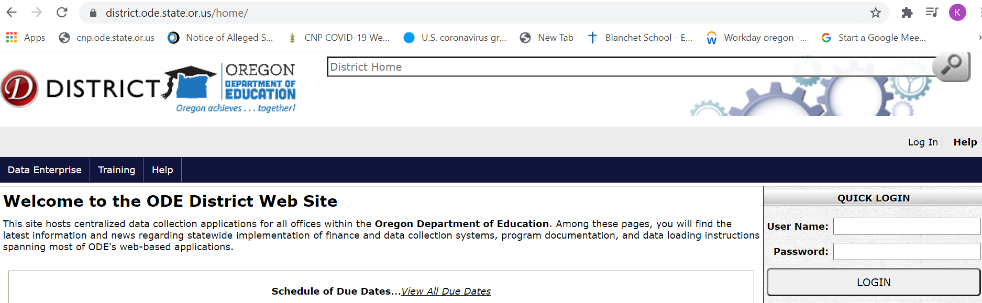

Click on “Consolidated Collections”
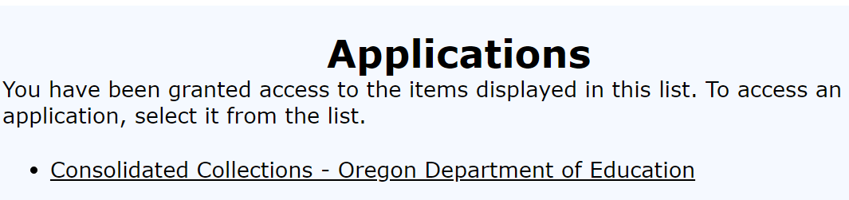
- Click on “Student Collections”
- Hover over “Child Nutrition Direct Certification Match (NSLP)
- Click on “Free & Reduced Meal Applications”

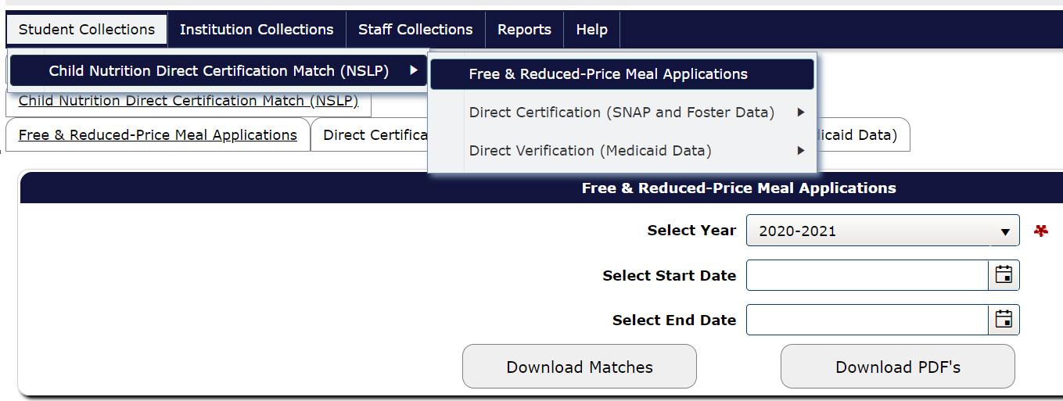

- Complete the following:
  - Select the School Year from the drop down box
  - Enter the Start Date. Use MMDDYYYY
  - Enter the End Date. Use MMDDYYYY
- After entering all of the required information, select “Download Matches” or “Download PDFs”.
- “Download Matches” this option creates a CSV data batch file
- If choosing “Download PDFs” you will receive individual applications in the same format as hardcopy applications
The next web page confirms your request.
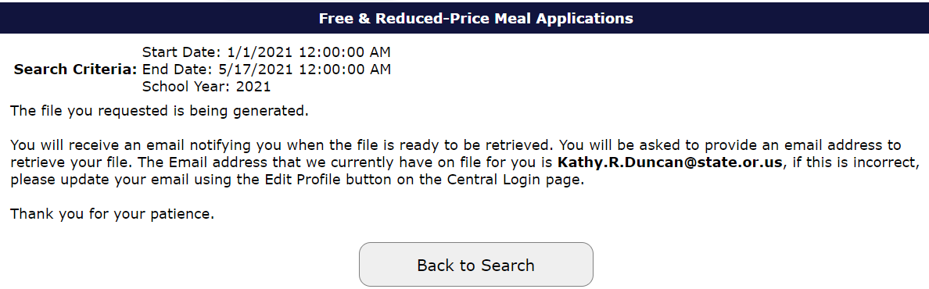

- When the file is available, you will receive email notification from ODE helpdesk with subject line “File Transfer”. Click on the link. This file is only available for 7 days.

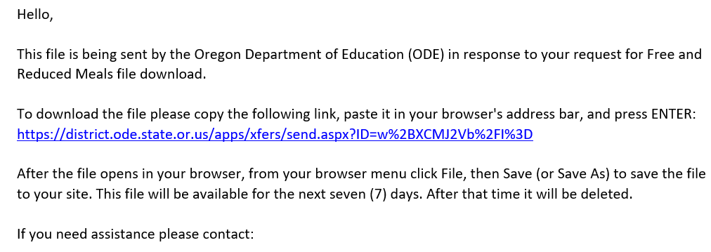

- Enter in your email address and click the “Submit Email Address” button
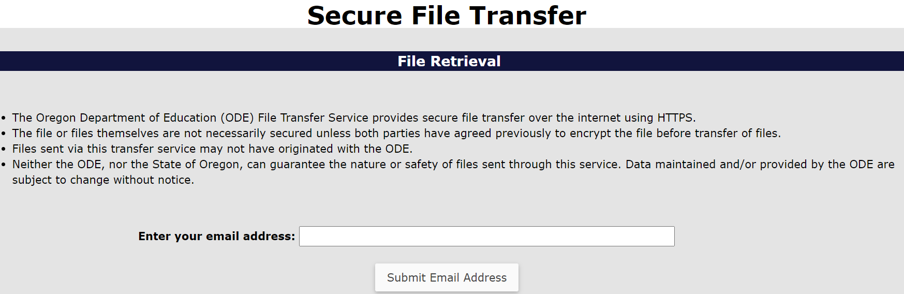
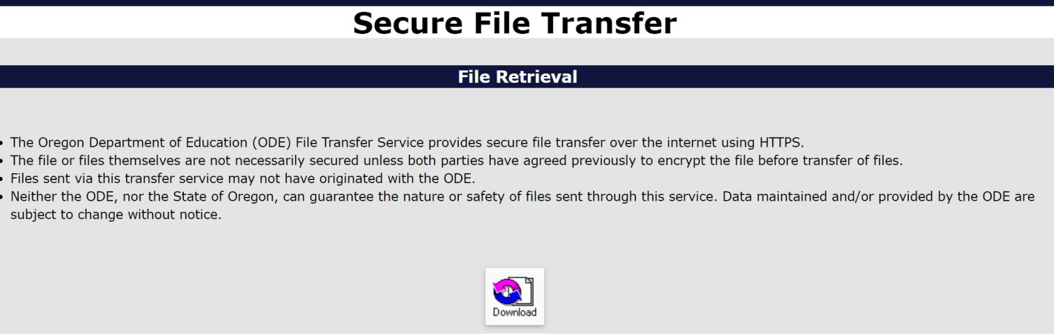
The next web page shows the requested file as an icon Click on the icon to download the file.

