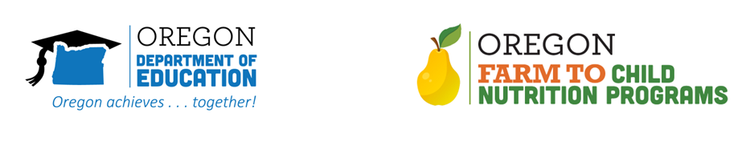

Key Messages for School and District Leaders
Use these key messages to initiate conversation and communication with staff, students, families and your community about the farm to school program. These messages are customizable, and intended to serve as a starting point for school leaders to modify as needed to communicate with their community.

Our Farm to School program is transforming the lives of our students!
- The school garden and the cafeteria do more than provide food to students. These areas can be an integral part of the education process by teaching students about food, nutrition, and where their food comes from.
- Any subject can be taught in the school garden! Studies have shown when students “get outside and get their hands in the dirt” attendance rates go up, and discipline problems go down.
- When the school garden works with the cafeteria, magical things can happen. If local, healthy food is put out on the cafeteria line, students may or may not eat it. But if the local food is supplemented by the school garden, and the two areas work together to promote and educate the students about the food, students get excited. When they learn about the food they are eating, they tend to devour it, and make lifelong healthy choices.
- Gardens are used to teach teamwork, highlight skills outside of the classroom and frequently used by SEL teachers and school counselors as places for mindfulness and healing trauma.
- [Insert local details] about the farm to school program.
- XXXX students participate in our school garden program.

Our teachers and school staff are creating rich opportunities for students.
- Skills that support learning now and actions they will continue through their lives.
- Brings students into new, creative ways to learn about the full food process.

Our school gardens contribute to a vibrant community.
- Local purchasing and farm field trips contribute to vibrant community, community connections and resilience during times of emergency/ disaster
- Farm to school enriches the connection our communities have with fresh, healthy food and local food producers by sharing the opportunity with students and staff.
- Students who participate talk about their rich experience across subject areas, including science, math, agriculture, and food services.
- Teaches lifelong skills in nutrition and what makes up healthy meals.

