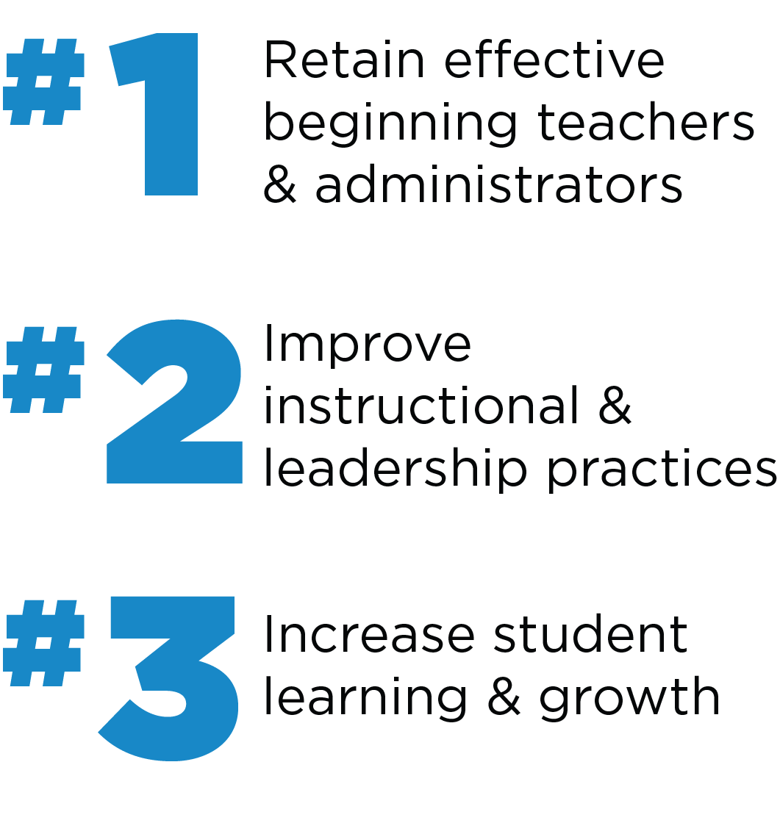
Beginning Teacher Mentor (BTM) Goal Setting Cycle
The goal setting cycle is intended to focus mentor activities on the three goals of the Oregon Mentor Program as defined by the Oregon Department of Education (ODE). Mentors support beginning teachers to help ensure a strong system of leadership, professionalism, and excellence for teachers in Oregon. A key component of this work relies on highly skilled mentors who utilize research-based mentoring techniques and job embedded professional learning intended to increase educator effectiveness and positively impact job satisfaction, student outcomes, and instructional practice.

OCTOBER  Note: New mentors without previous  mentoring experience may choose to identify opportunities for growth and add strengths later in the cycle. | 1) Complete Instruction and Student Learning Self-Assessment (pp. 2-3)  - Think about your role as a mentor to engage beginning teachers in learning-focused conversations in order to improve instructional practices and increase student learning and growth.  - How do you utilize Formative, Instructive, Collaborative, and Facilitative mentoring approaches to increase instructional effectiveness? Take time to catalog your strengths and identify opportunities for growth.  - Complete the Instruction and Student Learning Goal Worksheet (p. 4) and articulate your goal.  2) Complete Mentor Skills Self-Assessment (pp. 5-7)  - Think about your mentor practice. Place yourself on a scale from Emerging to Innovating and provide evidence where applicable.  - Use this document to highlight strengths and areas where you would like to improve.  - Complete the Mentor Skills Goal Worksheet (p. 8) and articulate your goal.  See SMART Goal Writing Tips and Examples (p. 9)
JANUARY | Review, reflect, and refine goals. Identify strengths and plan for continued improvement.
MAY | End of Year Reflection – Prepare evidence of practice related to goals and plan to share with PLC Leader or Project Director during the Exit Interview in June.
Instruction and Student Learning Self-Assessment

Mentor Name: ____________________________________________________________________ Date: _____________________________

Strengths and  Evidence | Learning–focused Conversations*  Differentiated Mentoring Stances | Areas for Growth and Possible Evidence
 | Formative Assessment Stance – The mentor defines and reinforces strengths and opportunities for growth. Conversations are teacher-centered, standards-based and data-driven, avoid subjectivity or bias, and utilize literal observation notes, specific classroom artifacts, and a variety of formative assessment data to produce evidence of the transfer of teacher’s learning into improved classroom practices that positively affect student actions and outcomes (i.e. Collaborative Discussions, Observation, Analysis of Student Work, etc.).
 | Instructive Stance – The mentor recognizes strengths as well as possible gaps in content knowledge, student knowledge, or instructional repertoire. The mentor clarifies standards by offering perspectives on concerns by naming possible causes and approaches that could improve performance. Skillful mentors propose a menu of teacher goals to promote student achievement and professional growth providing opportunities to choose, prioritize, reflect on practice, and define indicators of success and plan for continuous improvement. Mentor serves as a learning-focused consultant refraining from simply “fixing” and “telling”.
 | Collaborative Stance – The mentor creates shared platform for the co-construction of knowledge. Both mentor and mentee offer ideas, solutions, and analysis. Mentor provides support while respecting the teacher’s ability to generate ideas, analyze data, problem-solve, and develop strategies. A rich inquiry-driven collaboration inspires ideas and perspectives without one person dominating the conversation.
 | Facilitative Stance – The mentor assumes the teacher has the resources necessary to engage in data-centered reflection on practice. The mentor conveys respect for the teacher’s potential and emerging expertise. Questions/Inquiry enhance the teacher’s capacity for planning, reflecting, problem solving, and decision-making. Mentor seeks to reduce frustration by posing developmentally appropriate questions that stretch but do not strain thinking. Multiple appropriate responses are encouraged and the mentor does not predetermine a correct answer.
See Additional Guiding Questions on the Next Page
Think about how learning-focused conversations impact instruction, student learning, and/or growth?

How do you determine strengths and opportunities for growth? How do you gather data related to the new teacher’s present perspectives and performance related to the standards?
How do you balance your contributions as a mentor with the new teacher’s experience and expertise?

How do you determine what mental and emotional resources might be most useful for the new teacher at a given time?
How does student engagement, social/emotional/physical wellbeing, behavior, and academic performance drive your work as a mentor?
What supportive data could you collect related to mentoring practice?

Think about this… How might mentoring correlate with increased retention of new teachers, improved instructional effectiveness, and better student outcomes? What evidence could show possible relationships between mentoring and improved instruction and student learning?

*Adapted from the work of Laura Lipton and Bruce Wellman at MiraVia, LLC, The Road to Learning, 2012
Instruction and Student Learning
Goal Worksheet

Mentor Name: ____________________________________________________________________________ Date: _____________________
After completing the Instruction and Student Learning Self-assessment activities, use the following prompts to develop a goal related to student learning and growth.
1. This is what I want to achieve.
2. This is my main measure(s) for the achievement (i.e. artifacts, tools, data that will demonstrate the goal above).
3. Now here is what I want to achieve stated as a specific goal, which includes my measures.
(SMART = Specific, Measureable, Achievable, Realistic, Timed)

Please write your goal below:

4. List mentoring activities and sources of data that support the goal above.

Mentor Skills Self-Assessment*
Mentor Name: ______________________________________________________________________ Date: ___________________________
Rate yourself on the following mentoring skills:
Attends Fully | Emerging/  Exploring | Applying | Integrating/  Innovating | Evidence
Uses effective physical alignment (sits next to mentee)
Uses nonjudgmental body language (eye contact, nodding, smiling, etc.
Listens without interruption
Listens non-judgmentally, without personal referencing, personal curiosity, or personal certainty

Listens for assumptions, inferences, perceptions, perspectives
Invites Thinking  Uses Invitational stems that include: | Emerging/  Exploring | Applying | Integrating/  Innovating | Evidence
An approachable voice (intonation)
Plural Forms (What are some ways…)
Exploratory Language (How might…)

Sustains Thinking  Through pausing and paraphrasing | Emerging/  Exploring | Applying | Integrating/  Innovating | Evidence
Pauses
- After asking a question
- After hearing a response
- Before making a response or asking a question

Sustains Thinking  Through pausing and paraphrasing | Emerging/  Exploring | Applying | Integrating/  Innovating | Evidence
Paraphrases
- To acknowledge and clarify emotion
- To acknowledge and clarify content
- To summarize/organize content
- To shift level of abstraction

Sustains Thinking  Through Questioning | Emerging/  Exploring | Applying | Integrating/  Innovating | Evidence
Uses Inquiry Questions to Open Thinking
- Avoids yes/no format (i.e. Do you think cooperative learning is a good strategy?)

- Asks questions that produce new insights (i.e. How might this strategy keep your students more engaged?)
- Uses language to focus on specific cognitive process (i.e. How might you compare today’s mini-lesson to yesterday’s mini-lesson?)
Uses Probing Questions to Focus Thinking
- Asks questions to clarify explanations and ideas (i.e. In what ways was it better?)

- Surfaces specific examples (i.e. What are some examples of student learning that took place?)
- Asks questions to examine implications, consequences, inferences, or assumptions (i.e. How might this strategy influence the way you plan your future lessons?)

Extends Thinking | Emerging/  Exploring | Applying | Integrating/  Innovating | Evidence
Provides Information

Provides Resources

Frames Expectations
Differentiates Mentoring  Stances based on BT Needs | Emerging/  Exploring | Applying | Integrating/  Innovating | Evidence
Formative
Gathers data to identify strengths, opportunities for growth, and next steps for BT and mentor.
What percentage of time would you estimate you spend in this stance? ____________
Instructive
Consulting/Providing Expertise

What percentage of time would you estimate you spend in this stance? ____________
Collaborative
Co-Constructing/Collaborating

What percentage of time would you estimate you spend in this stance? ____________
Facilitative
Coaching

What percentage of time would you estimate you spend in this stance? ____________

*Adapted from the work of Laura Lipton and Bruce Wellman at MiraVia, LLC, The Road to Learning, 2012
Mentor Skills
Goal Worksheet
Mentor Name: ____________________________________________________________________________ Date: _____________________
After completing the Mentor Skills Self-assessment, use the following prompts to develop a goal related to your mentoring practice.

1. This is what I want to achieve.
2. This is my main measure(s) for the achievement (i.e. artifacts, tools, data that will demonstrate the goal above).
3. Now here is what I want to achieve stated as a specific goal, which includes my measures.
(SMART = Specific, Measureable, Achievable, Realistic, Timed)

Please write your goal below:
4. List mentoring activities and sources of data that support the goal above.

SMART Goals – Writing Tips

Specific Language

After Self-Assessing your mentoring practice, you should understand the “why” of your role as a mentor and opportunities for improvement – this is the starting point for a specific goal.
- Start your goal with, “I will _______________________ (what?)”

Achievable Result

This dimension serves as a reality check on the goal. Achievable does not have to mean easy. Think about how you might stretch as a mentor. What do you expect to accomplish? Keep this in mind when constructing the remainder of your goal.

Relevant to the role as mentor – with continuous improvement in mind

The goal should relate back to the opportunity for improvement. It responds to the “why” and increases the specificity of the action with a concrete course of action.
- Add the following language to your goal, “…by _____________ (specific course of action)”

Time-Delimited

Finally, the goal should have a delivery date or timeframe.
- Add the following language to your goal, “…by _____________________ (date)”

EXAMPLES of (1) Instruction and Student Learning Goal AND (1) Mentor Skills Goal

Opportunity for Improvement: Support new teacher to analyze student work, differentiate instruction, and improve student outcomes.
Instruction and Student Learning SMART Goal: I will facilitate conversations to improve instruction and student outcomes by engaging in an inquiry cycle (including Analysis of Student Work) with one new teacher at least twice by the end of May. Evidence to share in June will be copies of inquiry cycle tools used and student data indicating positive impact on instruction and learning outcomes.

Opportunity for Improvement: Utilize questioning strategies to move thinking forward and positively affect instructional effectiveness, job satisfaction and student learning.
Mentor Skills SMART Goal: I will observe my use of questioning to move new teacher thinking forward by videotaping myself and having a peer mentor observe me and provide feedback twice (pre and post) by the end of May. Evidence to share in June will be observation notes from myself and peer mentor as well as a brief reflection about how my mentor skills may have improved and/or where I need to continue improving.

- The opportunity for improvement is __________________.
- I will __________ (end result) by __________ (number) __________ (unit of measure) by __________ (specific course of action) by __________ (date)."
- Evidence/Data to share in June ________________________.

