



Oregon
Migrant Education Program Evaluation

Oregon Department of Education
Presented on
1653 Lititz Pike
PMB 202
Lancaster, PA 17601
240-515-8573
perrigo@urc-chs.com
May 30, 2013

Paula M. Errigo, Principal Evaluator
Gary Hargett, Data Analyst
Table of Contents
Introduction……………..……………………………………………………………………….3
Program Profile…………………………………………………………..………..……………….….3
1 Purpose….…………………………………………………………………………………………..….4
2 Methodology…………………………………………………………………………………5
3 Overview of Oregon Migrant Education Program…………..…………….…………………..…....7
4 Migrant Students in Oregon………………..…………………………………………………..……………..8
5 Results Related to the Scope of Work………..………………………………………………..….….. 11
6 Commendations..………………………………………………………………………………………………… 39
7 Findings Related to Evaluation Questions………………………..………………………..………..…39
8 Recommendations……..……………………………………………………………………..………………… 42
8.1 Supplantation……………………………………………………………………………..………….…42
8.2 Service Delivery Plan Evaluation Strategies…………………………………..…….…....43
8.3 The Role of Data Usage…………………………………………………………………..…...…...44
8.4 Restructure and Redesign of MEP……………………………………………………….……..44
8.5 Consistency of Guidance............................................................................46
APPENDIX A……………………………………………………………………………………………………….......….47
APPENDIX B…………………………………………………………………………………………………………..….…49

Introduction
The Oregon Migrant Education Program is a State-operated program that is implemented locally and regionally with services based on identified migrant student needs. While Migrant Education Program (MEP) funds are granted to the Oregon Department of Education (ODE), sub-grants are made to local operating agencies (school districts and Educational Service Districts known as ESDs) to carry out services. According to the current Oregon Service Delivery Plan of 2011 there were reported projects funded in whole or in part with MEP funds as 111 year round migrant projects and 80 regular school year projects. The vast majority of these projects are served through ESDs.
Migrant funds are used both for State administration as well as for part time support staff. A full-time State MEP director at the Oregon Department of Education oversees all aspects of the MEP. As reported for 2010-11, Oregon funded teachers (8 FTE during the regular year and 182 FTE during the summer), counselors (typically 2 total FTE during the regular year and summer), paraprofessionals (33 FTE during the regular year and 124 FTE during the summer), recruiters (41 FTE during the regular year and 20 FTE during the summer), and records transfer staff (11 FTE during the regular school year and 7 FTE during the summer.

Program Profile
As developed for the current Service Delivery Plan of 2011, the Oregon Migrant Education Program Profile defines the following:

Migrant Students There are 20,514 eligible migrant students ages birth to 21
Total State Allocation $10,622,190

Authorized Activities Supplemental PK-12 education and support services, services to out-of-school youth, collaboration with community agencies/referrals, information about community resources (e.g., health/medical/ dental referrals), supplemental translating/interpreting services, summer programs, parent involvement activities, staff professional development, identification and recruitment services

Crops/Agri-Industry Apples, berries, cherries, onions, nurseries, pears, potatoes
Priorities for Services (PFS) 6,590 (32%) of the eligible migrant students are PFS according to the State’s implementation of the Federal definition.

English Learners 8,897 (43%) of all eligible migrant students are identified as being limited in English proficiency (LEP).

Special Education 1,063 (5.2%) of the eligible migrant students also are children with disabilities as classified under Part B or Part C of the Individuals with Disabilities Education Act (IDEA).

Participating Students Of the total number of eligible migrant
Priority for Services (PFS) students, there were 7,538 (37%) with the greatest needs who were served during (PFS) the regular school year. 3,408 were identified as having PFS.

Type of Service 3,200 students received instructional services in reading and 2,433 received math. In addition, 1,238 migrant youth received high school credit accrual services.

High School Dropout 85 (<1%) of the participating migrant students dropped and OSY out of school. 1,452 OSY (7%) were reported as eligible migrant on the 2010-11 State CSPR.

Purpose

The Office of Migrant Education (OME) at the United States Department of Education (USDE) reviewed the OMEP during a Federal Title I-C monitoring visit on May 24-27, 2010. Their report, received by the Agency on February 4, 2011, outlined program requirements relating to federal statutes regulating MEPs. As a result of this monitoring visit, the Oregon Migrant Education Program (OMEP) at the Oregon Department of Education is required to conduct a program evaluation and submit the results to OME.

The purpose of this evaluation is to measure both the implementation of services and performance results of the recently implemented OMEP Service Delivery Plan (SDP). In particular, the charge for this program evaluation is to:

      - Evaluate the effectiveness of the program by comparing the results of the program to the measurable outcomes established for the MEP and the State’s performance targets. The report will provide data by migrant program area and statewide data.

      - Evaluate the effectiveness of the SEA leadership for the migrant program and the service and support given by the Migrant Education Service Center (OOMESC).

2 Methodology
This evaluation report of the 2012-13 Oregon Migrant Education Program was compiled from information that was obtained through the following methodology:
- Meeting with personnel from the Oregon Department of Education and Migrant Education Service Center. At that time a program overview was presented by the State Director of the Oregon Migrant Education Program, and staff from the OMESC presented an overview of their program support and services along with various documents for review.
- On-line survey was completed by personnel from the local operating agencies. The survey questions dealt with all operational aspects of local programs, including: Services to migrant students; staffing of local migrant programs; characteristics of migrant population; priority for service; recruitment; staff training; and notification of LEA personnel of students’ migrant status. Twenty-one individuals from 17 local projects responded to the survey.
- Analysis of data on migrant students’ academic achievement, gains in English proficiency, graduation and drop-out rates. The Service Delivery Plan listed a set of goals in such areas as improvement on state reading and math tests, increases in English proficiency, gains in reading, math and early childhood skills for summer school participants, etc. Data specialists from the Oregon Migrant Education Service Center and the Oregon Department of Education cooperated in provided data files on the following:
- State reading and math achievement (OAKS)
- English proficiency (ELPA)
- Graduation and Drop-Out Rates
- Summer School Gains in Reading, Math and Early Childhood Skills
Data were not available for some goals listed in the Service Delivery Plan, either because the pertinent services were not in place or because the data would not be collected until the end of the program year, while the due date for this report was May 30, 2013.
Given that the state assessment data and graduation and drop-out rates for 2012-13 would not be available in time for this report, the evaluation team, in consultation with the state migrant director, decided to use data from the three prior school years—2009-10, 2010-11, and 2011-12—to provide context for the 2012-13 data when it becomes available, and to use findings from those years as baseline and to identify trajectories that might inform subsequent goal-setting. Data from those three years were used to identify any changes in student achievement. ELPA scores for English proficiency were examined for actual individual gains from one year to the next since the goal for English proficiency had been expressed in terms of gains.
Data on non-migrant students for graduation and
drop-out rates were provided by the state in order to serve as a comparison point to better understand the migrant data.
- Data on summer school gains in reading, math and early childhood skills for summer 2012 programs had already been aggregated and provided to the evaluation team.
- A structured interview telephone survey with regional directors at local operating agencies was also conducted. A total of 15 regional directors of 19 were interviewed and discussed topics related to perceived program effectiveness, comparability of achievement rate for migrant students, program improvement suggestions, implementation issues, SEA leadership effectiveness, OMESC service and support analysis and data use analysis.
- In addition, many program documents from 2009-2012 were requested an analyzed to determine program effectiveness and implementation snapshots.
The remainder of this report describes the information obtained through this methodology.

Overview of Oregon Migrant Education Program
Leadership for the state’s MEP is housed in the Office of Educational Improvement and Innovation of ODE in Salem, Oregon. Key staff includes the state director, who has responsibility for Migrant Education and secretarial staff.

One service center provides technical assistance and professional development to local MEP projects including planning consistent with the needs of the regional programs. These needs include, but are not limited to, Identification & Recruitment, Record Exchange, Family Involvement, Binational Programs, and Educational Best Practices. The service center has a coordinator; an ID&R/Quality Control Manager, Oregon Migrant Student Information System (OMSIS) Data Analyst II, Re-interview-Recruitment Specialist, Customer Supp Spec/Program Trainer, an Education Specialist, an Administrative Assistant and a Consultant, Special Projects.

The Oregon Migrant Student Information System is housed at the Oregon Department of Education. Training is provided for local data entry clerks. The system collects migrant student data entered by those clerks, and provides data reports to the local projects, including, for example, tallies of individual students’ risk factors, which projects can use to identify Priority for Service migrant students.
The OMESC also trains the projects’ recruiters, who are responsible for identification and recruitment. It reviews COE
data supplied by local projects for accuracy. In addition, OMESC collates and reports the data included in the migrant portion of the state’s Consolidated State Performance Report, which is submitted to the US Department of Education annually.

4. Migrant Students in Oregon
Data provided by the OMESC showed a three-year trend for fewer local projects and diminishing numbers of migrant students enrolled, as summarized in the following table

Year | Number Enrolled in Regular Term | Number Enrolled in Summer Term
2009-2010 | 14,907 | 5,746
2010-2011 | 14,562 | 6,097
2011-2012 | 14,300 | 6,279

Category 1 Count
As reported in the state Consolidated State Performance Report of 2011-2012, the table below, indicates the unduplicated statewide number by age/grade of eligible migrant children age 3 through 21 who, within 3 years of making a qualifying move, resided in Oregon for one or more days during the reporting period of September 1, 2011 through August 31, 2012.
Age/Grade | 12-Month Count of Eligible Migrant Children Who Can Be Counted for Funding Purposes
Age 3 through 5 (not Kindergarten) | 2876
K | 1432
1 | 1349
2 | 1332
3 | 1282
4 | 1185
5 | 1189
6 | 1120
7 | 1075
8 | 1089
9 | 933
10 | 926
11 | 865
12 | 779
Ungraded | 82
Out-of-school | 1276
Total | 18,791

Category 2 Count
As reported in the state Consolidated State Performance Report Part I of 2011-2012, the table below indicates by age/grade the unduplicated statewide number of eligible migrant children age 3 through 21 who were served for one or more days in a MEP-funded project conducted during either the summer term or during intersession periods that occurred within the reporting period of September 1, 2011 through August 31, 2012.

Age/Grade | Summer/Intersession Count of Eligible Migrant Children Who Are Participants and Who Can Be Counted for Funding Purposes
Age 3 through 5 (no Kindergarten) | 705
K | 762
1 | 714
2 | 684
3 | 653
4 | 575
5 | 569
6 | 404
7 | 287
8 | 255
9 | 182
10 | 198
11 | 189
12 | 41
Ungraded | 60
Out-of-school | 0
Total | 6,279

The on-line survey asked about migrant student enrollments throughout the year and at the peak influx time. In most cases, projects reported influx from Spring through Fall. Local project staff who were interviewed reported a decline in the amount of work available. Moreover, many families are electing to settle and not pursue a migrant lifestyle. In some cases, parents, who have heard the message that moving during the school year has negative effects on the children’s learning, are moving but leaving their children with relatives so they will not miss school. When the children do not have their schooling interrupted, they do not qualify for MEP. .

5 Results Related to the Scope of Work

SDP Data Analysis 2013
The Oregon Migrant Education Service Delivery Plan for 2012-13 set goals in 13 areas:
- Achievement on state Reading and Math assessments
- Growth in reading and math in Migrant summer school
- Growth in preschool skills in Migrant summer school
- Increased coordination between local migrant programs and school districts
- Increased use of evidence-based methods to meet the needs of young migrant children
- Increased ability of migrant parents to help their children with reading and math and preschool readiness
- Greater ability of parents to help their children reach graduation or career goals
- Increased English proficiency of migrant English language learners
- Increase of developmental skills of migrant children participating in regular year preschool programs
- Increased graduation rates of migrant students
- Decreased drop-out rates of migrant students
- Greater ability of high school migrant staff to help migrant students meet graduation goals and career plans
- Better preparation of OSY for success in school or work
The present report was commissioned to evaluate the extent to which those goals were met. However, most data related to the desired outcomes would not be available until well after the end of the program year and this report’s contract period. Therefore, the report presents relevant data from the previous three years—2009-10, 2010-11, and 2011-12—to serve as baseline for when the current data do become available and to provide context by examining previous trajectories for the areas of concern.
Data for OAKS Reading and Math, ELPA, Graduation and Drop-Out were also collected by region. The detailed data are contained in the Appendix. However, comparisons across regions should be interpreted cautiously, particularly for cases where migrant enrollment was relatively small. When populations are small, fluctuations can occur based on only a small number of students.
Following are the specific goals that were set for 2012-13 and summaries of such current data as were available or relevant data from the previous three years.
Achievement on State Reading and Math Assessments (OAKS)
Goal: By the end of the 2012-13 school year, the percent of migrant students meeting or exceeding standards on the Statewide assessment in reading and math will increase by 2%.
The following table shows the percentages of migrant and non-migrant students who met standard on the state Reading and Math tests in the years indicated.
 | 2009-10 |  | 2010-11 |  | 2011-12
 | Reading | Math | Reading | Math | Reading | Math
Migrant | 50.5 | 56.0 | 56.0 | 41.2 | 42.4 | 42.2
Non-Migrant | 77.2 | 77.1 | 80.1 | 62.6 | 72.2 | 63.3
In each case, non-migrant students showed substantially higher rates of success in meeting standard in the two subjects test.
Data from those three years were also summarized to detect whether any pattern of greater achievement existed similar to the projected 2% increases. The following table shows the percentage of migrant students statewide who met standard in reading and math in the years indicated, and the percentage point change between the consecutive years.

Subject | Met 09-10 | Met 10-11 | Change | Met 11-12 | Change
Reading | 50.5 | 56.0 | 5.5 | 42.4 | -12.8
Math | 56.0 | 41.2 | -16.9 | 42.4 | -1.2

The table shows an improvement of 4.6% in reading from 2009-10 to 2010-11, better than the goal of 2% for the current year. However, the rate of students meeting standard fell by 12.8 percentage points from 2010-11 to 2011-12. That does not mean that migrant students actually lost ground in their reading skills. Instead, the state used a higher scale score as representing meeting standard as of the 2011-12 school year. The same phenomenon occurred for all groups across the state, not just migrant students, as the table comparing migrant and non-migrant students shows.
The data in the table show a decrease in the percentage of migrant students who met the standard in math from 2009-10 to 2010-11. The decrease was due to the same factor as accounted for the decline in reading performance, that the state raised the cut-off scale score representing proficiency as of the 2010-11 school year.
The new cut-off scores for meeting standard represent higher levels of difficulty for students and for the state migrant program in reaching its goals for student achievement.
Data on statewide reading and math scores were disaggregated according to PFS status. The following tables show the numbers of migrant students tested on the state OAKS tests for Reading and Mathematics over three years, including the numbers according to PFS status. The tables also show comparative performance in terms of percentages of students meeting standard in Reading and Mathematics, disaggregated by PFS status.

Numbers of Migrant Students, PFS and non-PFS, Tested Over Three Years
Status | Reading |  |  | Math
Status | 2009-10 | 2010-11 | 2011-12 | 2009-10 | 2010-11 | 2011-12
PFS | 2218 | 2230 | 2406 | 2225 | 2232 | 2411
Non-PFS | 3360 | 3916 | 4411 | 3365 | 3918 | 4417
Total | 5578 | 6146 | 6817 | 5590 | 6150 | 6828

Statewide Percentages Meeting Standard in Reading, PFS and non-PFS
Status | 2009-10 | 2010-11 | 2011-12
PFS | 39.6 | 43.5 | 23.0
Non-PFS | 57.7 | 63.1 | 52.9
Total | 50.5 | 56.0 | 42.4

Statewide Percentages Meeting Standard in Math, PFS and non-PFS
Status | 2009-10 | 2010-11 | 2011-12
PFS | 42.9 | 27.2 | 19.2
Non-PFS | 64.6 | 49.3 | 54.8
Total | 56.0 | 41.2 | 42.2

The data show a clear trend for non-PFS students to perform better than the PFS students.

Growth in Reading and Math in Migrant Summer School

Goal: By the end of the 2012-13 school year, 80% of migrant students participating in summer programs will show gains between pre/post on a State-accepted reading and math assessment.
The state migrant program aggregated data from the 2012 summer school programs, which showed that about 74% of 3924 participants had shown growth on approved reading assessments, and about 76% of 3470 participants had shown growth on approved math assessments. The success rates approximated the targets for the 2012-13 program year.
Growth in Preschool Skills in Migrant Summer School
Goal: By the end of the 2012-13 school year, 80% of preschool migrant children with at least 85% attendance in summer school will increase their developmental skills between pre- and post-test as measured by a valid and reliable developmental skills checklist.
Aggregated data from the 2012 summer school programs showed that 87% of 438 migrant preschool children increased their developmental skills according to the skills checklists used. That exceeds the Service Delivery Plan target.
Increased Coordination between Local Migrant Programs and School Districts
Goal: By the end of the 2012-13 school year, 80% of MEP staff will report increased coordination with district staff and other service providers in addressing individual migrant student learning needs in reading and math.
Through conversation related to the structured interviews with regional directors, there were indications that relationships were built and sustained with district staff. However, there is no data source to confirm this.
Increased Use of Evidence-Based Methods to Meet the Needs of Young Migrant Children
Goal: After participating in early childhood training, 80% of preschool staff will report using evidenced-based methods to address the needs of young migrant children.
CURRENTLY IN PROGRESS, NO DATA YET
Increased Ability of Migrant Parents to Help Their Children with Reading and Math and Preschool Readiness
Goals: 1. By the end of the 2012-13 school year, 80% of migrant parents who received family involvement services through the MEP will report an increased ability to assist their children with reading and math. 2. After participating in at least one parent learning activity, 80% of parents of preschool children will report being better prepared to assist their young children be ready for kindergarten.
Greater Ability of Parents to Help Their Children Reach Graduation or Career Goals
Goal: By the end of the 2012-13 school year, 80% of the parents of high school migrant children will report that services, outreach, and/or informational materials received through the program prepared them to assist their children with their high school graduation/career goals.
The goals stated above are subsumed under the general heading of parent involvement. Personnel from the Migrant Education Service Center conducted several workshops throughout the state in 2012-13 that centered on parent involvement although they did not appear to include specific guidance for parents on helping their children with reading and math or encouraging high school graduation. Some workshops were directed at local migrant staff to increase their capacity to work with migrant families. Those workshops included Cultural Identity: Understanding Cultural Identity to Support Migrant Families in Critical Points of Transition and Focus on Achievement: Aligning Family Involvement Activities to the Service Delivery Plan. The Aligning workshop was held at 9 locations around the state, and evaluations were completed by 77 participants. The Cultural Identity workshop was held at 6 locations around the state, and evaluations were completed by 46 participants.
Meetings specifically targeted to parents included one State Parent Advisory Committee meeting, with 7 completed evaluations; two local PAC meetings, with 9 evaluations; one leadership training with 8 evaluations; and one workshop on how to improve parents advisory meetings, with 8 evaluations.
The evaluations asked a short series of questions, rated on a scale of 1-5, with 5 being the most favorable rating. The great majority of ratings were 5 across all workshops, for staff and parents, and no ratings below 4 were recorded.
Increased English Proficiency of Migrant English Language Learners
Goal: By the end of the 2012-13 school year, 52% of migrant students who are LEP will increase one level on the state language proficiency assessment.
As pointed out in the introduction to this section of the report, the data for the 2012-13 school year will not be available until after the end of the program year. However, illustrative data for the previous three school years may serve as baseline and indicate trends to inform planning and goal-setting.
The following table shows the number of students who gained the indicated number of levels of proficiency on ELPA from 2009-10 to 2010-11 and from 2010-11 to 2011-12:

Years | Number of Levels Gained
Years | -3 | -2 | -1 | 0 | 1 | 2 | 3 | 4 | Total
2009-10 to 2010-11 | 7 | 35 | 429 | 2,227 | 1,718 | 379 | 19 | 1 | 4,815
2010-11 to 2011-12 | 4 | 26 | 482 | 3,007 | 2,411 | 546 | 51 | 2 | 6,529

The next table shows the same information but expressed in percentages.
Years | Number of Levels Gained
Years | -3 | -2 | -1 | 0 | 1 | 2 | 3 | 4 | Total
2009-10 to 2010-11 | 0.145 | 0.727 | 8.910 | 46.25 | 35.68 | 7.871 | 0.395 | 0.021 | 4815
2010-11 to 2011-12 | 0.061 | 0.398 | 7.382 | 46.06 | 36.93 | 8.363 | 0.781 | 0.031 | 6529

The table shows that from 2009-10 to 2010-11, 43.97% of migrant English learners advanced at least one level of proficiency on ELPA. The modal value was 0, with 46.25% of cases, meaning those students remained at the same level. It also shows that from 2010-11 to 2011-12, 46.1% of migrant English learners gained at least one level. Thus the percentage showing improvement increased by 2.13 percentage points over the two comparisons. In neither comparison did 52% of students advance by one proficiency level or more as specified in the English proficiency goal in the Service Delivery Plan.
The data were also calculated according to grade band. The following table shows the numbers of levels gained from 2009-10 to 2010-11 according to students’ grade bands as of the 2010-11 school year.

Grade Band | Number of Levels Gained |  |  |  |  |  |  |  | Total
Grade Band | -3 | -2 | -1 | 0 | 1 | 2 | 3 | 4 | Total
K-1 | 0 | 2 | 6 | 22 | 18 | 7 | 0 | 0 | 55
2-3 | 6 | 27 | 282 | 1,050 | 533 | 78 | 1 | 0 | 1,977
4-5 | 0 | 3 | 51 | 414 | 522 | 193 | 15 | 1 | 1,199
6-8 | 1 | 3 | 53 | 390 | 396 | 73 | 2 | 0 | 918
9-12 | 0 | 0 | 37 | 351 | 249 | 28 | 1 | 0 | 666
Total | 7 | 35 | 429 | 2,227 | 1,718 | 379 | 19 | 1 | 4,815

The following table shows the same information in percentages.

Grade Band | Number of Levels Gained |  |  |  |  |  |  |  | Total
Grade Band | -3 | -2 | -1 | 0 | 1 | 2 | 3 | 4 | Total
K-1 | 0.000 | 3.636 | 10.909 | 40.000 | 32.727 | 12.727 | 0.000 | 0.00 | 55
2-3 | 0.303 | 1.366 | 14.264 | 53.111 | 26.960 | 3.945 | 0.051 | 0.000 | 1,977
4-5 | 0.000 | 0.250 | 4.254 | 34.529 | 43.536 | 16.097 | 1.251 | 0.083 | 1,199
6-8 | 0.109 | 0.327 | 5.773 | 42.484 | 43.137 | 7.952 | 0.218 | 0.000 | 918
9-12 | 0.000 | 0.000 | 5.556 | 52.703 | 37.387 | 4.204 | 0.150 | 0.000 | 666
Total | 0.15 | 0.72 | 8.90 | 46.25 | 35.68 | 7.87 | 0.39 | 0.00 | 4,815

The table shows that the 55 students in grade band K-1 showed the greatest growth, with 85.4% advancing at least one level on ELPA. Experience shows that students in K-1 have the lowest initial English proficiency, and it is easier to show growth from the lower levels. As students become more proficient, it is harder to show growth.
The following tables contain data on the ELPA gains from 2010-11 to 2011-12.

Grade Band | Number of Levels Gained |  |  |  |  |  |  |  | Total
Grade Band | -3 | -2 | -1 | 0 | 1 | 2 | 3 | 4 | Total
K-1 | 0 | 0 | 6 | 20 | 21 | 9 | 1 | 0 | 57
2-3 | 1 | 19 | 273 | 1,269 | 620 | 99 | 7 | 0 | 2,288
4-5 | 1 | 1 | 59 | 545 | 855 | 325 | 35 | 1 | 1,822
6-8 | 0 | 4 | 76 | 530 | 584 | 91 | 7 | 1 | 1,293
9-12 | 2 | 2 | 68 | 643 | 331 | 22 | 1 | 0 | 1,069
Total | 0 | 0 | 6 | 20 | 21 | 9 | 1 | 0 | 6,529
The following table shows the same information in percentages.
Grade Band | Number of Levels Gained |  |  |  |  |  |  |  | Total
Grade Band | -3 | -2 | -1 | 0 | 1 | 2 | 3 | 4 | Total
K-1 | 0.000 | 0.000 | 10.526 | 35.088 | 36.842 | 15.789 | 1.754 | 0.000 | 57
2-3 | 0.044 | 0.830 | 11.932 | 55.463 | 27.098 | 4.327 | 0.306 | 0.000 | 2,288
4-5 | 0.055 | 0.055 | 3.238 | 29.912 | 46.926 | 17.838 | 1.921 | 0.055 | 1,822
6-8 | 0.000 | 0.309 | 5.878 | 40.990 | 45.166 | 7.038 | 0.541 | 0.077 | 1,293
9-12 | 0.187 | 0.187 | 6.361 | 60.150 | 30.964 | 2.058 | 0.094 | 0.000 | 1,069
Total | 0.061 | 0.398 | 7.382 | 46.056 | 36.928 | 8.363 | 0.781 | 0.031 | 6,529

The patterns of improvement vary from grade band to grade band. Overall, the modal gain was zero, but clear majorities did show progress at grade bands K-1, 4-5 and 6-8.
English proficiency data were also disaggregated by PFS status.
The following table shows the numbers of migrant students according to PFS by Grade Band on the English Language Proficiency Assessment (ELPA). Data are from the 2011-12 administration of ELPA.

Grade Band | Non-PFS | PFS | Total
K-1 | 30 | 17 | 47
2-3 | 1,033 | 624 | 1,657
4-5 | 890 | 440 | 1,330
6-8 | 537 | 448 | 985
9-12 | 324 | 458 | 782
Total | 2,814 | 1,987 | 4,801

This table shows the same information expressed in percentages. The table shows the interesting phenomenon of higher concentrations of PFS students in upper grade levels than in lower grade levels.

Grade Band | Non-PFS | PFS | Total
K-1 | 63.830 | 36.170 | 47
2-3 | 62.342 | 37.658 | 1,657
4-5 | 66.917 | 33.083 | 1,330
6-8 | 54.518 | 45.482 | 985
9-12 | 41.432 | 58.568 | 782
Total | 58.613 | 41.387 | 4,801

The next table shows the number of PFS and non-PFS who placed at each of the five ELPA proficiency levels in 2011-12.

Level | Non-PFS | PFS | Total
1 | 144 | 149 | 293
2 | 515 | 418 | 933
3 | 709 | 493 | 1,202
4 | 895 | 667 | 1,562
5 | 551 | 260 | 811
Total | 2,814 | 1,987 | 4,801

The next table shows the same information in percentages.

Level | Non-PFS | PFS | Total
1 | 5.117 | 7.499 | 293
2 | 18.301 | 21.037 | 933
3 | 25.195 | 24.811 | 1,202
4 | 31.805 | 33.568 | 1,562
5 | 19.581 | 13.085 | 811
Total | 2814 | 1987 | 4,801

As the table shows, no large differences appeared between PFS and non-PFS students overall in terms of English proficiency.
Subsequent analysis also showed no appreciable differences in numbers of proficiency levels gained form 2010-11 to 2011-12.
Increase of Developmental Skills of Migrant Children Participating in Regular Year Preschool Programs
Goal: By the end of the 2012-13 school year, 80% of preschool migrant children with at least 85% attendance in a regular school year (RSY) program will increase their developmental skills on a State-accepted assessment.
CURRENTLY IN PROGRESS, NO DATA YET
Increased graduation rates of migrant students
Goal: By the end of the 2012-13 school year, the high school graduation rate for migrant students will increase by 5%.
The following table shows the graduation data for migrant students for three consecutive years. The data include the number of migrant students who graduated with a regular diploma and the percentage of graduates, based on the number in their respective four-year cohorts. The table also shows the one-year change in graduation rates from the 2009-10 school year to the 2010-11 school year and from the 2010-11 school year to the 2011-12 school year.

Graduated 2009-10 |  | Graduated 2010-11 |  |  | Graduated 2011-12
Number | Percent | Number | Percent | Change | Number | Percent | Change
782 | 63.68% | 748 | 63.50% | -0.18% | 621 | 59.77% | -3.73%

Each of the two comparisons actually shows a slight decline in the graduation rates from one year to the next. The goal of increasing the graduation rate by 5% may be unrealistically ambitious.
The following table compares the statewide graduation rates for migrant and non-migrant students over the three-year period. Data also include differences in graduation rates, obtained by subtracting the migrant from non-migrant rates on the assumption that the latter would be higher.

2009-10 |  |  | 2010-11 |  |  | 2011-12
Migrant | Non-Migrant | Diff. | Migrant | Non-Migrant | Diff. | Migrant | Non-Migrant | Diff.
63.68% | 66.45% | 2.77% | 63.50% | 67.75% | 4.25% | 59.77% | 68.63% | 8.86%

The data show greater percentages of non-migrant than migrant students graduating, with the latter comparison showing a greater gap.
Graduation rates for the cohort that began in 2008-09 showed the following, disaggregated by PFS status.

Status | Graduation Rate
Non-Migrant | 68.77
PFS | 50.96
Non-PFS | 66.55

Again, the data show only a small disadvantage for non-PFS migrant students in comparison to non-migrant students, but a very large disadvantage for PFS students.

Decreased Drop-Out Rates of Migrant Students
Goal: By the end of the 2012-13 school year, the migrant student dropout rate will decrease by 3% as reported on the Consolidated State Performance Report.
The following table shows the statewide drop-out rates for migrant students for three consecutive years. The table displays the number who dropped out, the numbers enrolled in the fall membership, the percentage who dropped out based on fall membership, and the change in percentages from 2009-10 to 2010-11 and 2010-11 to 2011-12. Where “change” figures are enclosed in parentheses, the dropout rate actually went up.

2009-10 |  | 2010-11 |  |  | 2011-12
Number Dropped | Percent | Number Dropped | Percent | Change | Number Dropped | Percent | Change
156 | 4.70 | 173 | 5.22 | (0.52) | 159 | 5.07 | 0.21

Comparative drop-out rates for migrant and non-migrant students are shown in the following table, as a matter of interest.
2009-10 |  |  | 2010-11 |  |  | 2011-12
Migrant | Non-Migrant | Diff. | Migrant | Non-Migrant | Diff. | Migrant | Non-Migrant | Diff.
4.70 | 3.33 | 1.37 | 5.22 | 3.21 | 2.01 | 5.01 | 3.34 | 1.67

The data show small differences favoring migrant students in the drop-out rates for each of the three years. However, that picture changes when taking into account PFS students.
Comparison of Dropout Rates with PFS Status
Status | 2009-10 | 2010-11 | 2011-12
Non-Migrant | 3.32 | 3.21 | 3.34
PFS | 5.76 | 7.54 | 7.75
Non-PFS | 3.53 | 2.73 | 1.96

The data show a trend for disadvantage for PFS students.

Greater Ability of High School Migrant Staff to Help Migrant Students Meet Graduation Goals and Career Plans
Goal: By the end of the 2012-13 school year, 80% of staff that work with high school migrant students completing training will report being better able to assist migrant youth with their high school graduation and/or career plan.
CURRENTLY IN PROGRESS, NO DATA YET
Better Preparation of OSY for Success in School or Work
Goal: By the end of the 2012-13 school year, 80% of the migrant OSY receiving MEP services will report being better prepared for success in school or in the workplace.
CURRENTLY IN PROGRESS, NO DATA YET
OAKS Reading Assessment
The following table shows the percentage of migrant students who met the reading standard on the state assessment of each of three years, 2009-10, 2010-11, and 2011-12. Data are shown by region and for the state. The table also shows the change in percentage meeting standard from 2009-10 to 2010-11 and from 2010-11 to 2011-12.

Region | Met 09-10 | Met 10-11 | Change | Met 11-12 | Change
000 | 53.2 | 63.8 | 10.5 | 46.3 | -17.4
002 | 50.3 | 52.1 | 1.8 | 41.5 | -10.6
003 | 41.2 | 50.6 | 9.4 | 38.4 | -12.1
005 | 44.5 | 57.2 | 12.7 | 43.2 | -14.0
006 | 48.6 | 58.1 | 9.5 | 40.2 | -17.9
008 | 49.5 | 53.6 | 4.1 | 36.8 | -16.8
009 | 54.4 | 59.3 | 4.9 | 48.5 | -10.8
010 | 53.6 | 56.6 | 3.0 | 45.2 | -11.4
011 | 48.2 | 52.8 | 4.6 | 42.7 | -10.1
015 | 56.5 | 57.0 | 0.5 | 45.2 | -11.8
016 | 50.2 | 55.1 | 5.0 | 42.7 | -12.4
019 | 57.8 | 48.0 | -9.8 | 46.8 | -1.2
020 | 58.5 | 60.6 | 2.1 | 47.2 | -13.4
021 | 68.7 | 70.2 | 1.5 | 52.2 | -18.0
023 | 46.9 | 51.4 | 4.5 | 34.2 | -17.2
025 | 41.8 | 48.6 | 6.8 | 38.4 | -10.3
026 | 41.9 | 48.9 | 7.0 | 33.6 | -15.3
027 | 50.8 | 58.1 | 7.3 | 44.5 | -13.6
028 | 59.7 | 64.2 | 4.5 | 47.4 | -16.7
031 | 75.0 | 64.5 | -10.5 | 60.4 | -4.0
099 | 33.3 | 25.0 | -8.3 | 57.1 | 32.1
State | 51.7 | 56.3 | 4.6 | 43.2 | -13.1

The data show, in most cases, the percentages meeting standard increased from 2009-10 to 2010-11, but in nearly every case, percentages fell substantially from 2010-11 to 2011-12. That does not mean that migrant students actually lost ground in their math skills. Instead, the state used a higher scale score as representing meeting standard as of the 2011-12 school year. The same phenomenon occurred for all groups across the state, not just migrant students.
OAKS Math Assessment
The following table shows the percentage of migrant students who met the math standard on the state assessment of each of three years, 2009-10, 2010-11, and 2011-12. Data are shown by region and for the state. The table also shows the change in percentage meeting standard from 2009-10 to 2010-11 and from 2010-11 to 2011-12.

Region | Met 09-10 | Met 10-11 | Change | Met 11-12 | Change
000 | 63.9 | 45.6 | -18.4 | 45.1 | -0.4
002 | 62.4 | 41.0 | -21.4 | 44.9 | 3.9
003 | 46.5 | 31.5 | -15.0 | 32.4 | 0.9
005 | 57.2 | 44.6 | -12.6 | 46.4 | 1.8
006 | 54.2 | 41.2 | -13.0 | 42.1 | 0.8
008 | 51.0 | 37.6 | -13.4 | 30.9 | -6.7
009 | 61.3 | 44.1 | -17.3 | 46.8 | 2.8
010 | 56.3 | 34.5 | -21.8 | 39.0 | 4.6
011 | 49.0 | 30.6 | -18.4 | 36.8 | 6.2
015 | 58.8 | 46.4 | -12.4 | 43.2 | -3.2
016 | 54.3 | 41.2 | -13.1 | 43.3 | 2.1
019 | 67.3 | 38.4 | -28.9 | 40.0 | 1.6
020 | 62.2 | 45.3 | -16.9 | 45.8 | 0.5
021 | 73.5 | 43.3 | -30.1 | 47.4 | 4.0
023 | 56.3 | 36.8 | -19.5 | 35.3 | -1.5
025 | 55.3 | 40.7 | -14.5 | 38.7 | -2.0
026 | 45.6 | 28.9 | -16.6 | 29.1 | 0.2
027 | 66.0 | 52.5 | -13.6 | 54.5 | 2.0
028 | 59.2 | 41.3 | -18.0 | 42.0 | 0.7
031 | 70.8 | 47.9 | -22.9 | 59.7 | 11.8
099 | 33.3 | 0.0 | -33.3 | 14.3 | 14.3
State | 58.2 | 41.3 | -16.9 | 42.4 | 1.1

The data show a general decrease in the percentage of migrant students who met the standard in math from 2009-10 to 2010-11. The decreases are due to the same factor as accounted for the decline in reading performance, that the state raised the cut-off scale score representing proficiency as of the 2010-11 school years. Most regions showed small increases in the percentages meeting standard using 2010-11 as baseline.
Migrant Graduation rates
By the end of the 2012-13 school year, the high school graduation rate for migrant students will increase by 5%
The following table shows the graduation data for migrant students by region for three consecutive years. The data include the number of migrant students who graduated with a regular diploma and the percentage of graduates, based on the number in their respective four-year cohorts. The table also shows the one-year change in graduation rates from the 2009-10 school year to the 2010-11 school year and from the 2010-11 school year to the 2011-12 school year.
Migrant Graduate Rates Over Three Years
Region | Graduated 2009-10 |  | Graduated 2010-11 |  |  | Graduated 2011-12
Region | Number | Percent | Number | Percent | Change | Number | Percent | Change
State | 782 | 63.68% | 748 | 63.50% | -0.18% | 621 | 59.77% | -3.73%
2 | 44 | 55.00% | 39 | 59.09% | 4.09% | 32 | 50.79% | -8.30%
3 | 33 | 80.49% | 28 | 77.78% | -2.71% | 17 | 65.38% | -12.39%
5 | 33 | 71.74% | 46 | 63.01% | -8.73% | 28 | 63.64% | 0.62%
6 | 2 | 20.00% | 10 | 52.63% | 32.63% | 15 | 57.69% | 5.06%
8 | 94 | 69.63% | 82 | 77.36% | 7.73% | 68 | 65.38% | -11.97%
9 | 42 | 84.00% | 31 | 72.09% | -11.91% | 25 | 54.35% | -17.75%
10 | 82 | 74.55% | 71 | 61.74% | -12.81% | 86 | 69.35% | 7.62%
11 | 36 | 53.73% | 43 | 62.32% | 8.59% | 20 | 52.63% | -9.69%
15 | 30 | 53.57% | 32 | 55.17% | 1.60% | 27 | 56.25% | 1.08%
16 | 56 | 56.00% | 74 | 71.15% | 15.15% | 53 | 66.25% | -4.90%
19 | 7 | 41.18% | 7 | 31.82% | -9.36% | 7 | 70.00% | 38.18%
20 | 74 | 77.89% | 63 | 71.59% | -6.30% | 64 | 64.00% | -7.59%
21 | 27 | 72.97% | 15 | 71.43% | -1.54% | 25 | 71.43% | 0.00%
23 | 14 | 51.85% | 24 | 60.00% | 8.15% | 11 | 40.74% | -19.26%
25 | 44 | 57.14% | 33 | 50.77% | -6.37% | 21 | 44.68% | -6.09%
26 | 24 | 53.33% | 18 | 40.91% | -12.42% | 11 | 45.83% | 4.92%
27 | 104 | 60.47% | 110 | 70.51% | 10.05% | 84 | 59.15% | -11.36%
28 | 18 | 54.55% | 12 | 52.17% | -2.37% | 19 | 55.88% | 3.71%
31 | 15 | 65.22% | 9 | 64.29% | -0.93% | 8 | 80.00% | 15.71%

The following table compares the graduation rates by region for migrant and non-migrant students over the three-year period. Data also include differences in graduation rates, obtained by subtracting the migrant from non-migrant rates on the assumption that the latter would be higher.

Comparison of Migrant and Non-Migrant Graduation Rates by Region
Region | 2009-10 |  |  | 2010-11 |  |  | 2011-12
Region | Migrant | Non-Migrant | Diff. | Migrant | Non-Migrant | Diff. | Migrant | Non-Migrant | Diff.
State | 63.68% | 66.45% | 2.77% | 63.50% | 67.75% | 4.25% | 59.77% | 68.63% | 8.86%
2 | 55.00% | 69.25% | 14.25% | 59.09% | 72.38% | 13.28% | 50.79% | 73.53% | 22.74%
3 | 80.49% | 74.93% | -5.56% | 77.78% | 67.80% | -9.98% | 65.38% | 62.97% | -2.41%
5 | 71.74% | 72.00% | 0.26% | 63.01% | 73.44% | 10.43% | 63.64% | 72.24% | 8.60%
6 | 20.00% | 77.33% | 57.33% | 52.63% | 75.69% | 23.06% | 57.69% | 77.38% | 19.69%
8 | 69.63% | 77.08% | 7.45% | 77.36% | 78.26% | 0.90% | 65.38% | 76.16% | 10.77%
9 | 84.00% | 77.78% | -6.22% | 72.09% | 85.77% | 13.67% | 54.35% | 78.91% | 24.56%
10 | 74.55% | 63.45% | 11.10% | 61.74% | 65.97% | 4.24% | 69.35% | 67.31% | -2.04%
11 | 53.73% | 66.12% | 12.39% | 62.32% | 64.14% | 1.82% | 52.63% | 65.76% | 13.13%
15 | 53.57% | 66.25% | 12.68% | 55.17% | 63.64% | 8.46% | 56.25% | 62.41% | 6.16%
16 | 56.00% | 67.65% | 11.65% | 71.15% | 68.17% | -2.98% | 66.25% | 68.26% | 2.01%
19 | 41.18% | 53.60% | 12.43% | 31.82% | 62.46% | 30.64% | 70.00% | 63.07% | -6.93%
20 | 77.89% | 71.57% | -6.32% | 71.59% | 70.23% | -1.36% | 64.00% | 70.67% | 6.67%
21 | 72.97% | 85.37% | 12.39% | 71.43% | 85.23% | 13.81% | 71.43% | 82.25% | 10.82%
23 | 51.85% | 76.04% | 24.19% | 60.00% | 77.05% | 17.05% | 40.74% | 77.81% | 37.07%
25 | 57.14% | 61.59% | 4.44% | 50.77% | 65.44% | 14.67% | 44.68% | 60.40% | 15.72%
26 | 53.33% | 61.17% | 7.84% | 40.91% | 63.05% | 22.15% | 45.83% | 67.02% | 21.19%
27 | 60.47% | 65.98% | 5.52% | 70.51% | 69.60% | -0.91% | 59.15% | 69.46% | 10.31%
28 | 54.55% | 66.93% | 12.39% | 52.17% | 66.87% | 14.69% | 55.88% | 65.66% | 9.78%
31 | 65.22% | 75.38% | 10.16% | 64.29% | 70.36% | 6.08% | 80.00% | 78.15% | -1.85%

Migrant Student Drop-out Rates
By the end of the 2012-13 school year, the migrant student dropout rate will decrease by 3% as reported on the Consolidated State Performance Report.
The following table shows the drop-out rates for migrant students by region and statewide for three consecutive years. The table displays the number who dropped out, the numbers enrolled in the fall membership, the percentage who dropped out based on fall membership, and the change in percentages from 2009-10 to 2010-11 and 2010-11 to 2011-12. Where “change” figures are enclosed in parentheses, the dropout rate actually went up.
Migrant Drop-Out Rates by State and Region
Region | 2009-10 |  | 2010-11 |  |  | 2011-12
Region | #s | % | # | % | Change | # | % | Change
State | 156 | 4.70 | 173 | 5.22 | (0.52) | 159 | 5.01 | 0.21
2 | 8 | 4.30 | 23 | 10.45 | (6.15) | 17 | 6.77 | 3.68
3 | 3 | 2.56 | 4 | 4.00 | (1.44) | 2 | 1.90 | 2.10
5 | 5 | 2.44 | 7 | 3.24 | (0.80) | 4 | 2.00 | 1.24
6 | 6 | 10.71 | 3 | 4.62 | 6.10 | 3 | 4.62 | --
8 | 14 | 3.46 | 16 | 4.04 | (0.58) | 16 | 5.10 | (1.06)
9 | 3 | 2.26 | 4 | 2.70 | (0.45) | 7 | 4.27 | (1.57)
10 | 24 | 5.26 | 15 | 3.53 | 1.73 | 19 | 4.21 | (0.68)
11 | 5 | 5.38 | 9 | 9.38 | (4.00) | 4 | 5.33 | 4.04
15 | 12 | 7.41 | 11 | 6.51 | 0.90 | 16 | 9.94 | (3.63)
16 | 19 | 10.05 | 16 | 9.47 | 0.59 | 11 | 7.86 | 1.61
19 | 0 | -- | 1 | 3.23 | (3.23) | 3 | 6.12 | (2.90)
20 | 8 | 2.71 | 13 | 4.87 | (2.16) | 9 | 3.56 | 1.31
21 | 6 | 5.08 | 1 | 0.89 | 4.19 | 4 | 3.45 | (2.56)
23 | 3 | 3.41 | 4 | 3.85 | (0.44) | 8 | 7.55 | (3.70)
25 | 9 | 4.86 | 7 | 3.65 | 1.22 | 6 | 3.55 | 0.10
26 | 5 | 8.47 | 6 | 7.59 | 0.88 | 4 | 4.76 | 2.83
27 | 19 | 4.45 | 19 | 4.80 | (0.35) | 13 | 3.69 | 1.10
28 | 4 | 6.06 | 7 | 8.86 | (2.80) | 6 | 9.84 | (0.98)
31 | 2 | 5.56 | 2 | 6.90 | (1.34) | 3 | 10.00 | (3.10)

Non-Migrant Drop-Out Rates by Region
Region | 2009-10 |  | 20010-11 |  |  | 2011-12
Region | #s | % | # | % | Change | # | % | Change
State | 5824 | 3.33 | 5609 | 3.21 | 0.12 | 5797 | 3.34 | (0.13)
2 | 503 | 2.57 | 467 | 2.41 | 0.17 | 508 | 2.63 | (0.23)
3 | 53 | 4.28 | 68 | 5.72 | (1.44) | 37 | 3.25 | 2.47
5 | 43 | 2.33 | 38 | 2.10 | 0.23 | 36 | 2.07 | 0.03
6 | 269 | 2.42 | 228 | 2.04 | 0.38 | 205 | 1.83 | 0.21
8 | 162 | 2.74 | 222 | 368 | (0.95) | 177 | 2.86 | 0.82
9 | 27 | 2.36 | 9 | 0.82 | 1.54 | 19 | 1.76 | (0.94)
10 | 653 | 4.18 | 563 | 3.59 | 0.59 | 628 | 4.10 | (0.51)
11 | 232 | 2.30 | 261 | 2.60 | (0.30) | 300 | 2.96 | (0.36)
15 | 50 | 4.30 | 46 | 4.29 | 0.01 | 33 | 3.23 | 1.06
16 | 537 | 2.52 | 543 | 2.55 | (0.03) | 590 | 2.77 | (0.21)
19 | 714 | 5.38 | 551 | 4.21 | 1.17 | 437 | 3.36 | 0.84
20 | 217 | 3.05 | 231 | 3.25 | (0.20) | 268 | 3.84 | (0.59)
21 | 12 | 1.92 | 8 | 1.37 | 0.56 | 5 | 0.83 | 0.53
23 | 194 | 1.69 | 192 | 1.64 | 0.05 | 285 | 2.42 | (0.79)
25 | 63 | 4.89 | 21 | 1.60 | 3.28 | 7 | 0.53 | 1.08
26 | 562 | 4.10 | 611 | 4.43 | (0.34) | 581 | 4.22 | 0.21
27 | 437 | 3.72 | 439 | 3.71 | 0.01 | 305 | 2.60 | 1.11
28 | 574 | 2.90 | 626 | 3.18 | (0.28) | 809 | 4.19 | (0.01)
31 | 42 | 2.61 | 34 | 2.09 | 0.52 | 35 | 2.23 | (0.14)

Region by Region Comparison of Migrant and Non-Migrant Drop-Out Rates

Region | 2009-10 |  |  | 2010-11 |  |  | 2011-12
Region | Migrant | Non-Migrant | Diff. | Migrant | Non-Migrant | Diff. | Migrant | Non-Migrant | Diff.
State | 4.70 | 3.33 | 1.37 | 5.22 | 3.21 | 2.01 | 5.01 | 3.34 | 1.67
2 | 4.30 | 2.57 | 1.73 | 10.45 | 2.41 | 8.04 | 6.77 | 2.63 | 4.14
3 | 2.56 | 4.28 | -1.72 | 4.00 | 5.72 | -1.72 | 1.90 | 3.25 | -1.35
5 | 2.44 | 2.33 | 0.11 | 3.24 | 2.10 | 1.14 | 2.00 | 2.07 | -0.07
6 | 10.71 | 2.42 | 8.29 | 4.62 | 2.04 | 2.58 | 4.62 | 1.83 | 2.79
8 | 3.46 | 2.74 | 0.72 | 4.04 | 368 | 0.36 | 5.10 | 2.86 | 2.24
9 | 2.26 | 2.36 | -0.1 | 2.70 | 0.82 | 1.88 | 4.27 | 1.76 | 2.51
10 | 5.26 | 4.18 | 1.08 | 3.53 | 3.59 | -0.06 | 4.21 | 4.10 | 0.11
11 | 5.38 | 2.30 | 3.08 | 9.38 | 2.60 | 6.78 | 5.33 | 2.96 | 2.37
15 | 7.41 | 4.30 | 3.11 | 6.51 | 4.29 | 2.22 | 9.94 | 3.23 | 6.71
16 | 10.05 | 2.52 | 7.53 | 9.47 | 2.55 | 6.92 | 7.86 | 2.77 | 5.09
19 | -- | 5.38 |  | 3.23 | 4.21 | -0.98 | 6.12 | 3.36 | 2.76
20 | 2.71 | 3.05 | -0.34 | 4.87 | 3.25 | 1.62 | 3.56 | 3.84 | -0.28
21 | 5.08 | 1.92 | 3.16 | 0.89 | 1.37 | -0.48 | 3.45 | 0.83 | 2.62
23 | 3.41 | 1.69 | 1.72 | 3.85 | 1.64 | 2.21 | 7.55 | 2.42 | 5.13
25 | 4.86 | 4.89 | -0.03 | 3.65 | 1.60 | 2.05 | 3.55 | 0.53 | 3.02
26 | 8.47 | 4.10 | 4.37 | 7.59 | 4.43 | 3.16 | 4.76 | 4.22 | 0.54
27 | 4.45 | 3.72 | 0.73 | 4.80 | 3.71 | 1.09 | 3.69 | 2.60 | 1.09
28 | 6.06 | 2.90 | 3.16 | 8.86 | 3.18 | 5.68 | 9.84 | 4.19 | 5.65
31 | 5.56 | 2.61 | 2.95 | 6.90 | 2.09 | 4.81 | 10.00 | 2.23 | 7.77

Two-Year Gains on ELPA Proficiency
The following table shows the number of students who gained the indicated number of levels of proficiency on ELPA from 2009-10 to 2010-11 and from 2010-11 to 2011-12.

Years | Number of Levels Gained
Years | -3 | -2 | -1 | 0 | 1 | 2 | 3 | 4 | Total
2009-10 to 2010-11 | 7 | 35 | 429 | 2,227 | 1,718 | 379 | 19 | 1 | 4,815
2010-11 to 2011-12 | 4 | 26 | 482 | 3,007 | 2,411 | 546 | 51 | 2 | 6,529

The next table shows the same information but expressed in percentages.
Years | Number of Levels Gained
Years | -3 | -2 | -1 | 0 | 1 | 2 | 3 | 4 | Total
2009-10 to 2010-11 | 0.145 | 0.727 | 8.910 | 46.25 | 35.68 | 7.871 | 0.395 | 0.021 | 4815
2010-11 to 2011-12 | 0.061 | 0.398 | 7.382 | 46.06 | 36.93 | 8.363 | 0.781 | 0.031 | 6529

The table shows that from 2009-10 to 2010-11, 43.97% of migrant English learners advanced at least one level of proficiency on ELPA. The modal value was 0, with 46.25% of cases, meaning those students remained at the same level. It also shows that from 2010-11 to 2011-12, 46.1% of migrant English learners gained at least one level. Thus the percentage showing improvement increased by 2.13 percentage points over the two comparisons.
The data were also calculated according to grade band. The following table shows the numbers of levels gained from 2009-10 to 2010-11 according to students’ grade bands as of the 2010-11 school year.

Grade Band | Number of Levels Gained |  |  |  |  |  |  |  | Total
Grade Band | -3 | -2 | -1 | 0 | 1 | 2 | 3 | 4 | Total
K-1 | 0 | 2 | 6 | 22 | 18 | 7 | 0 | 0 | 55
2-3 | 6 | 27 | 282 | 1,050 | 533 | 78 | 1 | 0 | 1,977
4-5 | 0 | 3 | 51 | 414 | 522 | 193 | 15 | 1 | 1,199
6-8 | 1 | 3 | 53 | 390 | 396 | 73 | 2 | 0 | 918
9-12 | 0 | 0 | 37 | 351 | 249 | 28 | 1 | 0 | 666
Total | 7 | 35 | 429 | 2,227 | 1,718 | 379 | 19 | 1 | 4,815

Grade Band | Number of Levels Gained |  |  |  |  |  |  |  | Total
Grade Band | -3 | -2 | -1 | 0 | 1 | 2 | 3 | 4 | Total
K-1 | 0.000 | 3.636 | 10.909 | 40.000 | 32.727 | 12.727 | 0.000 | 0.00 | 55
2-3 | 0.303 | 1.366 | 14.264 | 53.111 | 26.960 | 3.945 | 0.051 | 0.000 | 1,977
4-5 | 0.000 | 0.250 | 4.254 | 34.529 | 43.536 | 16.097 | 1.251 | 0.083 | 1,199
6-8 | 0.109 | 0.327 | 5.773 | 42.484 | 43.137 | 7.952 | 0.218 | 0.000 | 918
9-12 | 0.000 | 0.000 | 5.556 | 52.703 | 37.387 | 4.204 | 0.150 | 0.000 | 666
Total | 0.15 | 0.72 | 8.90 | 46.25 | 35.68 | 7.87 | 0.39 | 0.00 | 4,815
The following table shows the same information in percentages.

The table shows that the 55 students in grade band K-1 showed the greatest growth, with 85.4% advancing at least one level on ELPA. Experience shows that students in K-1 have the lowest initial English proficiency, and it is easier to show growth from the lower levels. As students become more proficient, it is harder to show growth.

The following tables contain data on the ELPA gains from 2010-11 to 2011-12.

Grade Band | Number of Levels Gained |  |  |  |  |  |  |  | Total
Grade Band | -3 | -2 | -1 | 0 | 1 | 2 | 3 | 4 | Total
K-1 | 0 | 0 | 6 | 20 | 21 | 9 | 1 | 0 | 57
2-3 | 1 | 19 | 273 | 1,269 | 620 | 99 | 7 | 0 | 2,288
4-5 | 1 | 1 | 59 | 545 | 855 | 325 | 35 | 1 | 1,822
6-8 | 0 | 4 | 76 | 530 | 584 | 91 | 7 | 1 | 1,293
9-12 | 2 | 2 | 68 | 643 | 331 | 22 | 1 | 0 | 1,069
Total | 0 | 0 | 6 | 20 | 21 | 9 | 1 | 0 | 6,529
The following table shows the same information in percentages.
Grade Band | Number of Levels Gained |  |  |  |  |  |  |  | Total
Grade Band | -3 | -2 | -1 | 0 | 1 | 2 | 3 | 4 | Total
K-1 | 0.000 | 0.000 | 10.526 | 35.088 | 36.842 | 15.789 | 1.754 | 0.000 | 57
2-3 | 0.044 | 0.830 | 11.932 | 55.463 | 27.098 | 4.327 | 0.306 | 0.000 | 2,288
4-5 | 0.055 | 0.055 | 3.238 | 29.912 | 46.926 | 17.838 | 1.921 | 0.055 | 1,822
6-8 | 0.000 | 0.309 | 5.878 | 40.990 | 45.166 | 7.038 | 0.541 | 0.077 | 1,293
9-12 | 0.187 | 0.187 | 6.361 | 60.150 | 30.964 | 2.058 | 0.094 | 0.000 | 1,069
Total | 0.061 | 0.398 | 7.382 | 46.056 | 36.928 | 8.363 | 0.781 | 0.031 | 6,529

The following two tables show the percentage of students making the number of levels of gain indicated, by region.

Number of Levels Gained by Region, 2009-10 to 2010-11 in Percentages
 | Number of Levels Gained 2009-10 to 2010-11 |  |  |  |  |  |  |  | N
Region | -3 | -2 | -1 | 0 | 1 | 2 | 3 | 4 | N
0 | 2.44 | 4.88 | 14.63 | 41.46 | 17.07 | 19.51 |  |  | 41
2 |  | 1.27 | 7.30 | 49.84 | 33.65 | 6.984 | 0.95 |  | 315
3 |  | 1.56 | 11.71 | 48.43 | 28.90 | 8.59 | 0.78 |  | 128
5 |  | 0.39 | 5.10 | 41.57 | 43.53 | 9.02 | 0.39 |  | 255
6 |  | 0.94 | 9.43 | 5 | 32.08 | 7.55 |  |  | 106
8 |  | 0.21 | 8.49 | 47.35 | 36.73 | 7.01 | 0.21 |  | 471
9 |  |  | 11.77 | 41.77 | 35.29 | 10.59 | 0.59 |  | 170
10 | 0.19 | 0.19 | 8.69 | 45.17 | 37.84 | 7.72 | 0.19 |  | 518
11 | 0.75 | 1.50 | 13.53 | 48.87 | 27.82 | 7.52 |  |  | 133
15 |  |  | 12.66 | 46.20 | 36.71 | 4.430 |  |  | 158
16 | 0.51 | 0.76 | 9.16 | 44.28 | 33.59 | 10.94 | 0.76 |  | 393
19 |  | 3.57 | 7.14 | 42.86 | 39.29 | 7.14 |  |  | 56
20 |  | 1.22 | 11.25 | 45.90 | 33.74 | 7.30 | 0.61 |  | 329
21 |  | 1.98 | 14.36 | 43.56 | 33.66 | 6.44 |  |  | 202
23 | 0.51 | 1.52 | 11.11 | 49.49 | 32.83 | 3.53 | 0.50 | 0.55 | 198
25 |  | 0.53 | 6.21 | 50.74 | 32.34 | 10.09 |  |  | 337
26 | 0.63 |  | 6.33 | 46.20 | 37.98 | 8.23 | 0.63 |  | 158
27 |  | 0.31 | 5.85 | 46.77 | 38.77 | 8.15 | 0.15 |  | 65
28 |  | 0.72 | 10.53 | 40.60 | 41.35 | 5.26 | 1.50 |  | 133
31 |  |  | 12.90 | 45.16 | 38.71 | 1.613 | 1.613 |  | 62
99 |  |  |  | 5 | 5 |  |  |  | 2
Total | 0.14 | 0.73 | 8.9 | 46.25 | 35.68 | 7.871 | 0.39 | 0.02 | 4230

Number of Levels Gained by Region, 2010-11 to 2011-12 in Percentages

 | Number of Levels Gained 2010-11 to 2011-12 |  |  |  |  |  |  |  | N
Region | -3 | -2 | -1 | 0 | 1 | 2 | 3 | 4 | N
0 |  | 4.00 | 4.00 | 50.00 | 30.00 | 12.00 |  |  | 50
2 |  | 0.47 | 8.02 | 46.23 | 36.56 | 8.25 | 0.47 |  | 424
3 |  | 1.15 | 13.22 | 50 | 24.71 | 10.34 | 0.57 |  | 174
5 |  | 0.32 | 8.86 | 52.85 | 31.66 | 6.01 | 0.32 |  | 316
6 | 0.72 | 0 | 10.87 | 37.68 | 39.13 | 11.59 |  |  | 138
8 |  | 0.48 | 9.65 | 50.32 | 33.44 | 5.31 | 0.80 |  | 622
9 |  | 0 | 6.81 | 44.25 | 40.85 | 6.81 | 1.28 |  | 235
10 |  | 0.41 | 5.79 | 43.45 | 39.45 | 9.65 | 1.24 |  | 725
11 |  | 0.52 | 9.42 | 40.31 | 42.93 | 6.28 | 0.52 |  | 191
15 | 0.49 | 0.97 | 8.74 | 52.91 | 31.07 | 5.82 |  |  | 206
16 | 0.19 | 0.77 | 7.14 | 44.40 | 38.80 | 8.11 | 0.58 |  | 518
19 |  | 1.28 | 14.10 | 41.03 | 37.18 | 6.41 |  |  | 78
20 |  | 0.42 | 5.91 | 49.16 | 34.81 | 8.86 | 0.84 |  | 474
21 |  | 0.74 | 11.52 | 49.44 | 31.97 | 5.95 | 0.37 |  | 269
23 |  | 0.37 | 5.49 | 45.79 | 39.56 | 8.42 | 0.37 |  | 273
25 |  |  | 4.71 | 48.66 | 36.10 | 8.74 | 1.57 | 0.22 | 446
26 |  |  | 7.30 | 39.06 | 42.06 | 10.30 | 1.29 | 0 | 233
27 | 0.11 |  | 5.40 | 44.49 | 39.54 | 9.36 | 0.99 | 0.11 | 908
28 |  |  | 8.54 | 39.02 | 40.85 | 11.59 |  |  | 164
31 |  |  | 3.61 | 39.76 | 38.55 | 16.87 | 1.2 |  | 83
99 |  |  |  |  | 100 |  |  |  | 2
Total | 0.06 | 0.40 | 7.38 | 46.06 | 36.93 | 8.36 | 0.78 | 0.03 | 6529

In terms of the SDP goal of increasing the percentage of migrant ELL students who advance one level or more on ELPA, the above data become easier to interpret by reporting only the percentages who actually showed improvement. Those data are presented by region in the following table:

Percentages Advancing One or More Levels on ELPA by Region

Region | Percentages Advancing |  | Difference
Region | 2009-10 to 2010-11 | 2010 -11 to 2011-12 | Difference
0 | 36.58 | 42 | 5.42
2 | 41.58 | 45.28 | 3.7
3 | 38.27 | 35.62 | -2.65
5 | 52.94 | 37.99 | -14.95
6 | 39.63 | 50.72 | 11.09
8 | 43.95 | 39.55 | -4.4
9 | 46.47 | 48.94 | 2.47
10 | 45.75 | 50.34 | 4.59
11 | 35.34 | 49.73 | 14.39
15 | 41.14 | 36.89 | -4.25
16 | 45.29 | 47.49 | 2.2
19 | 46.43 | 43.59 | -2.84
20 | 41.65 | 44.51 | 2.86
21 | 40.1 | 38.29 | -1.81
23 | 37.41 | 48.35 | 10.94
25 | 42.43 | 46.63 | 4.2
26 | 46.84 | 53.65 | 6.81
27 | 47.07 | 50 | 2.93
28 | 48.11 | 52.44 | 4.33
31 | 41.936 | 56.62 | 14.684
99 | 50 | 100 | 50
Total | 43.961 | 46.1 | 2.139

The yearly gains appear to be understated for comparisons before 2011 and 2012 because data for those years do not include students who exited from ELL classification in 2010 and 2011. The data base appears only to include students who were actively ELL in 2011-12. In that year, 1,406 migrant students exited from ELL status, 357 of them based on factors other than ELPA scores.
Online Survey Results
The on-line survey was completed by 21 individuals from 17 local migrant programs. Following are highlights of the responses:
Services: All programs reported serving all age groups—early childhood (0-4), pre-K, kindergarten, elementary, middle school, high school and out-of-school youth—in some fashion. Most reported year-round services. Two reported summer-only early childhood services, five reported summer-only kindergarten, three reported regularly term only for early childhood, and four reported regular term only for kindergarten.
The survey asked respondents to identify services that were particularly effective. Summer school was the most frequently mentioned, closely followed by extended day programs. Credit recovery and coordination with HEP and GED were also mentioned, as was family literacy, small group tutorials by basic education staff, and technology such as Rosetta Stone.
The survey also asked about challenges in fostering migrant student success. Responses varied with no clear unifying themes. Responses included migrant families’ social disadvantage, the problems of migrant students who are also identified for Special Education or as English learners, mobility, funds for staff for extended day, finding staff willing to work beyond the regular school day, parents’ isolation from school, and others.
Staffing: Most reported having a part-time federal programs director, and most reported a full-time program supervisor or coordinator. Most did not report employing certified teachers, but nearly all reported employing paraprofessionals on either a full-time or part-time basis. All reported having a designated person for student records, and most reported employing home visitors, either full time or part time. None reported employing nurses, counselors, or a PASS contact.
Migrant Populations: Regular school enrollments of migrant students were reported in a range of 300 to 1700 students. In many cases, there was no difference between regular year enrollment and enrollment at the peak of the migrant influx. Where there was a migrant influx, most reported it occurring in the summer, but some reported spring months. One program experiences a late fall influx for harvesting Christmas trees. Seventeen respondents said that the local project adjusts staffing patterns to correspond with the peak season, but three said no.
Priority for Service: All respondents stated that their data systems record migrant students’ PFS status, and they have systems in place to ensure PFS students are selected first for migrant services.
Recruitment: The two most effective means of recruitment reported were identification of migrant status during school enrollment and door-to-door canvassing in communities or migrant camps. Referral by camp managers and employers were seen as only moderately effective. In fact, several respondents listed those as a negligible source of referrals. In open-ended responses, relationships among school personnel and community agencies were signaled as important, as well as word of mouth among migrants themselves, and phone calls to families that are nearing the end of their eligibility. Respondents also reported a few factors that make recruitment difficult. One said families sometimes do not see migrant services as meaningful. Some families, and many OSY, remain fearful of “the system.” Some employers do not allow access to the work site for recruitment. And more families are settling out and not working in jobs that bring eligibility. One fact cited as an incentive to enroll in the migrant program was the provision of insurance.
Staff Training: Nearly all respondents reported that their staff receive regular training in ID&R and OMSIS, and some mentioned family involvement.
Notification of Migrant Status: All programs reported that migrant students’ classroom teachers and guidance staff are notified of students’ migrant status. Notification occurs as the identification is made. Office staff and other migrant staff also receive the information.
Results of Regional Director Structured Telephone Interviews
From a structured interview of regional directors within the Oregon Migrant Education statewide, there appeared to be some emergent trends in responses.
Overall project directors felt that they had a successful program for migrant students that every year was able to add more services to meet the changing needs of students. Parent involvement with the projects appears to be strong and fully supported. There is cooperation from the districts that seems to be a cultivated relationship that effectively communicates the needs of migrant students through extensive relationship building. Many projects expressed the fact that “wraparound services” exist for students and include a focus on pre-school as well. One project, the Portland School District has even received a national award for its tutor placement program. Although successful, many expressed the thought that resources cannot reach everyone in need.
In speaking about how to improve the effectiveness of their programs, administrators spoke of improving services to Out of School Youth (OSY). Several mentioned expanding after school services for students and increasing the focus on documented needs of students, an increased use of data to further target funds and services and an expanded look at research. With the ability to use data to help focus on what the needs are, measures can become more strategic. Other ideas for increased effectiveness include helping to further educate staff, after school programs for middle school students, primary language support, more staff for home visits, and more mentoring opportunities for students.
When asked if migrant students were achieving at a rate comparable to non-migrant students, there was great variance among responses. In some cases, it was stated that migrant students were outperforming their non-migrant peers. In other instances, although not achieving at a rate comparable, there was still a 65% graduation rate which is outstanding and above the national rate. It was the majority sense that there was a strong band of students achieving within the state although rates will vary by district. Interruption was still cited as an ongoing issue and credit recovery was identified as a need. However, one project area reported 58.8% proficiency rate in reading and a 59% proficiency rate in math, an exemplary rate of achievement for migrant students. Another project area although acknowledging an achievement gap, had a graduation rate of 66%. Almost all stated a higher achievement rate that other subgroups because of targeted services.
It was stated that interventions provided could be improved by continuing to build capacity and raising the awareness of migrant students to general education staff. In addition, the following areas were highlighted:
- Continued focus on students’ needs with targeting individual skill deficits identified through data.
- Manage funds to involve more students
- Coaching within largest schools
- Case managers to pass on information and broker services
- Improved data collection
- Summer school more complementary to the regular school year
- More specific strategic curriculum and pre/post measures for summer school
- More innovative use of technology

Problems incurred in implementation include a lack of man power and resources, how to impact reading and math scores, collaborating with classroom teachers, difficulty finding after school teachers, and bridge-building with principals.
Other services recommended for students would be increased preschool services, after school programs as well as Saturday programs and partnerships with community colleges. In addition, more emphasis on reading/math/graduation rates and more targeted intervention. In addition, more innovative services were mentioned including a “testing boot camp”, more counseling on college admission, preschool summer programs, more cooperation with the Oregon Child Development Council, and better services for OSY.
On the effectiveness of the State Education Agency (SEA) leadership for migrant education in Oregon, all responses indicated much happiness with the current administration. Comments ranged from indications that there is great communication from the SEA to the local projects multiple times during the week, to great leadership and support to the fact that there is a “great leader” with a “strong vision” for the program. Many spoke of how they are grateful for the support and the fact that there is a “bridge” to ODE for all. It was also mentioned that the good leadership provided is enhanced by the current director’s experience at all levels of the program. His experience has enabled him to be an extremely effective advocate for the program.
In regard to the services provided by the Oregon Migrant Education Service Center (OMESC), staff spoke about the excellent support received from the center even stating that without them, projects would not be as successful as they are. Training, parental involvement and recruitment efforts were particularly noted. Their staff was spoken of as most knowledgeable, flexible and providing good, professional and timely responses.
In terms of receiving data from the state on program results in comparison to MPOs and state performance targets, some directors stated that they did they did their own disaggregation of data and only received demographic information.
Among the suggestions made to improve program performance were

- More funding at the district level
- More focus on preschool and common core
- Continuing the academic conversation to respond to the needs of migrant students
- More outreach to smaller counties
- More collaboration among programs
- Have non-migrant staff hear from former students about their experience
- More attention to the planning process and the goals, looking at where you are and how to get there.
- More opportunities for Middle School students such as leadership
- Should be working off data, more access to data, and every district using the same system and tied to the state.

Migrant Parent Survey Results
In a survey of SPAC parents on the goal areas of Reading/Math Achievement, School Readiness and Graduation, migrant parents expressed concern at the highest percentage regarding children who do not have access to preschool services not being well-prepared for K-12 curriculum. In addition, parents expressed concern that students’ basic skills in reading and math are low due to repeated moves and loss of instructional time. In addition, parents want high expectations for their students recognizing that Limited English Proficient students have difficulty with mainstream classroom content and are in need of instructional and support services tailored to their specific needs. Also, because of irregular work hours, their interaction with schools and teachers is limited and that migrant students often drop out to contribute financially to the family. They stated that they are asked to assist in identifying needs to be addressed and through collaboration they can access more services for their students. Almost all agreed that the program as made a difference in their lives and the lives of their children. As one parent put it, “giving us information will help us in lighting the road to education for our children.”

6 Commendations
1. The Oregon Department of Education Migrant Education Program State Director is to be commended for his vision, his expertise and his leadership to the state wide program. It is clear that it is with a renewed vigor that his program knowledge and understanding of the challenges of program administration have made him a respected leader within the OMEP.
2. All project areas are to be commended for their emphasis on Priority for Service students who are highlighted first for program service.
3. Programwide there is recognition that services must be driven by data. Even if data is not current or easily accessible, there is the acknowledgement this is very much needed to design targeted programming.
4. Most programs are keenly aware that the key to district involvement is relationship building and continued advocacy for migrant students and their unique needs.
5. Oregon is to be commended for its emphasis on ID&R Quality Control Procedures, particularly training and evaluation of recruiters

7 Findings Related to Evaluation Questions

- How effective are the MEP services currently being provided?
Assessing MEP effectiveness poses problems in every situation the evaluation has studied. Effectiveness can be defined in terms of the numbers of students and families reached and served, and it can be defined in terms of demonstrable improvements in the performance of the students served. This report has already presented data showing that many migrant students had success when served by MEP. However, surveys and interviews showed that supplemental services such as extended day and tutoring had non-MEP support. Therefore, it is possible that many of those migrant students were receiving appropriate service contributing to their success, just not through MEP. At this point, there is no way to determine whether that is the case. To demonstrate improved outcomes for students who were served would require detailed quantitative analysis. Most data on migrant students reflects the entire population—how many failed to meet math and reading standards, how many were credit deficient, etc. An outcome analysis would have to separate such data on students who were actually served by MEP. The feasibility of such a study would have to be considered.

- Are data being used to inform the program’s practices?

The team did come across some evidence of the use of data to guide practice, although more opportunities to do so should be capitalized on. For example, greater analysis of data would enable more targeted service to migrant students’ benefit. Also, while numbers of OSY have been growing, nothing systematic has been done to meet that population’s needs
The OMESC seems to run a very thorough and efficient operation. The oversight of migrant data makes for a wealth of data on migrant students. This needs to be distilled another generation to be easily useable by program planners. Several people expressed a desire to see an OMSIS interface with ODE’s data system.
A review of the data needs of the program should also be undertaken. Collected data should have a purpose related to the decision-making for program services. Training on the use of data for program design and operations should be given to local program sites, with a specific emphasis on documenting student needs

- Is ODE providing concrete guidance that affects performance?
Whether guidance affects performance is difficult to operationalize. However, the question of concrete guidance did come up in survey responses and several of the local interviews. All respondents in interviews, and most on the on-line surveys, reported that ODE staff is prompt in answering questions. Many projects also turn to the OMESC for guidance, including interpretation of rules.

- Is the Service Delivery Plan appropriate, effective and measurable?
Reviewing the plan, the evaluation team could opine that even though goals are worthwhile, more thought needs to be given to the measures that will verify the effectiveness of the interventions and represent the best measure of the goals of promoting learning activities.

- Is the MEP supplementing rather than supplanting?
This is always a concern when there are multiple co-funded positions. The concern must always be that services provided could otherwise be available through other sources. The question of supplantation cannot be separated from program design: that is, identifying the ways that MEP can truly meet the unique unaddressed needs of migrant students.
GLAD and SIOP are English language development approaches to be used with any population of English learners. They are not specifically related to issues of mobility. Care must be given to keep distinctive and easily documented services for migrant students.

- How is the MEP coordinated with other programs and services?
At the local level, MEP typically is overseen by administrators who also have responsibility for other categorical and supplemental programs. However, that structure does not by itself constitute coordination. In a few cases, coordination in its best sense was seen when the district ensured that migrant students were effectively served by basic education, then the other supplemental programs, reserving Migrant services for needs that remained otherwise unmet. In many cases, PASS met that need. In many or most cases, MEP meets other basic needs that are not provided by other sources.

- Is the MEP structured to yield best return on investment of funds?
Supplemental services, particularly in large districts, are being provided that include migrant children. Larger programs already have many supplemental services in place, and smaller programs do not draw enough MEP funds to provide effective services.
During interviews, several individuals, in local districts and in MEP field offices, offered similar ideas on how better to use MEP. The evaluation team heard ideas on MEP consortia, so several smaller programs could consolidate funds to support an administrator who could pay adequate attention to the project, and to support enough staff positions to provide meaningful services. In addition, some interviewees, at both district and regional levels, suggested regional programs whereby services would not come from a district but from a regional office, and districts could contract with the regional office for specifically needed services.
Some interviewees also expressed the opinion that Migrant dollars be used to support educational experiences that are truly unique and really address migrant student needs in ways that other supplemental programs do not. Migrant students need more than practice in basic skills. They need rich language development and engaging experiences that are interesting and develop cognition. Alternate service models, such as a differently formulated summer school, after-school programs or Saturday academies, could provide those experiences.

8 Recommendations

8.1 Supplantation

8.1.1 Recommendation

Ensure that since there are co-funded positions and programs, all staff is fully apprised of the “supplement and not supplant” rule. All other programs and services for which migrant children qualify should be accessed first. Only when all other service avenues have been exhausted, and the children’s needs are still not being met adequately, should migrant dollars be used to fund services. Create thorough, clear policy and procedures directives and disseminate them through a manual produced at ODE. Such a manual must contain clear language and examples of “supplement not supplant” guidance for all program areas; it should also illustrate to program areas the appropriate chain of program services for migrant students and families.
MEP
Title III
Title I Other
Basic Education
SPED

8.2 Service Delivery Plan Evaluation Strategies

8.2.1 Recommendation

It is recommended that the program plan ahead for the data implications of goals and desired outcomes that are written in the SDP. Make sure that the services that lead to stated outcomes are well defined and will be in place. Devise means to document the implementation of the services in terms of the nature of the service, staff, participants, and time frames. Anticipate data requirements, including student characteristics such as PFS status, grade levels, and ELL status. Identify needed assessments results, including state and local measures, graduation and dropout data, and perhaps progress in credit accrual. Determine whether the needed data will be readily available or if it will be necessary to collaborate with ODE or any other agency to obtain the data in a format that can be summarized and analyzed.
Disaggregate achievement data by ELL status. A large percentage of Oregon’s migrant students are limited in English proficiency. It would be valuable to know the achievement of non-ELL migrant students to determine the extent to which limited English proficiency influences the overall data.
Track and report credit accrual. The data in this report showed that migrant dropout rates do not differ significantly from the dropout rates of other students. However, migrant students showed a lower graduation rates in 2011-12. Obviously, graduation and dropout are not two sides of the same coin. Many migrant students do not drop out, but they also do not graduate. Lack of credits may be the reason, and if so, that fact should be made clear and form the basis for program planning. Similarly, Oregon now requires that high school students meet standard in reading to graduate. It would be worthwhile to determine how many migrant students failed to graduate due to that requirement.

8.3 The Role of Data Usage

8.3.1 Recommendation:

The OMSIS system of Oregon Migrant Education is a large and complex data system that yields a vast amount of student and family data. It is recommended that information contained in the system be interpreted and constructed into manageable reports that can be used by regions to assist with program design that is targeted to individual student needs.
In terms of program assessment, more than one project area mentioned that summer pre/post testing was often cumbersome as it was the same used during the regular school year for the entire curriculum rather than just doing pre/post on skills taught. Program success would become much more apparent through a targeted assessment approach.
In addition, continued effort should be made to interface with the state data system for increased access to standardized data. Along with this, effort should be made to have migrant students be part of the disaggregation for the state report card and state assessment data.

8.4 Restructure and Redesign of MEP

8.4.1 Recommendations:
Some consideration should be given to the value in restructuring the MEP, at least in part, through one or two changes. First, consortium arrangements could make it easier for small districts to access migrant funds in a cost-effective way. In the current system, small districts’ allocations do not allow for any real services. Combining allocations through consortia could result in greater economies of scale and lower overall administrative costs. A fully-funded migrant director could oversee program services for a large area, without the distractions of other non-migrant responsibilities. This might also free up enough money to hire staff for a variety of direct services for migrant students.
A second approach would be regional services, perhaps through an additional regional center, that would hire and place migrant staff in districts; the staff would not be district employees, thereby eliminating local personnel issues. The regional center could act as a resource where local districts could “contract” services. This would also be consistent with a redesign of the program that would reach out to sparsely populated areas and areas to be canvassed for qualifying activity.
Consideration should be given to more creative and educationally sound programming, through enrichment or contracting with non-school entities for some services.
- Restructure migrant funding to operate through a consortium arrangement with an appropriate entity, perhaps a larger district, taking the lead over districts with smaller migrant student populations.
- Create innovative technologically infused summer programs funded by MEP dollars with staff hired through entities other than school districts and housed either in schools or non-school settings.
- With most summer programs running an average of four weeks, consider summer programs that run for five or six weeks at a minimum and serve as credit-bearing schools, with earned credits applied to regular term programming. According to identified student needs, programming would be available at times conducive to student age and occupations. Such schools could be supported through several funding sources in addition to MEP. Making credit opportunities available to migrant students might enhance their graduation rates as well.
- Consideration should be given to creating a program similar to the successful Student Leadership Institute for secondary students, but geared to middle school migrant students. In this manner, skills, attitudes and behaviors could be nurtured at an earlier level for maximum success.
- Since the percentage of Oregon migrant student identified as special education (5.2%) is significantly below the national average (13%), it could indicate under identification of migrant students who are in need of special education. This is an issue that bears further study.

8.5 Consistency of Guidance

8.5.1 Recommendations

- Within the program redesign, create a policy and procedure manual based on federal non-regulatory guidance for the MEP that can be distributed statewide. Training on the manual can be given to project managers within regional sites.

- Create a chain of command from ODE to regional sites with distinctly delineated responsibilities, all overseen by the MEP Director.

APPENDIX A – INTERVIEW QUESTIONS

Interview with Regional Directors

Do you have a successful program for migrant students?
How would you improve the effectiveness of your program?
Are your migrant students achieving at a rate comparable to non-migrant students?
How could you improve the intervention provided?
Is your project implemented as planned?
What problems are you incurring in implementation?
In what areas do you feel students need different services?
What are they?
How effective is the SEA leadership for migrant education?
What comments would you make regarding the service and support received by the Migrant Education Service Center (OOMESC)?
Have you received program results in comparison to the measureable program objectives? The state performance targets?
What suggestions would you make to improve program performance

OMESC Interview Questions

How do you determine the projects on which you work?
Is there a written plan for the work of the OMESC?
In what ways does your work support the SDP?
How do you interact with ODE? What is the nature of the relationship? Do they guide your work in any way?
Describe your interface with the project areas.
If you had the power to make changes in how Migrant Education operates, what changes would you make?
What do you find is the greatest weakness in the program services?
What is the greatest strength of the program?
If you had total discretion and control, what changes would you make to the Migrant Education Program, whether at the state or local level?
Please comment on the Service Delivery Plan. Is it clear and on target? Is it feasible for a local project to implement?
Do you spend your total allocation?

APPENDIX B - Online Survey
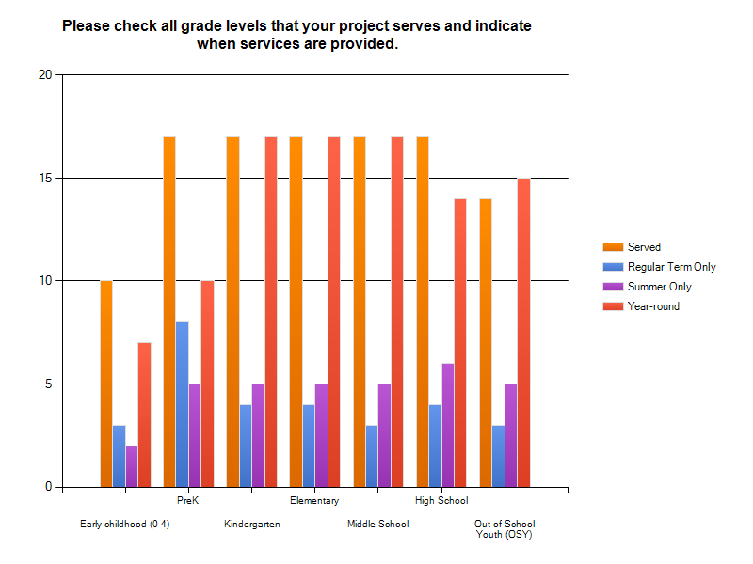
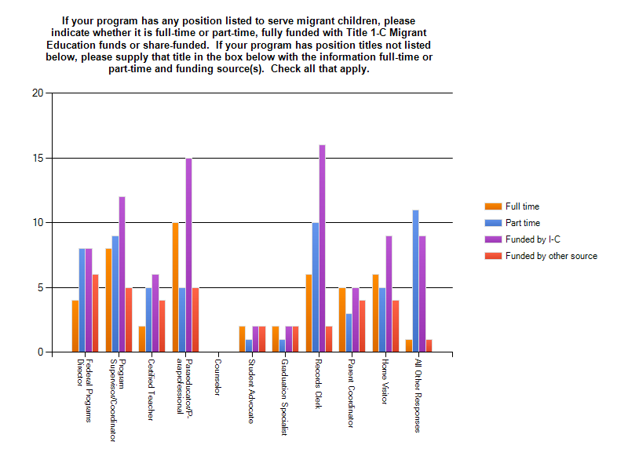
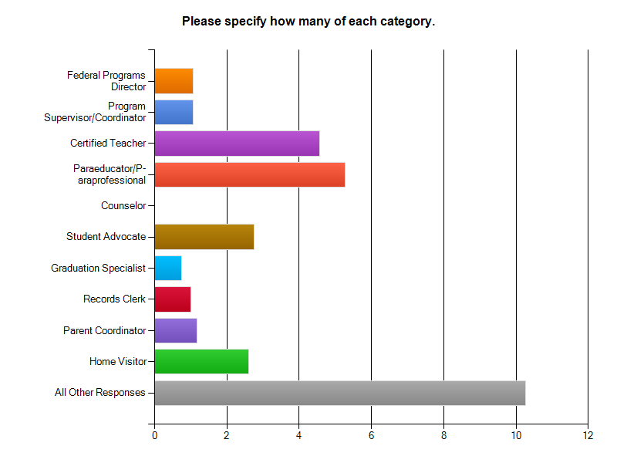
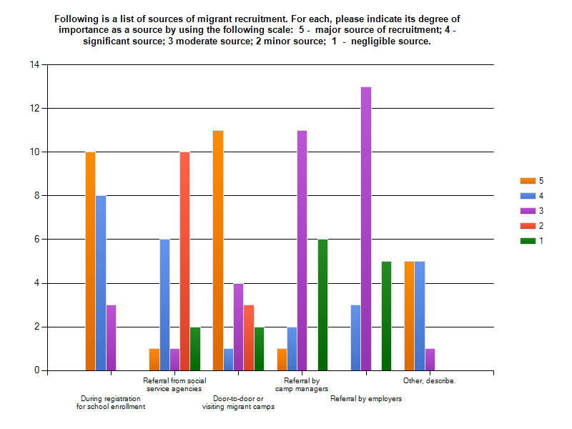

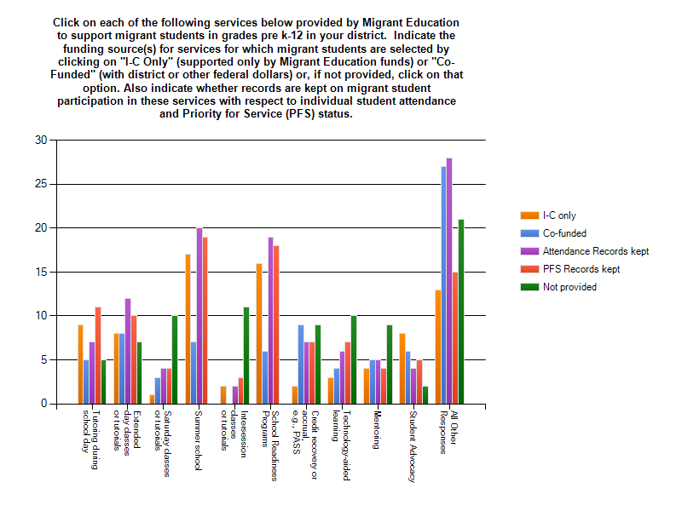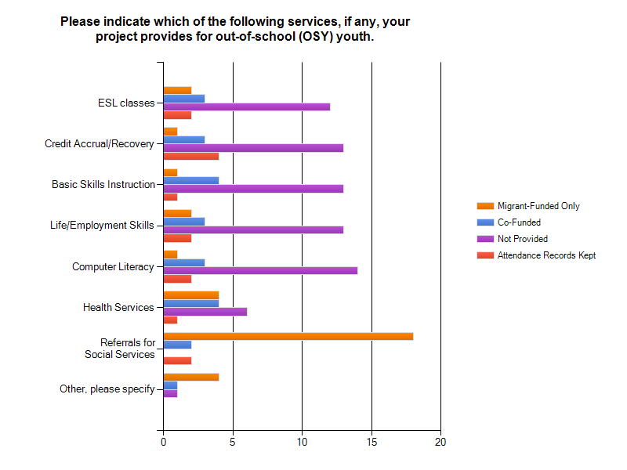

APPENDIX C - PARENT SURVEY

