Qorshaha Waxqabadka Gobolka (SPP)

Xaashida Macluumaadka

Tilmaamaha C3: Natiijooyinka Carruurnimada Hore

Qorshaha Waxqabadka Gobolka Oregon
Marka loo eego Xeerka Waxbarashada Shaqsiyaadka Naafada ah ee 2004 (IDEA), Waaxda Waxbarashada ee Oregon (ODE) ayaa looga baahanyahay inay u soo gudbiso Qorshaha Waxqabadka Gobolka (SPP) ee lixda sano ah Xafiiska Waxbarashada Gaarka ah (OSEP). OSEP waxaa ay soo saartay cabirada waxqabadka muhiimka ah, oo loo yaqaano tilmaameyaal, si loogu cabiro u hoggaansanaanta iyo natiijooyinka labadaba. OSEP waxaa ay dajisaa bartilmaameedyada loogu talagalay tilmaamayaasha u hoggaansanaanta iyo ODE waxaa ay dajisaa bartilmaameedyada loogu talagalay natiijooyinka tilmaamayaasha. SPP waa inay ku dartaa bartilmaameedyada loogu talagalay natiijooyinka tilmaame kasta. ODE waxaa ay ka warbixisaa horumarka la sameeyay ee ku aadan tilmaamayaashaan sannad kasta Warbixinta Waxqabadka Sannadlaha ah (APR). Lixdii sana oo kasta ODE-da waa inay dib u eegtaa bartilmaameedyada natiijooyinka oo ayna kala shaqeysaa iskaashatada muhiimka ah dhanka horumarinta bartilmaameedyada cusub. Fadlan eeg Qorshaha Waxqabadka Gobolka ODE iyo Warbixinada Sannadlaha ah ee loogu talagalay bogga mareegta ee Waxbarashada Gaarka ah wixii macluumaad dheeraad ah.

Waa maxay waxa tilmaamayaashaan ay cabiraan maxayna muhiim u yihiin?
Tilmaamaha C3 waxa uu cabiraa boqolkiiba ee dhallaanka iyo socod baradka leh Qorshayaasha Adeegga Qoyska ee Shakhsi ahaaneed (IFSP) kuwaas oo muujiya inuu hormaray:
- A. Xirfadaha dareenka bulsheed ee togan (ay ka mid yihiin xiriirada bulshada);
- B. Helitaanka iyo adeegsiga aqoonta iyo xirfadaha (ay ka mid yihiin luqadda hore/ isgaarsiinta); iyo
- C. Adeegsiga habdhaqanada ku habboon si ay u daboolaan baahidooda. (20 U.S.C. 1416(a)(3)(A) iyo 1442)
Tilmaamahaani waxaa uu muujinayaa natiijooyinka koritaanka iyo waxbarashada ee loogu talagalay dhallaanka iyo socod baradyaasha ku jira barnaamijyadeena EI/ECSE. Natiijooyinkani waxay ku xiran yihiin maalgelinta Xeerka Guusha Ardayga iyadoo barnaamijyada EI/ECSE ee gobolka shaqsi uu u isticmaalo xogtan si uu u kala mudnaan siiyo hormarka laga sameeyay natiijooyinka la xushay.

Waa maxay xigashada xogta?
Sheeg xigashada xogta la xushay.

Sidee ayay Oregon wax u qabatay waqti kadib?
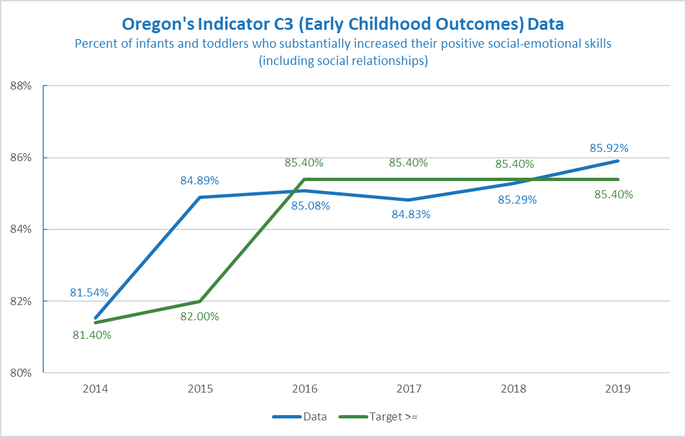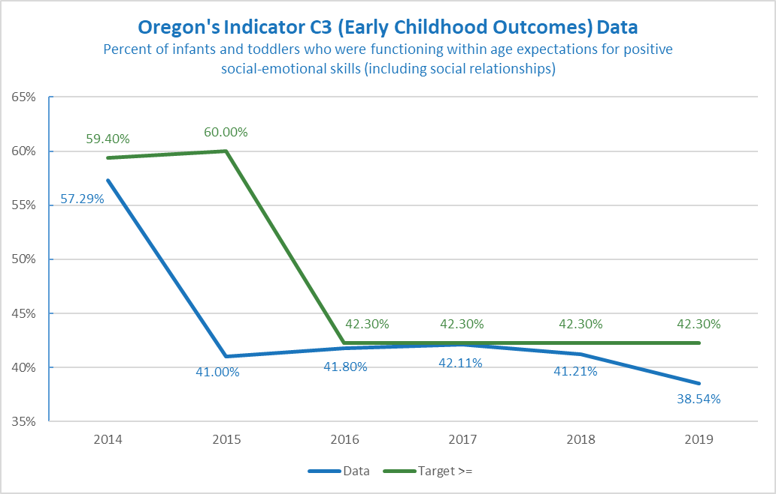

Natiijada | Gundhigga | FFY | 2014 | 2015 | 2016 | 2017 | 2018
A1 | 2015 | Bartilmaameedka>= | 81.40% | 82.00% | 85.40% | 85.40% | 85.40%
A1 | 84.89% | Xogta | 81.54% | 84.89% | 85.08% | 84.83% | 85.29%
A2 | 2015 | Bartilmaameedka>= | 59.40% | 60.00% | 42.30% | 42.30% | 42.30%
A2 | 41.00% | Xogta | 57.29% | 41.00% | 41.80% | 42.11% | 41.21%
B1 | 2015 | Bartilmaameedka>= | 64.20% | 64.30% | 66.70% | 66.70% | 66.70%
B1 | 66.42% | Xogta | 61.33% | 66.42% | 64.32% | 61.85% | 61.40%
B2 | 2015 | Bartilmaameedka>= | 7.60% | 8.00% | 36.00% | 36.00% | 36.00%
B2 | 35.69% | Xogta | 8.51% | 35.69% | 34.82% | 34.39% | 34.50%
C1 | 2015 | Bartilmaameedka>= | 64.90% | 65.00% | 77.80% | 77.80% | 77.80%
C1 | 77.28% | Xogta | 65.97% | 77.28% | 75.83% | 75.75% | 74.62%
C2 | 2015 | Bartilmaameedka>= | 18.40% | 18.50% | 40.60% | 40.60% | 40.60%
C2 | 40.33% | Xogta | 13.29% | 40.33% | 38.95% | 36.61% | 36.38%

FFY 2019 | Bartilmaameedka | Xogta
A1 | 85.40% | 85.92%
A2 | 42.30% | 38.54%
B1 | 66.70% | 61.98%
B2 | 36.00% | 31.72%
C1 | 77.80% | 74.85%
C2 | 40.60% | 33.87%

Gundhiga miyuu u baahanyahay in la dajiyo ama dib loogu habeeyo tilmaamahaan? Haddii ay haa tahay, waa maxay gundhigga cusub?
Maya, gundhigga dib looma habeyn doono sanadkan. Gundhigga xogta ee sannadka hadda waa 2015 markii Oregon uu u wareegay shirkadda Brookes Publishing Company Sort ee AEPS I iyo II ee ku aadan Natiijooyinka Ilmaha ee C3. Waxqabadka xogta laga soo bilaabo 2015 ayaa la isku daray oo xitaa aad ayuu u kacsanaa intii lagu guda jiray aafaada. Hay'ada waxaa ay sii wadan doontaa xogta gundhigga ee 2015. Maadaama Oregon ay qaadan doonto AEPS-3-da loogu talagalay xogta natiijada carruurta ee C3 inta lagu jiro 2022 ama 2023, bartilmaameedyada la dajiyay sanadkan way adkaan doontaa in loo isticmaalo waxqabadka xogta sanadaha xiga.

Maxay yihiin bartilmaameedyada cusub?
ODE ma dajin doonto bartilmaameedyo cusub ilaa aan ka maqalno dhanka iskaashatadeena. Waxaa jira qaabab badan oo loo dajiyo bartilmaameedyo cusub. Waxaa ay noqon kartaa kordhida boqolkiiba ah, ku bilow ciyaarta dhamaadka ee maskaxda ku jirta, ama baar isbeddellada waqti kadib oona samee saadaalo ku saleysan isbeddellada. Qaar ka mid ah macluumaadka waxtarka leh ee ku saabsan dajinta bartilmaameedyada:
- Bartilmaameedyada waxaa loogu talagalay in lagu taageero natiijooyinka hormarsan iyo natiijooyinka loogu talagalay carruurta iyo qoysaska. Waa inay ku jiraan meel la gaari karo laakiin weli waxay muujinaysaa koritaan.
- Badelka waxaa uu qaataa waqti. Bartilmaameedyada waxaa la abuuri karaa iyadoo maskaxda lagu hayo fahamkan. Tusaale ahaan, bartilmaameedyada waxay ahaan karaan sidoodii sano badan oo isku xigxiga, ka dibna wax yar ayuu kordhi karaa inta lagu guda jiro sanadka bartilmaameedka u dambeeya (FFY 2025). Ama wuxuu muujiya kordhitaan yar sannad kasta.
- Hadafka laga leeyahay tilmaamahaan waa inuu la ekaadaa ama ka sareeya bartilmaameedka.
Tusaale A
FFY | 2020 | 2021 | 2022 | 2023 | 2024 | 2025
Bartilmaameedyada A1 ≥ | 85.40% | 85.50% | 85.50% | 85.60% | 85.60% | 85.70%
Bartilmaameedyada A2 ≥ | 42.30% | 42.40% | 42.40% | 42.50% | 42.50% | 42.60%
Bartilmaameedyada B1 ≥ | 66.70% | 66.80% | 66.80% | 66.90% | 66.90% | 67.00%
Bartilmaameedyada B2 ≥ | 36.00% | 36.10% | 36.10% | 36.20% | 36.20% | 36.30%
Bartilmaameedyada C1 ≥ | 77.80% | 77.90% | 77.90% | 78.00% | 78.00% | 78.10%
Bartilmaameedyada C2 ≥ | 40.60% | 40.70% | 40.70% | 40.80% | 40.80% | 40.90%
Tusaalaha A waxaa uu muujinaya kordhitaan tartiib ah.
Tusaale B
FFY | 2020 | 2021 | 2022 | 2023 | 2024 | 2025
Bartilmaameedyada A1 ≥ | 85.40% | 85.60% | 85.80% | 86.00% | 86.20% | 86.40%
Bartilmaameedyada A2 ≥ | 42.30% | 42.50% | 42.70% | 42.90% | 43.10% | 43.30%
Bartilmaameedyada B1 ≥ | 66.70% | 67.90% | 68.10% | 68.30% | 68.50% | 68.70%
Bartilmaameedyada B2 ≥ | 36.00% | 36.20% | 36.40% | 36.60% | 36.80% | 37.00%
Bartilmaameedyada C1 ≥ | 77.80% | 78.00% | 78.20% | 78.40% | 78.60% | 78.80%
Bartilmaameedyada C2 ≥ | 40.60% | 40.80% | 41.00% | 41.20% | 41.40% | 41.60%
Tusaalaha B waxaa uu muujinayaa koritaan badan.
Haddii aad u baahantahay macluumaad dheeraad ah oo ku saabsan tilmaamahaan si aad u bixiso fikrad ku biirinta, fadlan la xiriir Bruce Sheppard, Khabiirka Waxbarashada, bruce.sheppard@ode.state.or.us

