Abbreviated Day Collection Manual
October 2023
Oregon Department of Education
Office of Enhancing Student Opportunities
255 Capitol Street NE
Salem, OR 97310-0203

It is the policy of the State Board of Education and a priority of the Oregon Department of Education that there will be no discrimination or harassment on the grounds of race, color, religion, sex, marital status, sexual orientation, national origin, age or disability in any educational programs, activities or employment. Persons having questions about equal opportunity and nondiscrimination should contact the Deputy Superintendent of Public Instruction at the address above; phone 503-947-5740; or fax 503-378-4772.

Table of Contents
What’s New 1
September 2023 1
October 2023 1
General Information 2
Purpose 2
Introduction 2
Important dates 2
Contact List 2
Training & Materials 2
ODE Help Desk & Data Security and Privacy Overview 4
ODE Helpdesk Contact Information 4
Services 4
Help Desk vs. Data Team – who to call? 4
ODE Help Desk: What to Expect 4
Data Security and Privacy 5
Student Data Security: Handle With Care 5
ODE Policies 5
Information Security Questions 5
Navigating the Abbreviated Day Collection 6
Login Information 6
Submitting Data to the Abbreviated Day Collection 9
Web Submission 10
Abbreviated Day Fields 11
Uploading a PDF 13
File Submission 15
Deleting Records 18
Correcting Errors 19
Verification Process 21
Coding Key Fields 23
Resident District Student 23
Resident District Student - Other Local or Regional Correctional Facilities (Not ACEP, YCEP, or JDEP) 23
LTCT Student (Contractor Submission) 24
Hospital Program Student (Contractor Submission) 24
Pediatric Nursing Facility (PNF) 24
State Placed Juvenile Detention Education Program (JDEP) Student (Contractor Submission) 25
State Placed Youth Corrections Education Program (YCEP) (Contractor Submission) 25
Production Download 26
Frequently Asked Questions 29
Appendices 30
Reason Codes 30

What’s New

September 2023
- None - This is a new collection.

October 2023
- Added instructions on File Submission.
- Added instructions on Production Download.

General Information

Purpose
The Abbreviated Day Collection collects student level records who are on an Abbreviated School Day Program. SB 819 was signed into law on July 13, 2023 and outlines the provisions relating to Abbreviated School Day Programs.
It is open year around for each school year. Records are reported on students who are on an IEP, 504 or referred for an evaluation for IEP or 504 who are on an Abbreviated School Day Program.

Introduction
The purpose of this document is to be an easy reference tool for individuals responsible for reporting data related to the Abbreviated Day Collection. If this manual does not provide the guidance necessary to answer a specific data collection question, please contact ODE collection staff. It is extremely important that data submitted for all collections are accurate, valid, and reliable.
Icon | Description
 | An information circle indicates an informational note.
 | A light bulb indicates a useful tip.
 | A warning triangle indicates a warning, and the user should use caution.

Important dates
Open 09/14/2023
Close 7/05/2023

Contact List
Elizabeth Jankowski Education Specialist (503) 881-9798 elizabeth.jankowski@ode.oregon.gov
Data Support ode.oss-datateam@ode.oregon.gov

Training & Materials
Collection documents, including the collection manual and training resources are located on the on the District Collection page.

Important - Please Read
Rules for Submitting Timely & Accurate Abbreviated Day Collection Data
- Keep your data up to date at all times. As soon as a record is reportable, enter it.
- Read all the instructions and documentation related to the data collection.
- Submit data as early as possible, but do not rush! Technology, weather, and other factors beyond district control can suddenly keep a district from submitting a record.
- Train at least one backup person to submit, validate, and correct data for each data collection. Key people may get sick, injured, or leave without notice. Do not forget to have the district security administrator grant appropriate permissions to the backup staff member. Your District’s Security Administrator can be found on the ODE District website.
- Make a plan. Collect and report records throughout the school year as they become reportable to this collection.
- If you have questions, contact the data collection owner at the ODE as soon as possible. ODE data owners are here to help you.
Following these rules throughout the year will help reduce the risk of your district being late and/or inaccurate.

ODE Help Desk & Data Security and Privacy Overview

ODE Helpdesk Contact Information
ODE Helpdesk ODE.Helpdesk@ode.state.or.us (503) 947-5715

Services
ODE Help Desk can
- Provide technical assistance with how to submit your data
- Check to see if your data has submitted
- Provide assistance with questions about access rights and permissions
ODE Help Desk can not
- Submit your data for you
- Make changes to your data
- Answer content area questions

Help Desk vs. Data Team – who to call?
Question | Answer
How to report a student? | Data Team
Why won’t my data submit? | Data Team (will refer to HelpDesk if needed)
Audit/Error Corrections? | Data Team
How can I get a new user added? | ODE Help Desk

ODE Help Desk: What to Expect
When you call or email ODE Help Desk, the best way to contact the ODE Help Desk is at ODE.helpdesk@state.or.us or (503) 947-5715.

Data Security and Privacy
The student data that you collect, handle, and submit is protected student data governed by:
- Family Educational Rights and Privacy Act (FERPA) (34 CFR Part 99)
- Oregon Identity Theft Protection Act
- And in some cases, the Health Insurance Portability and Accountability Act (HIPAA), such as the transfer of records between agencies
Consequences: Loss of protected data can have financial impact to your school, district, or ESD, including fines and cost of remediation!

Student Data Security: Handle With Care
Basic tips to protect student level data
- Use Secure File Transfer. Never send information that would identify an individual student via email, not even to the ODE Help Desk or a member of the Data Team. Emails sent to and from the ODE are considered public record.
  - In order to provide information to ODE, it is advisable to send only the student’s SSID number
  - Never send student’s name, birth date, telephone number, grade or anything else that could be used to identify a specific student.
  - On ODE’s Secure File Transfer users can send secure documents to ODE Staff.
  - The Consolidated Collections manual has instructions how to send a Secure File Transfer.
- Never share your username and password
  - You are responsible for everything done in the system using your username and password
  - Avoid storing your password in an obvious place (desk drawers, under keyboards, sticky notes on monitors are all bad places to store passwords)
- Use a Passphrase instead of a Password
  - Passphrases are sentences you can remember and include spaces and punctuation.
  - Example: Trust the force, Luke!
  - Example: Scotty, beam us up.
- Lock your computer monitor (Window key +L) when you leave your desk
  - Avoid leaving your monitor open and unattended
- Never store or transport student data on an unencrypted thumb drive/flash drive
  - Portable drives are one of the biggest risk factors for losing large volumes of data
The privacy and security of student data depends upon you.
People are the most important part of information security

ODE Policies
Handling Confidential Information
Information Asset Classification

Information Security Questions
Contact ODE Chief Information Security Officer and Team at ODE.Infosec@ode.state.or.us.

Navigating the Abbreviated Day Collection
The Abbreviated Day data collection opens September 14, 2023 and closes July 5, 2023.

Login Information
Access your applications list from the ODE District site at https://odedistrict.oregon.gov/Pages/default.aspx. Click on the Central Login Application button.
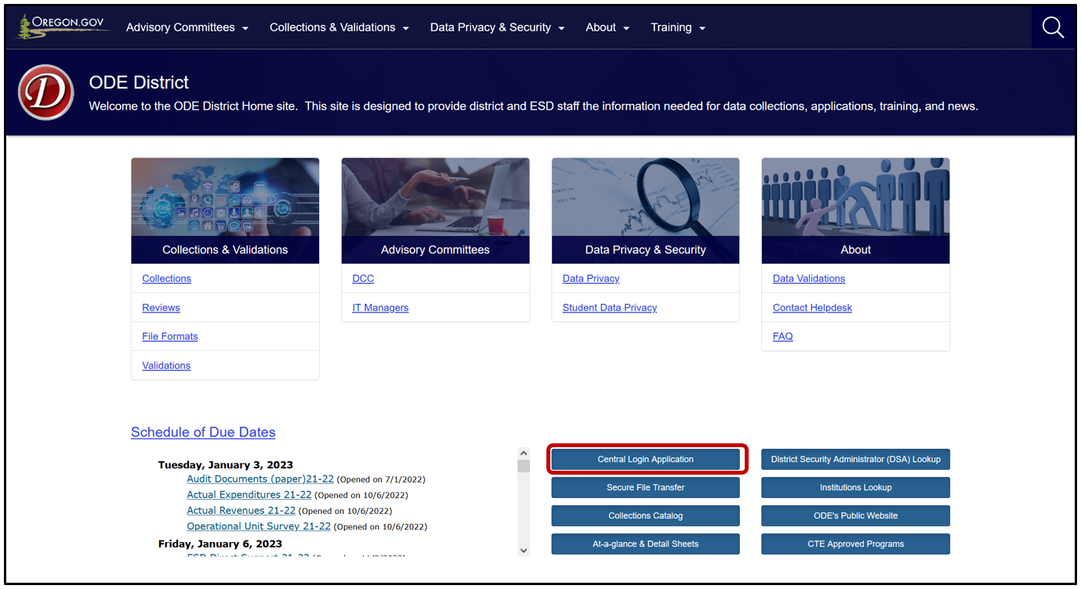
Enter your Username and Password, then click Login.
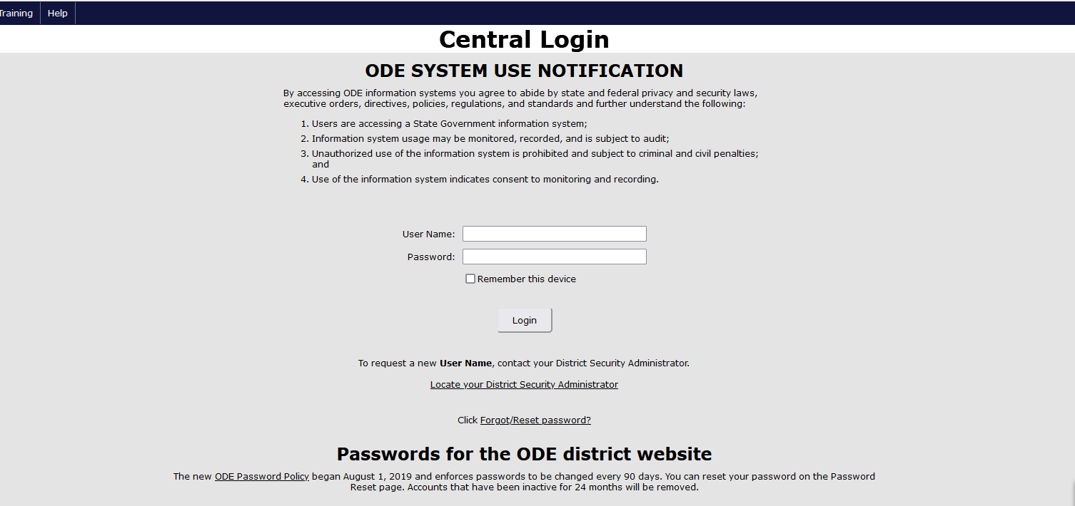

Logging in takes Users to their Applications List, (yours might appear differently).
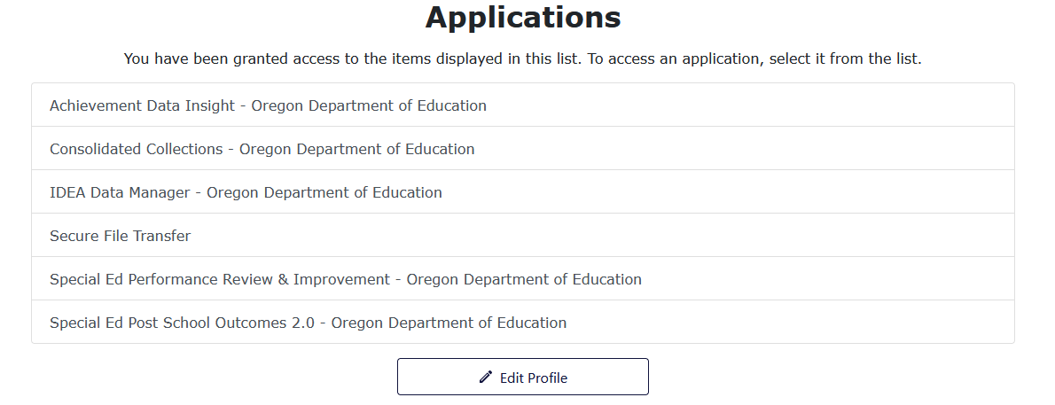
From the Applications list, click on Consolidated Collections.
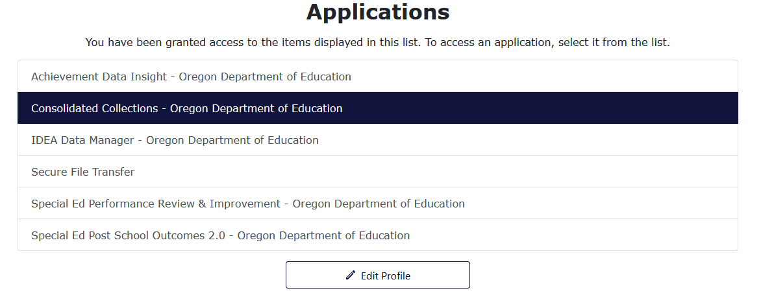
Users should see a screen that looks similar to this:
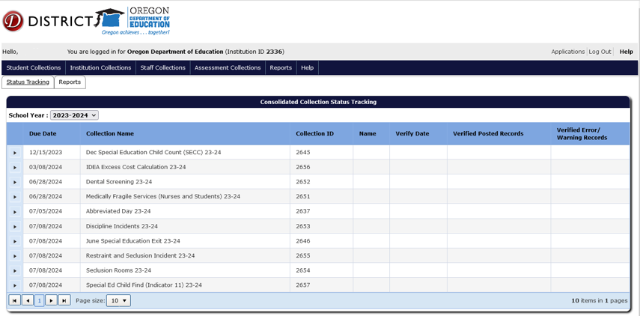
The list of collections users see will depend on the collections they have permissions to view and/or modify. If a user does not see the specific collection for which they are submitting data, they will need to contact their District Security Administrator for Modify permissions and Submitter permissions.

Submitting Data to the Abbreviated Day Collection
Abbreviated Day Collection records are submitted by resident districts and submitting agencies for applicable programs. Report students on an IEP, 504 plan or referred for an initial evaluation for special education or 504 who are on Abbreviated School Day Program. An Abbreviated School Day Program per SB 819 is defined as:
- An education program in which the school district restricts access for a student with a disability to hours of instruction or educational services to less than the number of hours of instruction or educational services that are provided to the majority of other students who are in the same grade within the student’s resident school district
- That results in a student with a disability having an abbreviated school day for more than 10 school days per school year.
Criteria for Reporting a Record:
A record becomes reportable to this collection, when the student who is on an IEP, 504 or referred for an evaluation for either, is considered on an abbreviated school day program for greater than 10 days. On day eleven, the student is reported to the collection.
If Count of Days Are 11 Consecutive Days:
Report one record by entering the first day the student was on an abbreviated school day as the Abbreviated Day Start Date. Do not enter day 11 as the Abbreviated Day Start Date.
If Count of Days are 11 Cumulative Days:
Report multiple records, one for each instance leading up to a count of 11 days total.
Report all records that meet the criteria from July 1 to June 30.
- The collection is open year around, so records meeting the criteria should be reported as soon as possible. The same day or the next day is best.
- Only one “open” record allowed per student in school year. A student can have multiple records reported, but only one with BLANK Abbreviated School Day Program End Date.
- Caution! Records must be entered in chronological date order (earliest first to the most current last). If entered out of order, an error message will be generated. To clear the error, delete the most current record and resubmit it.
Submitting Agencies (see Coding Key Fields for more information):
- Resident Districts
- Contractors (districts and ESDs) on behalf of resident districts for the following programs:
- Long Term Care and Treatment (LTCT)
- Youth Correctional Education Program (YCEP)
- Juvenile Detention Education Program (JDEP)
- Hospital Programs
- Pediatric Nursing Facilities
Records that are exempt and not reported to this collection:
- Home schooled
- Parent Placed Private Schools
- Excluded from or limited access to school due to court order
- Component of discipline imposed
- Exposure to disease
- Public health emergency, i.e. restricted access or school closures as a result
Please ODE collection staff if you have questions or need help.

Web Submission
To submit data hover your mouse over Student Collections. A drop menu will appear, containing a list of open collections. When ready to submit, hover over the collection name Abbreviated Day. A fly-out menu will appear with three options: Data Submission, Error Management and Record Management. Hover over Data submission, and then Web Submission to submit student records one at a time.
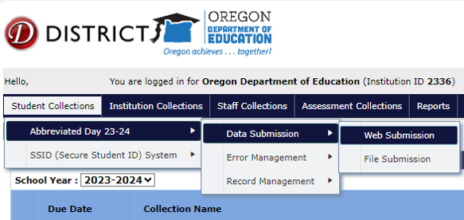
The Web Submission takes you to a search screen. Search for a student using one of the options to search by SSID, Last Name, etc. and then click Search.
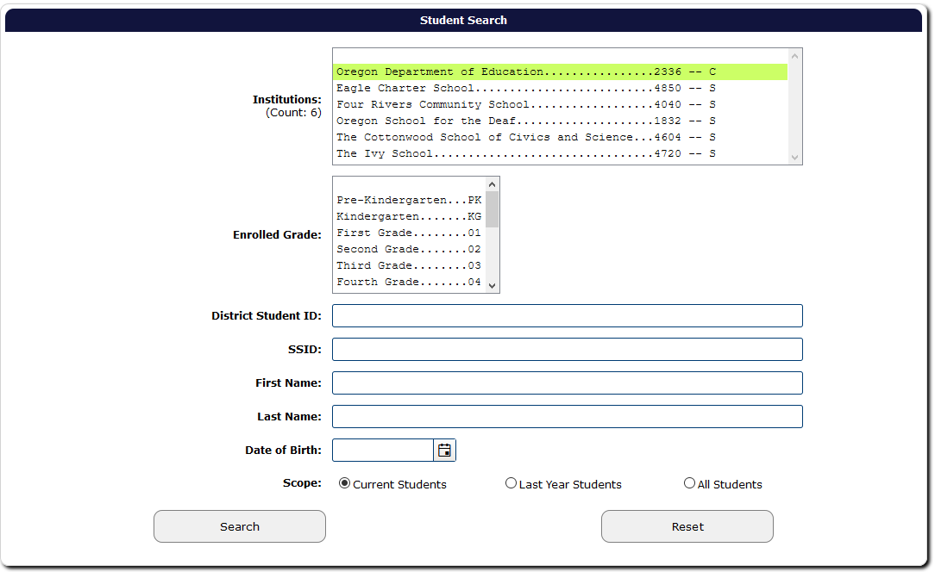
After clicking Search, the application will generate a list of student(s) that meet the search criteria. Click the green checkmark to open the student record.
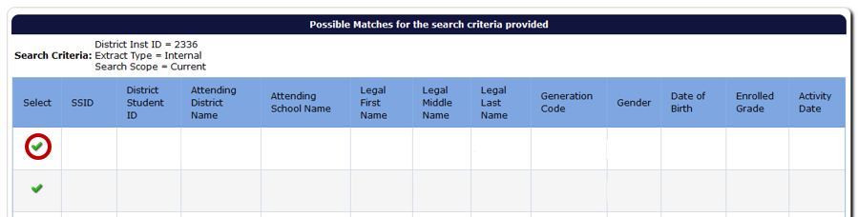
The application will open a data entry screen for the selected student. The top half of the screen contain fields for the Abbreviated Day collection. The bottom of the screen are core fields, such as the student’s personal, demographic, and program data.
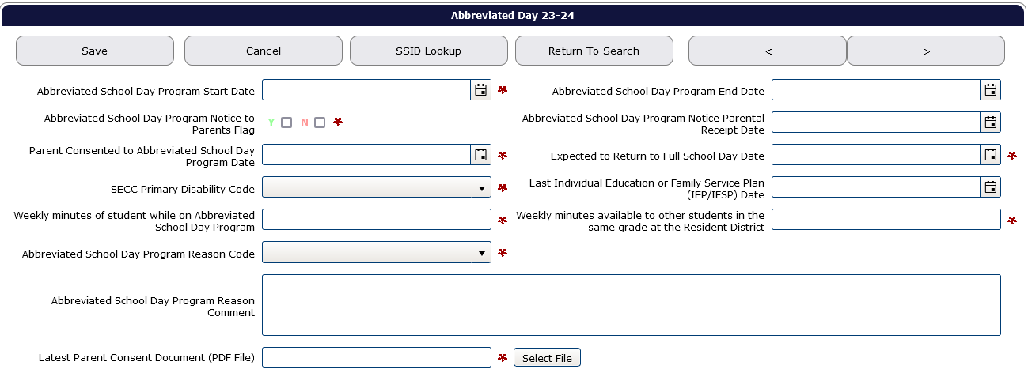

Abbreviated Day Fields

Abbreviated School Day Program Start Date (Required)
The date the student started on an Abbreviated School Day Program.

Abbreviated School Day Program End Date
The date the student was last on an Abbreviated School Day Program. Leave blank if student is still on an Abbreviated School Day Program.

Abbreviated School Day Program Notice to Parents Flag (Required)
Yes/No Flag that indicates district provided the parent of the student written notice regarding the district’s legal requirements for an Abbreviated School Day Program per ORS 343.161(4).

Abbreviated School Day Program Notice Parental Receipt Date
Date district obtained required parental signature of acknowledgement of receipt of required Abbreviated School Day Program Information per ORS 343.161(4).

Parent Consented to Abbreviated School Day Program Date (Required)
The date parent signed required consent to place student on an Abbreviated School Day Program per SB819.

Expected to Return to Full School Day Date (Required)
The date the student is expected to return to a full school day.

SECC Primary Disability Code (Required)
The code indicating the primary disability (eligibility) of the student. For Students with Special Education Flag N, this code should be “00 Not Applicable.”

Last Individual Education or Family Service Plan (IEP/IFSP) Date
The date that the student’s most recent Individual Education or Family Service Plan was completed.

Weekly minutes of student while on Abbreviated School Day Program (Required)
The weekly minutes of student while on an Abbreviated School Day Program.
Note: This is the total weekly instructional and educational service minutes provided to the student, that is less than the total weekly instructional and educational service minutes provided to other students in the same grade in the resident district (for comparison, see Weekly minutes available to other students in the same grade at the Resident District)

Weekly minutes available to other students in the same grade at the Resident District (Required)
Weekly minutes available to other students in the same grade at the Resident District.
Note: This is the total weekly instructional and educational service minutes provided to other students in the same grade in the resident district, i.e., the total bell to bell minutes for the week.

Abbreviated School Day Program Reason Code (Required)
The code indicating the reason the student is on an Abbreviated School Day Program.

Abbreviated School Day Program Reason Comment
If the Reason Code entered is 06 (Other), district is required to provide comment further describing the Abbreviated School Day Program reason.

Latest Parent Consent Document (PDF File) (Required)
Uploaded PDF of the latest paperwork associated with the Abbreviated School Day Program pertaining to the Signed Consent and Acknowledgement of receipt of program information. Must be a PDF.
IMPORTANT! Once you save the record, the only fields that are editable will be the Abbreviated School Day Program End Date field and the Latest Parent Consent Document (PDF File).

Uploading a PDF
When districts need to upload a new consent document, go to Record Management, Record Maintenance. From the drop menu of currently open collections, hover over Abbreviated Day to access the fly out menus. Then hover over Record Management, and click Record Maintenance.
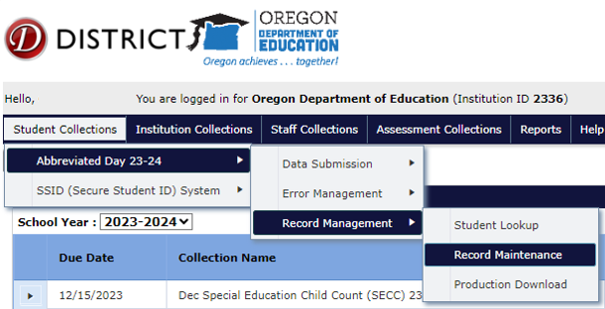
This screen allows users to search for student records. Enter a student SSID and select Search.
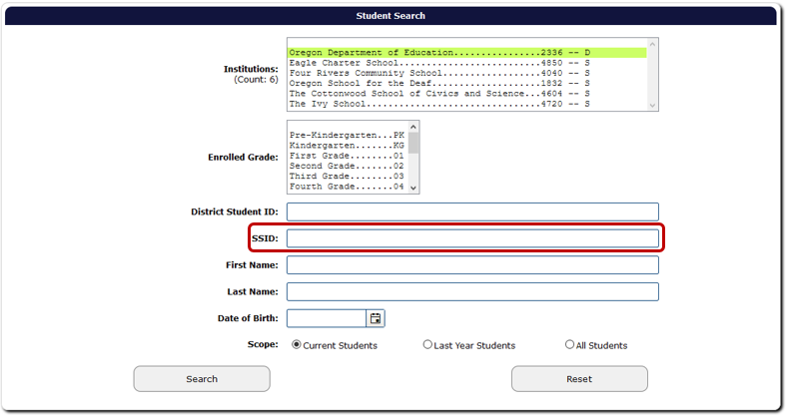

After clicking Search, the application will generate a list of student(s) that meet the search criteria. Click the green checkmark to open the student record.
The application will open a data entry screen for the selected student. To upload a new PDF, click Select File.
When the document is uploaded, the screen will refresh and show a Reset button. This is how users know the document successfully uploaded.
If the wrong document is uploaded, use the Reset button to access the Select File button again to upload the correct document.
Final step is to click the Save button. Caution, all PDFs uploaded are saved to the database and cannot be deleted.

File Submission
To upload a submission file, hover your mouse over Student Collections in the top menu bar. A drop menu will appear, containing a list of open collections. When ready to submit, hover over the collection name Abbreviated Day. A fly-out menu will appear with three options: Data Submission, Error Management and Record Management. Hover over Data submission, and then File Submission to submit a file of multiple student records.
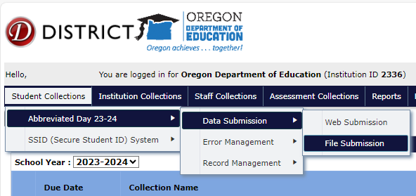
Next, click the Browse button to locate the submission file from the IDEA Data Manager or district SIS. Depending on the browser, the Browse button will be a Choose File button.
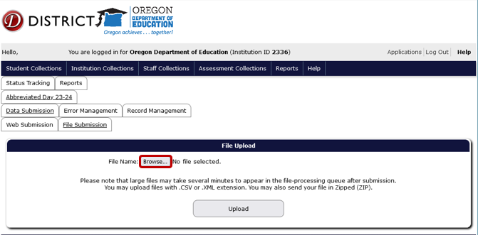

A File Upload dialog box will appear. Select the submission file and then click the Open button.
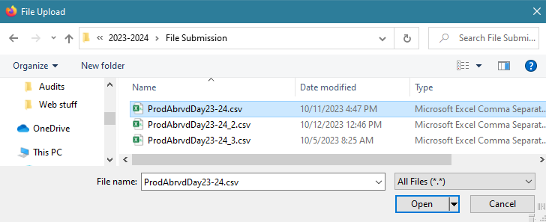
Finally, click the Upload button to submit the file to ODE.
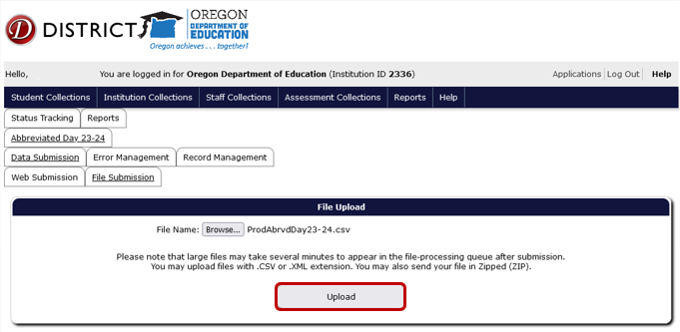

If the upload is successful, the screen will display information boxes with information on the file and processing status. Consolidated Collections will notify users by email when the validation processing is complete.
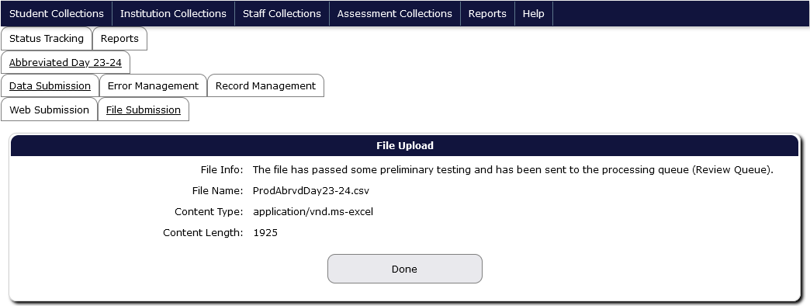
Note: All records uploaded will receive an error until a PDF is added to the record. To fix this, go to Review Errors, click on the green checkmark then attach the PDF (see Correcting Errors and Uploading a PDF).
Users must check for errors throughout the reporting period. Caution! Users are not finished submitting data to ODE until all errors are corrected AND the collection has been verified at the end of the reporting period. Users must click the Verify Submission button before the collection cycle closes. See the sections Correcting Errors and Verification Process.

Deleting Records
Records should only be deleted if the wrong student was entered, or a record was entered and saved with incorrect information in fields that are not editable after saving.
To delete a record, hover over Student Collections. From the drop menu of currently open collections, hover over Abbreviated Day to access the fly out menus. Then hover over Record Management, and finally click Record Maintenance.
e
This screen allows users to search for student records. Enter a student SSID and select Search.

The system will generate a table with the student record. To delete, click the red X to the right of the record. If deleting duplicate record(s), click green check mark to the left of the record, located in the Edit column, next to SSID column. This will allow users to double check they are deleting applicable record.
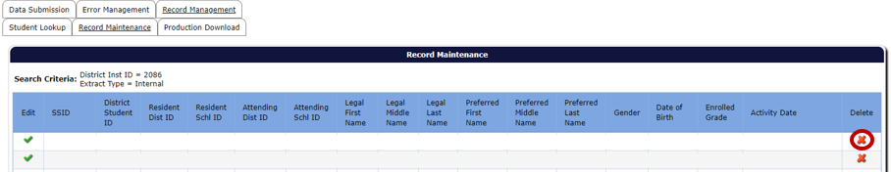
Users can double check the record has been successfully deleted by searching for the record in the search screen located under Record Management, Record Maintenance.

Correcting Errors
Once all data has been loaded, the next step is to correct errors. To view and correct errors, hover your mouse over Student Collections in the top menu bar. From the drop menu, hover over Abbreviated Day, hover over Error Management, then from the fly out menu click on Review Errors.
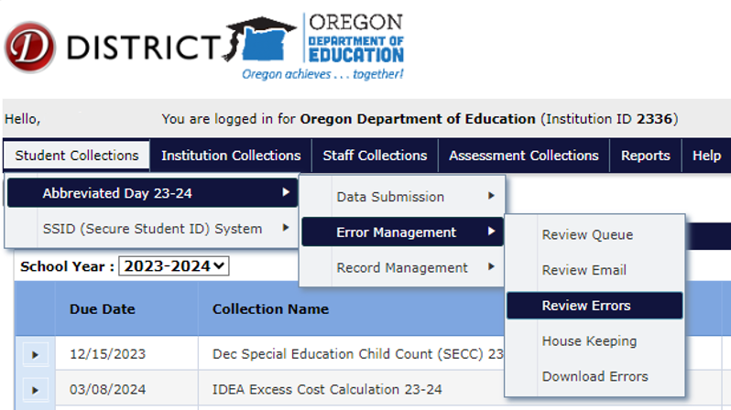
The Error Screen shows a list of errors by type, count and description. The Error Count is the number of records with the Error Type. Click the triangle expand button, in the row of the Error Type you wish to correct, which expands to show the records with that type of error.
This expanded screen contains a table with demographic information, a green check mark to access the record, a red “x” to delete the record, the values causing the error, and the column names for these values.
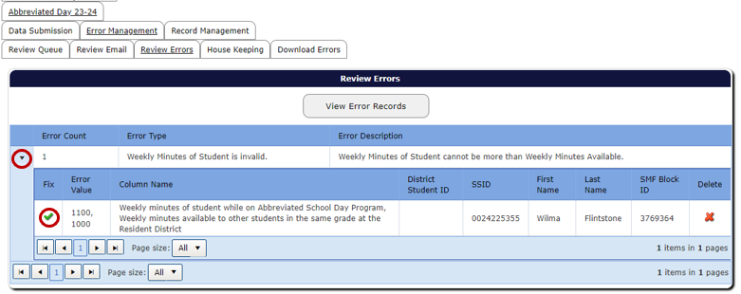
Clicking the green check mark will open the record. The top of the record will display each validation error for the record. Consolidated Collections puts a red outline around the field that contains a validation error. If there is more than one validation error, each field that is in error will be outlined in red.
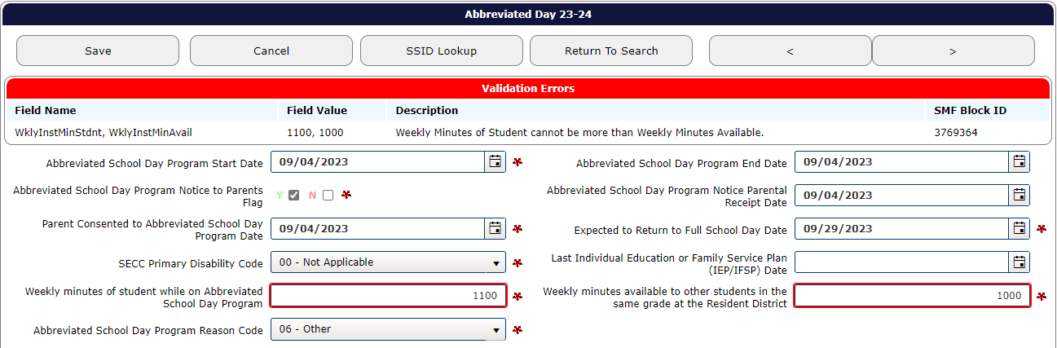
After fixing each error, click the Save button, located at the top and bottom of the record, which will clear the error. After clicking Save, the system will produce a green “Record Saved” message. The system also will revalidate the entire record, to check for any further errors.
If there is more than one error in the Error Type, the system will keep the Error Type expanded. Once all errors are fixed, the record will post to Record Management.

Verification Process
At the end of the collection cycle, the final step is verifying the submission for the school year. This must be done before it closes on July 5, 2024. ODE cannot consider the collection complete until the submitting district verifies it as complete. All districts are required to complete the verification process on the Status Tracking tab at the end of the collection cycle in June/July.
From anywhere in the Consolidated Collections application, click the Status Tracking tab to go to the list of collections. Make sure the School Year dropdown displays the correct school year. This dropdown will automatically advance to the next school year on July 1. If the 2023-2024 collection closes on July 5 and is not verified, when users arrive at the Status Tracking page, the dropdown will show 2024-2025 and all the collection names will end with “24-25.” The example below uses 2023-2024 collections.
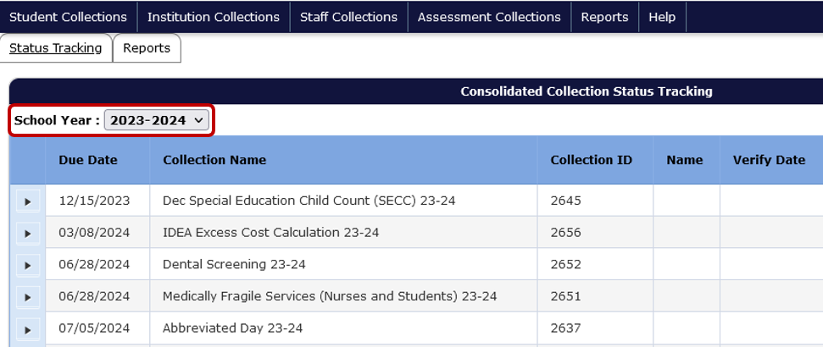
On the Status Tracking tab, use the expand triangle to select the Abbreviated Day collection. This reveals the Verify Submission button.
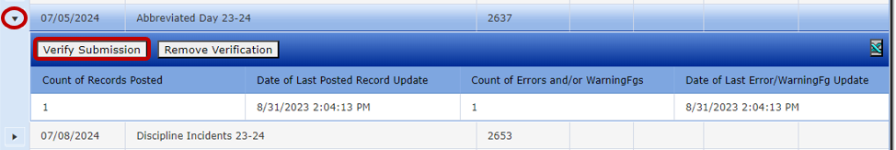

Under the Verify Submission button is a grid showing the count of records posted, date of last update, count of errors and warnings, and date of last error/warning update. Review submitted data to ensure accuracy and to ensure the data is error free. When the Verify Submission button is clicked, a message will appear indicating that your submission has been verified, and the application will display the staff name and date of verification, as well as the number of records that posted and if there are any errors.
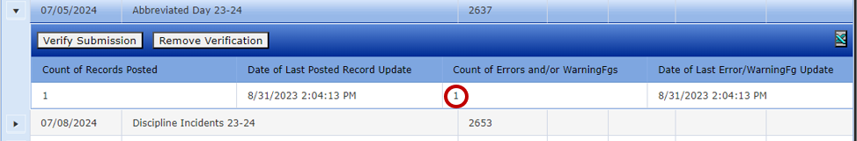
When these final steps have been completed, districts attest that they submitted accurate and complete data and that submission is considered complete.

Coding Key Fields
The following provides general guidance for different reporting scenarios. If you encounter any difficulties reporting these data, please reach out to one of the ODE staff contacts.

Resident District Student
Student resides within your district boundaries and attends school in or outside your district’s boundaries.
The resident district is responsible for submitting these students.
Field | Correct Code/Identifier
Logon at ODE District Website | - Agency submitting data
03 – Resident District ID | - Submitting Agency ID (the district responsible for FAPE)
04 – Resident School ID | - This field may be your district ID or a public school ID located within your district boundaries.
05 – Attending District ID | - District ID where the student is receiving instruction and where state assessments are administered.
06 – Attending School ID | - Public school ID within attending district boundaries or district placed private school. If no private school ID exists, enter District ID)

Resident District Student - Other Local or Regional Correctional Facilities (Not ACEP, YCEP, or JDEP)
Definition: When the student is placed in a local or regional correctional facility located within the school district that is not an ACEP, YCEP, or JDEP (ORS 339.129).
Coding Example:
Student resides within your district boundaries and receives education programs in a correctional environment that is not an ACEP, YCEP, or JDEP.
The resident district is responsible for submitting these students.
Field | Correct Code/Identifier
Logon at ODE District Website | - Agency submitting data
03 – Resident District ID | - Submitting Agency ID (the district responsible for FAPE)
04 – Resident School ID | - This field may be your district ID or a public school ID located within your district boundaries.
05 – Attending District ID | - District ID where the student is receiving instruction and where state assessments are administered.
06 – Attending School ID | - Public school ID within attending district boundaries or private school ID. If no private school ID exists, enter District ID)

LTCT Student (Contractor Submission)
The student is placed in and was receiving their education in an LTCT program.
The school district or ESD that contracts with ODE to provide educational services submits these students.
Field | Correct Code/Identifier
Logon at ODE District Website | - Agency submitting data (Contractor only)
03 – Resident District ID | - District where LTCT is located
04 – Resident School ID | - District where LTCT is located
05 – Attending District ID | - (3559) ODE LTCT District
06 – Attending School ID | - LTCT Program ID from Supplement A

Hospital Program Student (Contractor Submission)
Definition: When the student resides in and receives their special education services in a Hospital Program. ORS 343.261
Coding Example:
The student receives their education in a Hospital Program.
Only the school district or ESD that contracts with ODE to provide educational services submits these students.
Field | Correct Code/Identifier
Logon at ODE District Website | - Agency submitting data (Contractor only)
03 – Resident District ID | - District where Hospital Program is located
04 – Resident School ID | - District where Hospital Program is located
05 – Attending District ID | - (5401) ODE Hospital Program District
06 – Attending School ID | - Hospital Program ID from Supplement B

Pediatric Nursing Facility (PNF)
Definition: A pediatric nursing facility is a licensed nursing facility where at least 50 percent of whose residents entered the facility before the age of 14, and all of whose residents are under the age of 21 (ORS 343.941). Currently there is only one PNF, and Portland SD 1J reports the data for this facility.
Coding Example:
The student receives their education in a pediatric nursing facility.
Only the school district or ESD that contracts with ODE to provide educational services submits these students (see note above).
Field | Correct Code/Identifier
Logon at ODE District Website | - Agency submitting data (Contractor only)
03 – Resident District ID | - Submitting Agency ID (the district responsible for FAPE) (2180)
04 – Resident School ID | - Submitting Agency ID
05 – Attending District ID | - (5269) ODE PNF District
06 – Attending School ID | - PNF Institution ID from Supplement B (5269)

State Placed Juvenile Detention Education Program (JDEP) Student (Contractor Submission)
Definition: When the student has been placed in a Juvenile Detention Center. ORS 336.585
Coding Example:
The student receives their education in a juvenile detention center.
Only the school district/ESD that contracts with ODE to provide educational services submits these students.
Field | Correct Code/Identifier
Logon at ODE District Website | - Agency submitting data (Contractor only)
03 – Resident District ID | - Submitting Agency ID
04 – Resident School ID | - Submitting Agency ID
05 – Attending District ID | - (3476) ODE JDEP District ID
06 – Attending School ID | - JDEP Facility ID from Supplement E

State Placed Youth Corrections Education Program (YCEP) (Contractor Submission)
Definition: When the student resides in an Oregon Youth Correctional Facility and receives their education services through a Youth Corrections Education Program. ORS 336.590
Coding Example:
The student receives their education in an Oregon Youth Correctional Facility.
Only the school district or ESD that contracts with ODE to provide educational services submits these students.
Field | Correct Code/Identifier
Logon at ODE District Website | - Agency submitting data (Contractor only)
03 – Resident District ID | - Submitting Agency ID
04 – Resident School ID | - Submitting Agency ID
05 – Attending District ID | - (3477) ODE YCEP District ID
06 – Attending School ID | - YCEP Facility ID from Supplement D

Production Download
A Production Download Report is a report of all data submitted to Consolidated Collections for a given collection. It is located in the Reports tab, which contains a list of various reports that can be download for collections assigned to the user.
Select Reports tab, located next to Status Tracking tab.
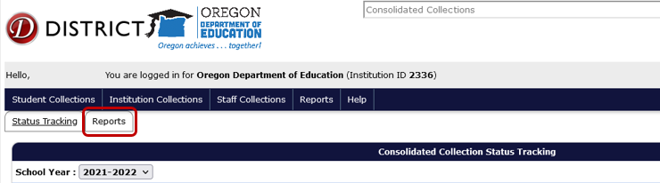
In the Collection menu, select Abbreviated School Day Program.
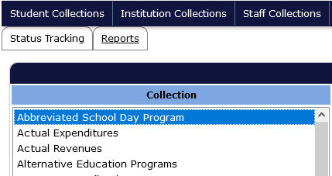
In the Report Year menu that appears below or to the right, select the AbrvdDay Report from the collection year needed.
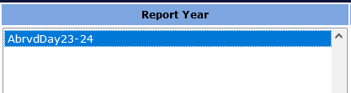
In the Report menu that appears below or to right, select Production Download Report.
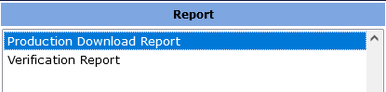
A new tab will open notifying which report was selected, and identifying the collection and year requested.
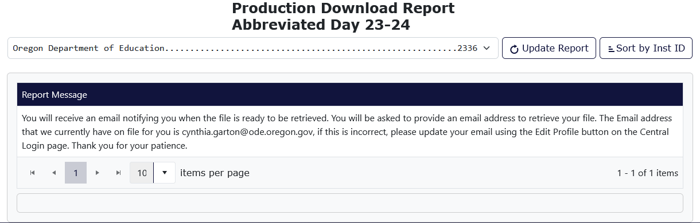
Consolidated Collections will send the user an email, using the email address associated with the users login/account. Click the link in this email.
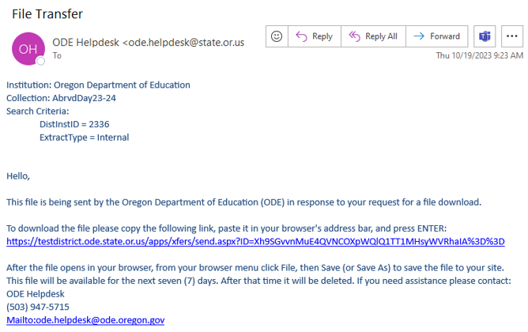

The link will take users to a Secure File Transfer page on the ODE District website. Enter the user’s email address, the same address the email was sent to, and click the Submit Email Address button.
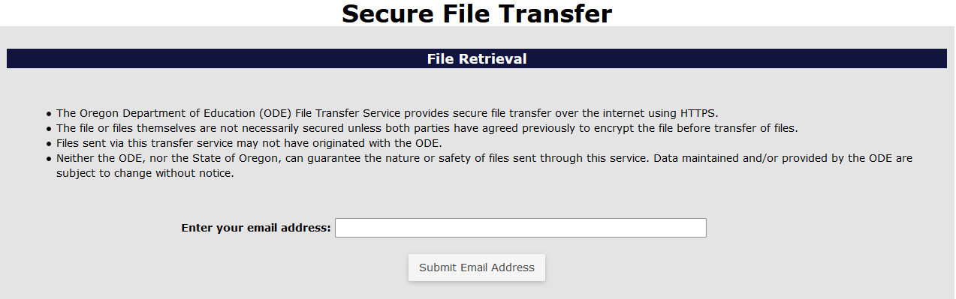
After the Submit Email Address button is clicked, the page will generate a Download button. Click the Download button to download the zip file of the Production Download Report.
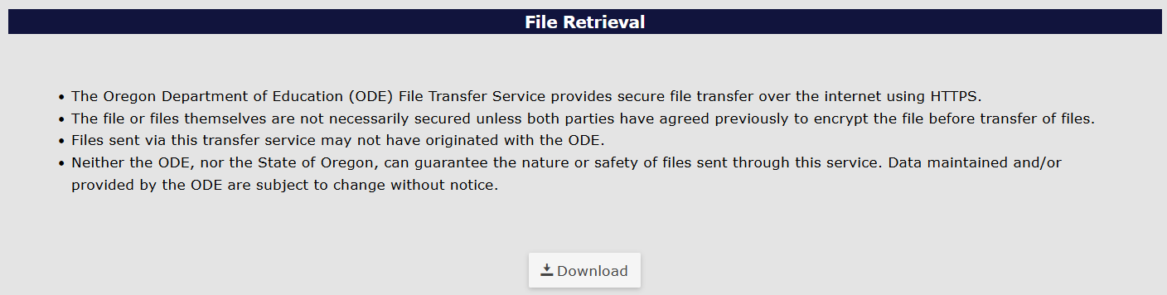
The system will generate a download box in the top right of the bowser. Users can click on the file name or the folder icon. Clicking the file name will open a zip folder containing a CSV workbook. Clicking the folder icon will open the Downloads folder where the file has been saved.
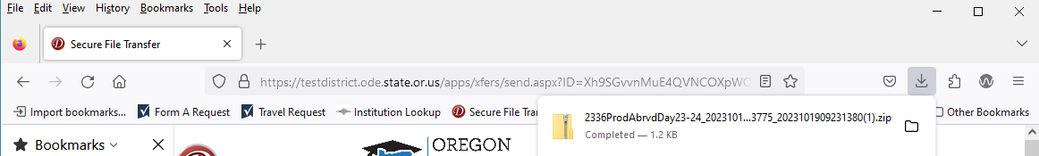

Frequently Asked Questions
Q: How do I log into the district site?
A: Visit ODE’s District webpage. Your District’s Security Administrator must give you access and permissions for the Discipline Incidents Collection.
Q: How do I locate my District Security Administrator?
A: If you do not know who your District Security Administrator is, go to the District Home page, on the right-hand side, and click Find Security Administrator. On the Search for Security Administrator page, enter an institution ID or District Name, then click the Search button.
Q: Where do I find the Abbreviated Day Collection once I have logged into the site?
A: From the Application List, select Consolidated Collections, then the Student Collections drop menu. When the collection is open, Abbreviated Day will appear in the drop menu.
Q: How do I submit online through the web submission process?
A: Please see the section on Web Submission for information on submitting one record at a time for this collection.
Q: How do I attach the latest parent consent document (PDF) to a student’s record for the Abbreviated Day Collection?
A: Please see the section on Uploading a PDF.
Q: A student is no longer on an abbreviated day program. Should I remove them from my submission?
A: Enter an Abbreviated School Day End Date and save the record.
Q: How can I find another school’s or district’s Institution ID number?
A: 1. Go to the Institutions Lookup page
2. In the second field, for Institution Name, enter the school district name; and click Search.
Q: What are Demographic Errors?
A: Demographic errors occur when a student record has three or more mismatches compared to the student’s record in SSID. In the record’s error screen, the fields in error will have a red outline. The Validation Errors message at the top of the record will display the fields in error in the Field Name column, as well as the incorrect value plus the SSID values in the Field Value column.
Q: What do I do when I receive an error that indicates a student is merged to another SSID?
A: The cause of this error is one student with two SSIDs. To fix this error, please work with district staff that works with the SSID system.

Appendices

Reason Codes

Code | Name | Description
01 | Behavior Needs | To help student meet their IEP goals related to behavior
02 | Medical Needs | To help student meet their medical needs
03 | Student/Parent Choice to Alter Education Program | Student/parent choice to alter student’s education program
04 | Student/Parent Choice - Senior Doesn’t Need Full School Day Credits | Student/parent choice due to needing less than full school day credits to graduate
05 | Court Order | Student has limited access to school due to court order.
06 | Other | Student on abbreviated day for other reason detailed in comment

https://www.ode.state.or.us/instid/

