D R A F T |2024 – 2027

Oregon’s CTE State Plan
Oregon Department of Education
In partnership with the
Oregon Higher Education Coordinating Commission

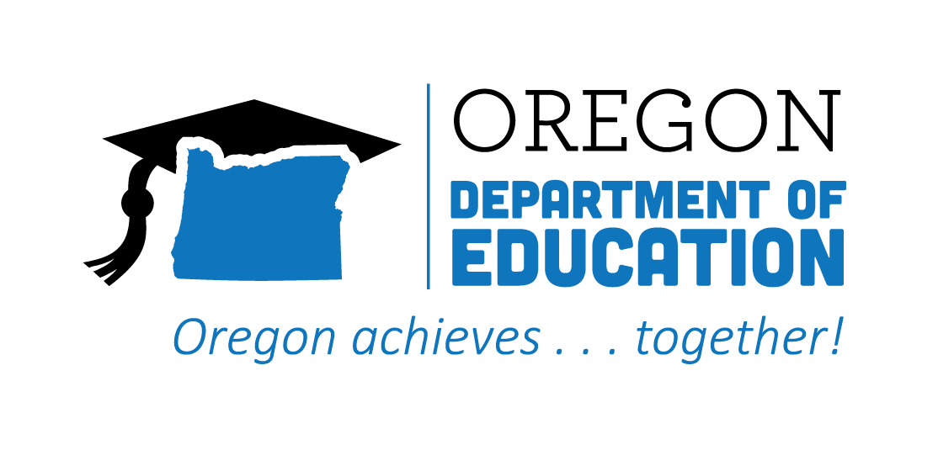
Table of Contents
Structure of the CTE State Plan 1
Building Equitable Aligned Career and Technical Education (CTE) 2
Oregon’s Vision for CTE 3
Oregon CTE Today 4
Achieving Our Vision 10
Achieving Equity 13
Our Beliefs: 14
Matching Strategies to the Vision 16
Outcome 1: Career connected learning that is systemically integrated with education and workforce development. 17
Outcome 2: Increased equitable participation in high-quality CTE and career connected learning. 18
Outcome 3: Expanded communication, transparency, and diversity of voices and contributors connected to education and workforce development partnerships. 21
Accountability 23
Fiscal Guidance and Support 24
Perkins Reserve Fund Use 26
Appendices 27

Structure of the CTE State Plan
Oregon’s vision for Career and Technical Education (CTE) guides the structure of our State Plan. Ongoing consultation and coordination between the Oregon Department of Education (ODE) and the Higher Education Coordinating Commission (HECC), in partnership with local education entities, other agencies, and Oregon’s communities, have been key to the growth and changes CTE has experienced since 2020. This revision of Oregon’s CTE State Plan is meant to be a high-level, four-year strategic plan outlining outcomes and strategies to guide Oregon’s ongoing work to build world-class CTE. The appendices provide the context and details of the plan and how Oregon will meet federal Perkins requirements. The appendices also include an action plan aligned to Advance CTE’s National CTE Without Limits Framework and will guide priorities over the coming years. This action plan serves as one means to measure the state’s progress, in combination with others, including CTE data, number of programs, and connections with business and industry. The action plan and progress reports will be updated each summer and posted on the ODE website.

Building Equitable Aligned Career and Technical Education (CTE)
Education and workforce development are the cornerstones of building an equitable economy and community. In an ever-evolving global landscape, where access to opportunities and resources are not distributed equally, career connected learning (CCL) and career and technical education (CTE) play a crucial role in bridging the gaps between education and workforce, as well as influencing who has access and opportunity to benefit from these systems. CCL and CTE can help level the playing field. Education with multiple pathways that empower individuals with knowledge, skills, and opportunities to develop career identity and build a network of professional connections can serve as a catalyst for upward mobility. CCL and CTE strengthen communities and form the foundation upon which Oregon can construct a society where everyone has the chance to make an impact and thrive.
The CTE State Plan focuses on more fully integrating academic knowledge, professional/employability skills, and technical ability for all learners, ensuring that historically and currently marginalized populations have the support needed to feel welcome and be successful in the CTE program of their choice.
The authorization of the Strengthening Career and Technical Education for the 21st Century Act (Perkins V) allowed Oregon CTE leaders and partners to collaborate on developing a CTE State Plan in 2020. The CTE State Plan has been updated to be more than a Perkins plan; it is Oregon’s guide to building equitable CTE pathways and prioritizing our career-related learning resources. This plan supports a future-ready Oregon workforce and aligns with the Workforce and Talent Development Board’s focus on workforce readiness by aligning CTE and the skills needed to succeed in the workplace beyond those learned in academic settings. In Oregon, these are known as Essential Employability Skills.
As we have worked to revise this plan, agencies have been collaborating to align CTE with other federal initiatives, including the Every Student Succeeds Act, Workforce Innovation and Opportunity Act (WIOA), Higher Education Act, and the Individuals with Disabilities Act. Oregon state staff worked closely together to coordinate and align the development of the CTE and WIOA state plans. There are increasing partnerships and coordination in the joint work as one of Oregon's WIOA Joint Priorities is to: “Concretely deepen the integration of K-12 education in the entire workforce system.” CTE also connects to other WIOA joint priorities around the transition of adults to credit-bearing CTE through Integrated Education and Training models, Career Pathways, Credit for Prior Learning, career connected learning, and work-based learning opportunities. The CTE State Plan supports the Oregon Business Plan by building systems to prepare Oregonians for the jobs of today and tomorrow and by ensuring alignment of CTE programs with labor market needs.
By 2027, Oregon will make progress on achieving three overarching outcomes:
- Career connected learning that is systemically integrated with education and workforce development,
- Increased equitable participation in high-quality CTE and career connected learning, and
- Expanded communication, transparency, and diversity of voices and contributors connected to education and workforce development partnerships.
Oregon CTE programs, with the support of state agency staff, CTE regional leaders, STEM leaders, educators, faculty, administrators, community partners, Tribes, workforce development agencies, and business and industry partners, will ensure that historically and currently underserved and marginalized students and families feel welcome, safe, and included in our institutions and programs. The goal is that all Oregonians will receive appropriate and equitable access to and benefits from CTE and career connected learning. Our priority is to create quality relationships, experiences, and interactions among learners, educators, business partners, and community members.
Salem-Keizer student works on a soldering project

Oregon’s Vision for CTE
Oregon’s CTE State Plan will highlight Oregon’s shared vision for CTE, outcomes that the state is working toward, and actionable strategies for working together to achieve that vision. All Oregonians deserve meaningful living wage careers, access to opportunities to learn about career opportunities, and to receive training to develop the skills necessary to secure these careers and contribute to their communities. With an intentional focus on equity and removing barriers to ensure high-quality learning and access for each learner regardless of race, gender, or zip code, the state can realize the full potential of each of our talented residents. CTE is a proven strategy that increases educational outcomes and grows a skilled workforce. CTE is critical to creating a more equitable and prosperous future for Oregon.
Vision for CTE
Building on CTE’s past vision and based on input from CTE partners and agency staff, Oregon has identified the following vision for CTE that will guide Oregon’s CTE State Plan:
Oregon will reimagine and transform learner experiences to enhance learners’ future prospects, empower their communities, and ensure equity in an inclusive, sustainable, innovation-based economy.

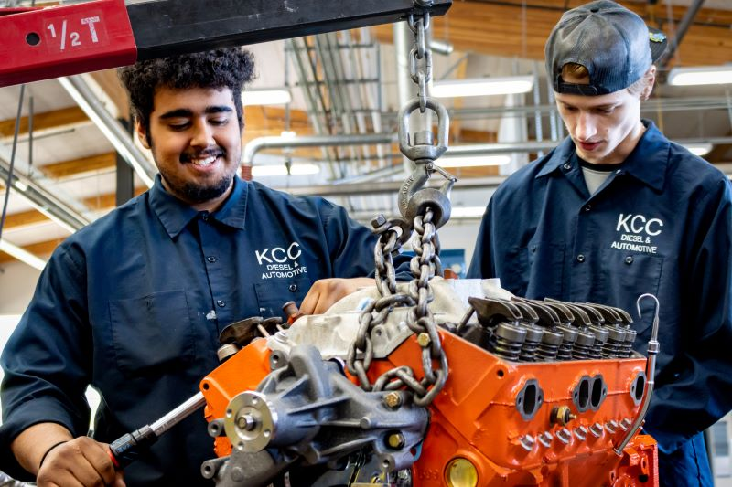
Photo Courtesy of Klamath Community College Diesel and Automotive program

Oregon CTE Today
With the CTE State Plan, Oregon has an opportunity to improve how we prepare Oregonians to succeed in high-wage, high-skill, and in-demand careers and, in doing so, put the state on a path to an even brighter future for our communities and our economy. More specifically, we have an opportunity to continue to remove barriers and ensure high-quality learning and access for each learner regardless of age, race, gender, or zip code. More than 184,000 K-12 learners participate in CTE, and over 7,000 CTE degrees and certificates were awarded at Oregon community colleges (Figure 1). Regional partnerships, led by CTE Regional Coordinators, exist in every corner of Oregon. CTE Programs of Study exist in nearly every Oregon high school and all 17 community colleges. Secondary students who concentrate in CTE graduate high school at rates higher than their counterparts who do not participate in CTE (Chart A); this finding holds true across all demographics but is even more significant for historically and currently underserved and marginalized students. The CTE State Plan will build on the success of the past and improve programs to bring greater consistency and access.

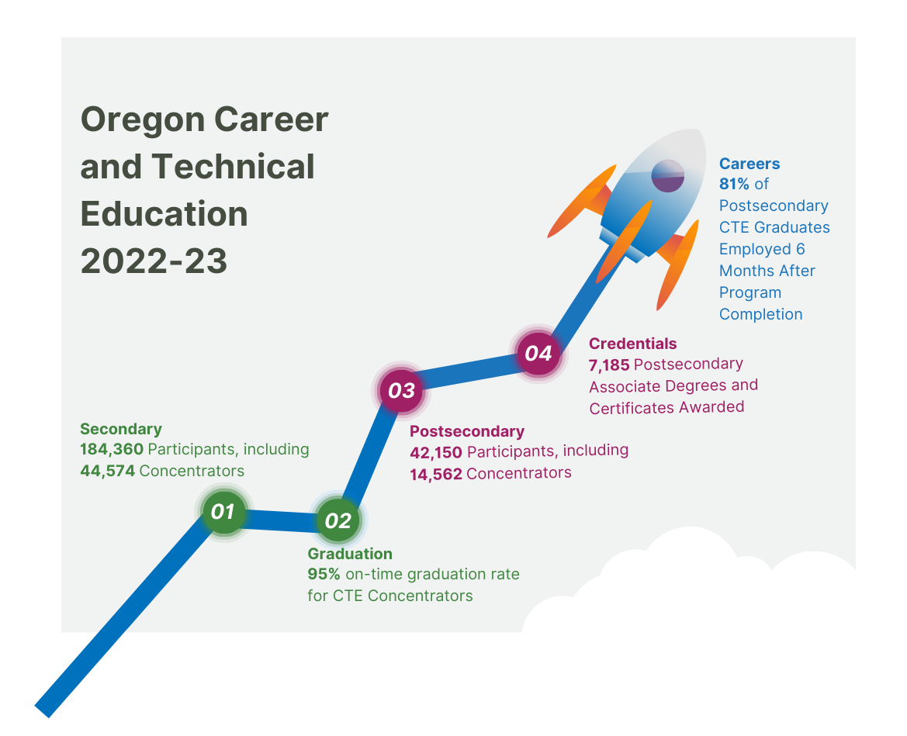Figure 1: CTE participation and outcomes

Chart A: High school graduation and CTE
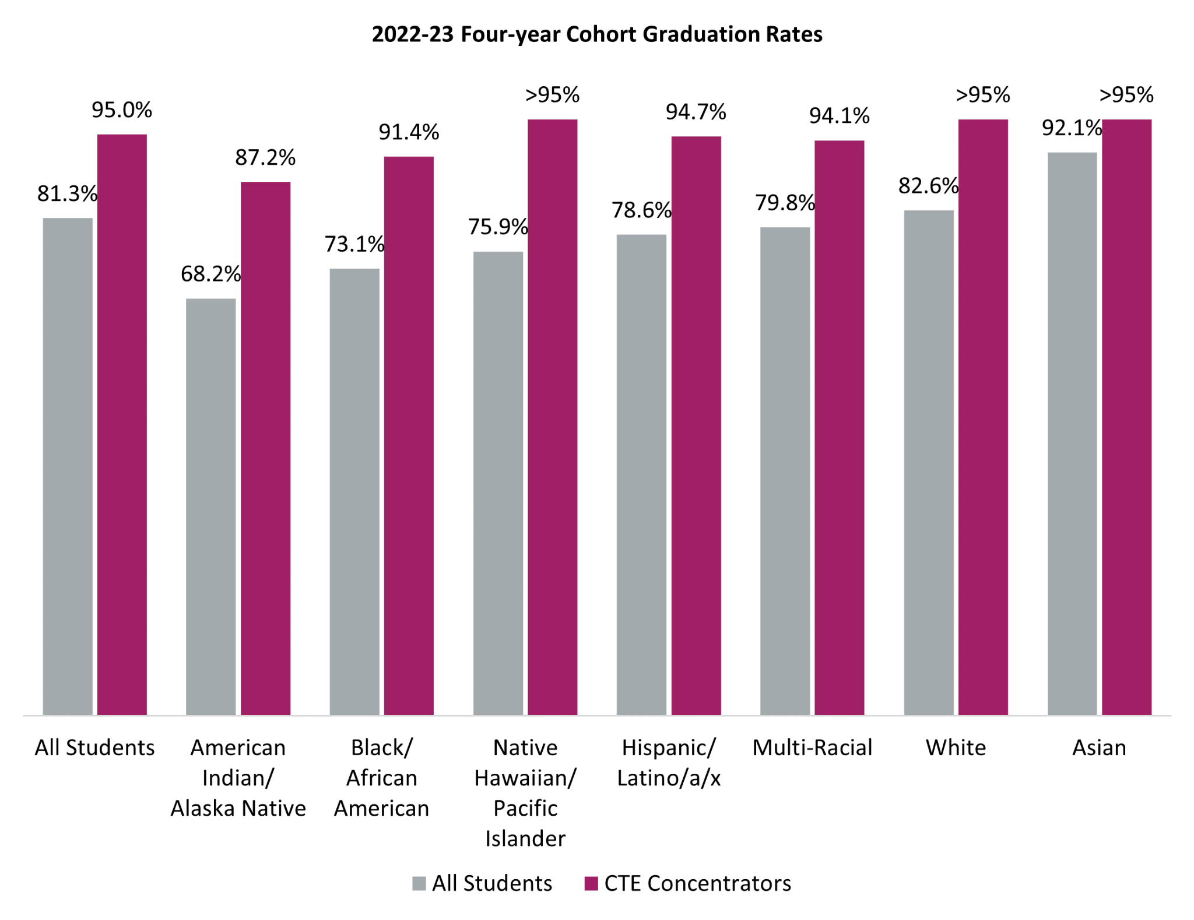

Chart B: High school enrollment in CTE
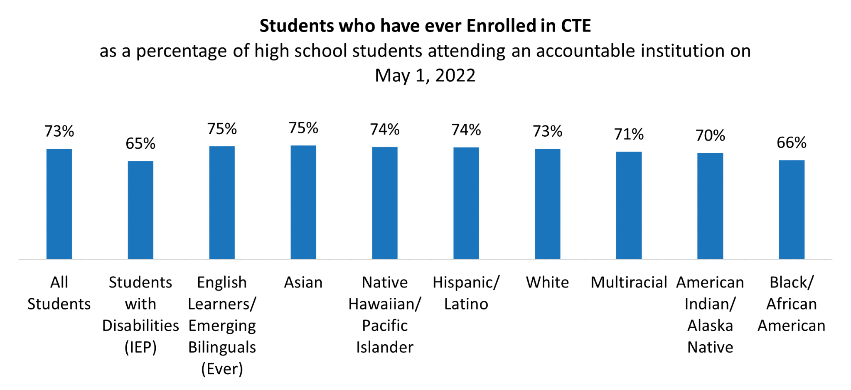
Note: “Ever” Emerging Bilinguals includes students who currently or previously were eligible to participate in an English Language Development program.

Chart C: High school CTE participants in 2020-21 or 2021-22
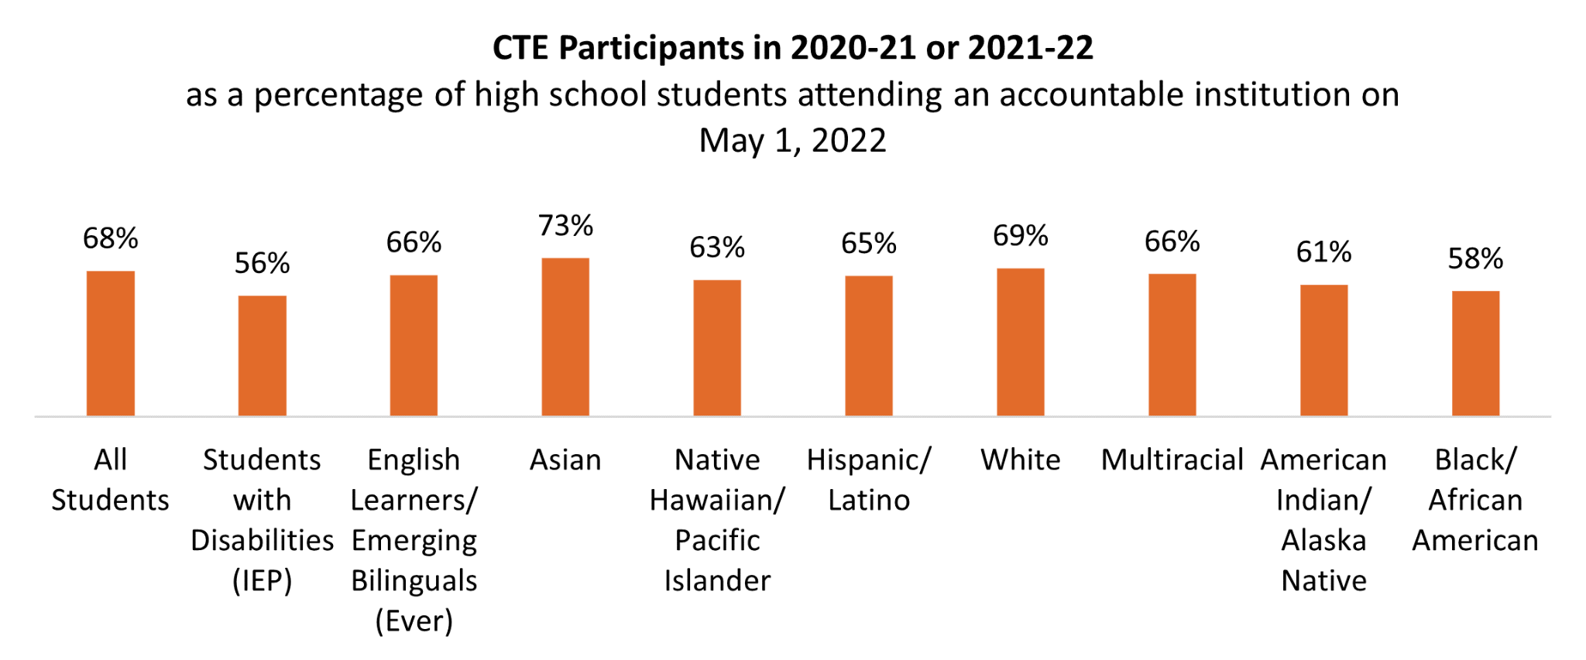
Note: “Ever” Emerging Bilinguals includes students who currently or previously were eligible to participate in an English Language Development program. Participants also include concentrators.

Chart D: High school CTE concentrators in 2020-21 or 2021-22
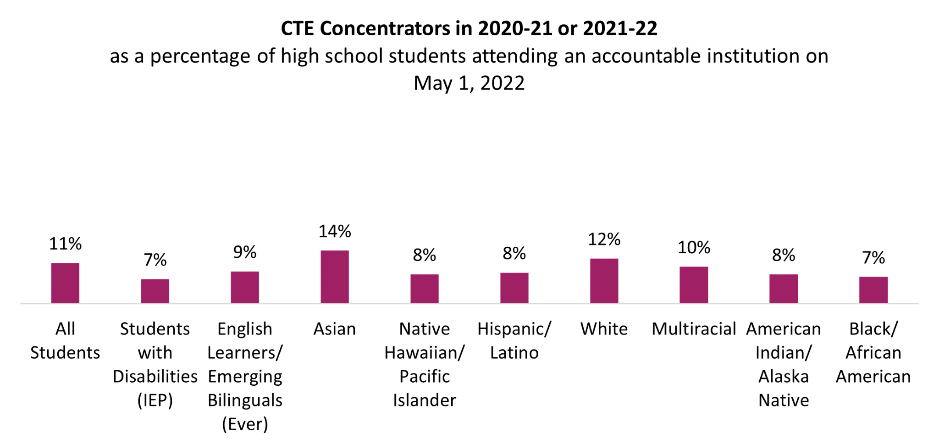
Note: “Ever” Emerging Bilinguals includes students who currently or previously were eligible to participate in an English Language Development program. Participants also include concentrators.

CTE can celebrate the fact that enrollment rates are similar across demographic groups, though gaps remain for some focal populations, and the consistent achievement of higher graduation rates across all student groups taking one year of CTE in high school. However, a closer look at the data shows that students of color, students with disabilities, and emerging bilingual students are underrepresented in obtaining CTE concentrator status (in-depth CTE as shown in Charts B-D). In postsecondary CTE, most historically underrepresented race/ethnicity groups participated in CTE at higher rates than the overall community college student population, and Hispanic/Latino students were represented at higher rates in CTE programs (Chart E). The recent Regional Education Laboratory report highlights these opportunity gaps, but as an example, in the Business and Management Career Cluster®, a greater percentage of students who are not on an Individual Education Plan (IEP) and not emerging bilingual concentrate in a CTE program and complete three credits in the program (see Chart F).

Chart E: Postsecondary CTE participants and concentrators by race and ethnicity compared to overall community college student population (2022-23)
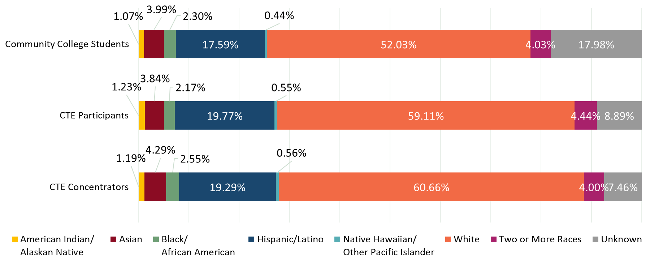
These findings are significant because greater benefits of CTE in terms of graduation, college success, and smooth transitions into a career are associated with in-depth participation. Far too often, students of color, students with disabilities, and emerging bilingual students are not benefiting from the promise of CTE at the same level as students who are white, not experiencing poverty, or don’t identify as having a disability. Chart F shows the range of CTE secondary participation from one course to three credits for students with disabilities (IEP), emerging bilingual students (EL), and students who are not members of these groups. There is a clear gap in the percentage of students taking more CTE courses for these two student groups. We see a similar gap in postsecondary, where students with disabilities are less likely to become CTE Concentrators, but English Language Learners are more likely to become Concentrators (Chart G). Understanding how all of our learners fit into the learning environment and supporting them accordingly is necessary to achieve our vision.

Chart F: Gap in CTE participation versus completing three credits in secondary CTE programs
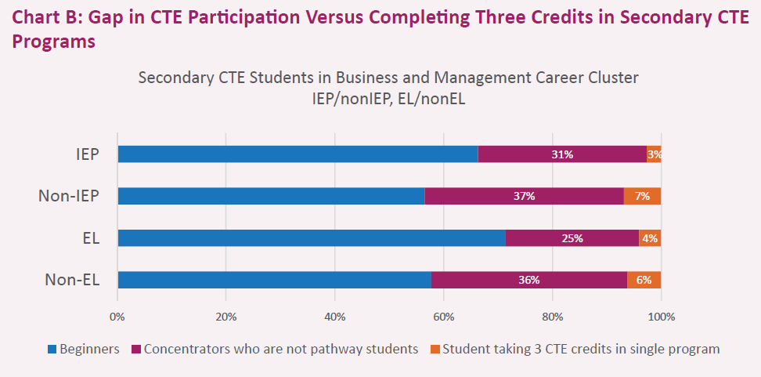

Chart G: Postsecondary CTE student persistence to Concentrator status 2022-23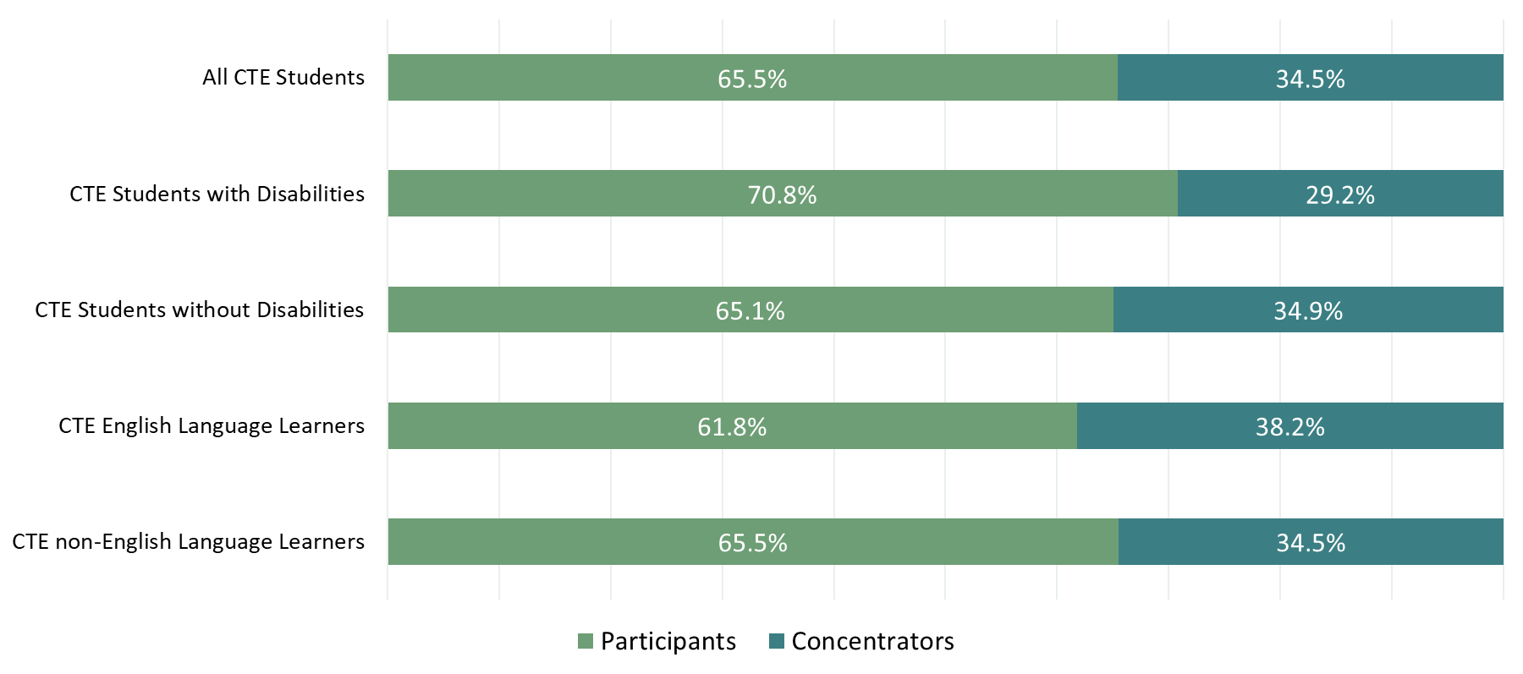
Students with disabilities experience better retention and post-school outcomes when they participate in one credit of CTE compared to students with disabilities who are not involved with CTE (Chart F). Oregon has been working to promote career connected learning and CTE and to purposefully remove barriers that exist for students with disabilities to persist within a CTE Program of Study. The Oregon Department of Education (ODE) partners with vocational rehabilitation and student services and will focus on communication and support to encourage school structures that improve access for students with disabilities in CTE. Oregon’s community colleges also have strong partnerships with vocational rehabilitation, and 11 of these colleges are participating in the Inclusive Career Advancement Program (ICAP). This program helps people with disabilities obtain the training they need to find a pathway to a career, not just a job. Through individualized support, ICAP opens the door to a living wage and a lifetime of career advancement potential. ICAP is a grant-funded program through the U.S. Department of Education supported by Cornell University and Portland Community College.
Additionally, too often, participation rates vary by gender in specific Programs of Study. For example, female-identifying students are underrepresented in Computer Science and Manufacturing programs, and male-identifying students are underrepresented in Education programs. Over the past six years, Oregon has partnered with the National Alliance for Partnerships in Equity (NAPE) to train regional cohorts of instructors and advisors to identify and overcome barriers to success. Oregon will continue to support strategies to address gender inequities by sponsoring recruiting events, providing statewide training, and using state leadership funds to support regional and local evidence-based programs.
During an annual review process, ODE will work with partners to monitor the performance and participation of all students. In the event any of the performance elements fall short, state-level improvement plans will be developed and monitored to ensure intentional steps are taken to address any gaps in performance.
Additionally, state staff will continue to offer professional development on providing accommodations for students, monitor access through the Methods of Administration plan, and provide grants to local education entities to use to increase equitable training in career areas dominated by a particular gender.

Achieving Our Vision
Photo Courtesy of Clatsop Community College Fire Science Program

Implementing Oregon’s CTE State Plan and disrupting current program, participation, and outcome inequities requires workforce development, higher education, K-12, and business and industry to align our work and support our common goals. Oregon continues its commitment to improved systems alignment and equity.
“Career and Technical Education is foundational to thriving communities. There are very few skill-based services that don’t require training in some form of CTE. As Central Oregon continues to grow and our economy diversifies, CTE helps ensure our local businesses have the workforce they need today—and long into the future.”

~ Dr. Laurie Chesley | President, Central Oregon Community College
ODE collaborates extensively with both internal and external partners to enhance the prominence of Career and Technical Education (CTE) as a pivotal component of school improvement initiatives. As a result, the CTE/Perkins application process has been integrated with other grant programs into a comprehensive application framework. This integrated approach encourages schools, districts, colleges, and regions to adopt a broader perspective on how CTE can contribute to student growth and success by engaging with all constituents and community members to conduct a comprehensive needs assessment that is inclusive of CTE/Perkins requirements. Internally, the CTE staff has been strategically incorporated into the Office of Education Innovation and Improvement, fostering close collaboration with teams dedicated to expanding access to CTE and college-level opportunities, improving student attendance, supporting student mental and behavioral health, improving academic performance, reducing disparities, and other related initiatives. This concerted effort aims to provide robust support for our students, families, and communities while enabling schools and districts to act with greater coordination and braid multiple funding sources to achieve critical outcomes.
Oregon’s CTE State Plan integrates with the broader priorities and goals of other Oregon plans, as orchestrating collective effort and investing together in Oregon’s future is essential. A key step has been to build Oregon’s CTE State Plan in alignment with the principles, commitments, and priorities laid out in Future Ready Oregon, Oregon’s K-12 Education Plan, the Higher Education Coordinating Commission (HECC) Strategic Roadmap, the Workforce and Talent Development Board Strategic Plan, the Workforce Innovation and Opportunity Act State Plan, and the Oregon STEM Education Plan. One example is the direct connection to K-12 education in the Workforce Innovation and Opportunity Act State Plan Joint Priorities. “Concretely deepen the integration of K-12 education in the entire workforce system.” Starting with connections like this, the next step to building coherence is a joint commitment to ongoing dialogue and partnership among offices and teams implementing the many interwoven strategic initiatives across the state. In particular, a cross-agency team will continue working together to support work-based learning across the state. This joint effort connects workforce investment and CTE priorities and is guided by the Workforce System Executive Team (WSET).
The state consulted with over 1,000 CTE partners, including students and families/caregivers, tribal leaders, educators, administrators, regional coordinators and grant managers, advisory council/board members, and business, industry, and workforce development partners and community-based organizations, to help develop the new four year CTE strategic plan. Below is a summary of the responses.
- Students wanted more CTE courses, teachers, and wrap-around support, such as advising and industry opportunities.
- Tribes, caregivers, and families wanted more career exploration offered in middle schools and targeted marketing campaigns to increase exposure and opportunities for students and families, particularly in underserved populations.
- Educators and administrators expressed a need for sustainable, consistent funding to support existing and future CTE Programs of Study, including industry-identified equipment, educator prep time, and professional development.
- Workforce partners desire more funding for data sharing and alignment between education and workforce development.
- Oregon Tribes indicated a need for more CTE access (especially in remote rural locations), better ways to connect with families and communities about those opportunities, and to have a voice in the development of these programs.
- Across the board, partners and Tribes expressed the need for more funding to support a strong CTE regional coordination and leadership structure, targeted resources for small/rural schools, more communication and marketing of CTE and the opportunities available for students, and the ability to effectively support the growth and maintenance of CTE programs, pathways, and opportunities that lead to high-wage, in-demand careers in Oregon.
Appendix A: Community Engagement Summary contains a comprehensive community engagement report.

“Oregon is positioned to make additional progress in continuing to strengthen the relationship between CTE programs and the marketplace trends facing Oregon’s employers. It’s an exciting time to envision a future where barriers between educational institutions and real world employment opportunities can be broken down and addressed head on.”

~ Jason Brandt | President & CEO, Oregon Restaurant & Lodging Association
In 2020-2021, the state recruited partners to serve on an ongoing basis to advise the state on the implementation of the Oregon CTE State Plan, forming a standing CTE Advisory Council. The CTE Advisory Council identified three overarching priorities: Alignment, Equity, and Systems of Sharing/Communication.
Current Advisory Council membership composition includes
- 24 Standing Members
- 11 Business and Industry and Workforce Development Representatives
- 6 Secondary and Postsecondary Students
- 17 Ex Officio Members
- 36% of Members Identify as Other than White
More information about the Advisory Council, including the charter, the membership roster and meeting materials can be found on the Statewide CTE Advisory Council web page.
As Oregon implemented the 2020-2024 CTE State Plan and worked with the Advisory Council, it became clear that there was a need for an intentional effort to include student voices in this work. With that in mind, Oregon participated in the Advance CTE Leveraging Learner Voice to Strengthen CTE Cohort, and the state created a CTE Youth Advisory Council to ensure that learner voices are used to improve CTE policies and practices.
Photo Courtesy of Mt. Hood Community College Healthcare program
As state staff implement Oregon’s CTE State Plan, they will ensure clear communication, partnership, tracking of progress, and continuous improvement. Staff will also provide guidance on braiding/leveraging funding and will work toward cross-agency funding opportunities. The Statewide CTE Advisory Council and the CTE Youth Advisory Council members will be invited to participate in guiding the work, holding the staff accountable for progress on the work plan, and serving as important advocates who communicate with their constituents about the work being done in CTE across the state.

Achieving Equity
Oregon’s vision for CTE requires that learners have equitable opportunities for success. In light of this understanding, we will examine all policies, practices, and procedures using the SPST Decision Tool, ODE’s equity stance, and the HECC Equity Lens to deepen understanding, build relationships, and avoid harm to currently and historically underserved communities. Oregon will know we have achieved our equity goals when a learner’s demographic characteristics or geographic location can no longer predict participation and success in CTE programming.

Our Beliefs:
- We have an ethical and moral responsibility to ensure an education system that provides optimal learning environments that lead students to be prepared for their individual futures.
- Speaking a language other than English is an asset, and our education system must celebrate and enhance this ability alongside appropriate and culturally responsive support for emerging multilingual students.
- Students receiving special education or disability services are an integral part of our educational responsibility, and we must be inclusive, make appropriate accommodations, support skill development, and celebrate their strengths and workforce contributions.
- Students who have previously been described as “at risk,” “underperforming,” “underrepresented,” or “minority” actually represent Oregon’s best opportunity to improve overall educational outcomes. Many counties in rural and urban communities have populations of color that make up the majority. The ability to meet the needs of our increasingly diverse population is a critical strategy for us to reach our state education goals successfully.
- We respect the right of each Tribe to assert both Tribal and educational sovereignty, emphasizing our dedication to the unique cultural and educational rights of Native American students in Oregon. Collaborating with Tribal communities to inform our educational programs is fundamental to advancing a more inclusive educational environment for all Native American students in the state.
- Every learner must be supported in accessing information about a broad array of career opportunities and education and training programs, including apprenticeships.
- Communities, parents, teachers, and community-based organizations have unique and important solutions to improving outcomes for our students and educational systems. Our work will be successful only if we are able to truly partner with communities, engage with respect, authentically listen, and have the courage to share decision-making, control, and resources.
- The rich history and culture of learners are a source of pride and an asset to embrace and celebrate.
- We believe in the critical importance of culturally responsive teaching and workforce diversification. An equitable education system requires providing educators with the tools and support to meet the needs of each student and a dedicated effort to increase the culturally and linguistically diverse educators who reflect Oregon’s rapidly changing student population. Our institutions of postsecondary education and training, and the P-20 system, will truly offer the best educational experience when their faculty, staff, and students reflect this state, its growing diversity, and the ability for all of these populations to be successful in their educations and ultimately in their careers.
Understanding that there have been barriers that have limited opportunities for many groups of students to benefit from high-quality CTE, we will focus on better understanding and then removing these barriers for our students—including but not limited to students of color, students with disabilities, students navigating housing instability, American Indian/Alaska Native students, students navigating poverty, students who are currently or were incarcerated, students pursuing nontraditional careers by gender, youth in or formerly in the foster care system, and adults who desire to increase their basic skills attainment to enter or advance in careers.
Photo Courtesy of Southwestern Oregon Community College
Successful implementation of the CTE State Plan relies on the engagement and support of our CTE partners: students, families, Tribes, diverse communities, educators, schools, colleges, business and industry, workforce development, local governments, and other state agencies. We all play a role in supporting CTE and our learners seeking to build and expand their careers. Participants who helped craft the CTE State Plan felt strongly that they wanted to see their role in the work and the actions they could take to achieve our state vision. Appendix C: Implementing the Plan – Proposed Partner Actions provides many of the recommended ways partners can support the operationalization of this plan. State agencies will monitor the implementation of the CTE State Plan and engage with the CTE Advisory Council, Agency leadership, CTE leaders, and our constituents to ensure that our state is making progress toward our goals.

Youth Corrections
Oregon has a team that helps youth correctional (YCEP) and juvenile detention (JDEP) facilities provide career exploration, programming, certifications, and other opportunities for their students that can lead to community college enrollment and/or a career in CTE. The team helps to distribute funding for various projects across the state.

“We have added to our ability to help our youth develop skills and character that give them hope for their future. When we do our work through hands-on, project-based learning experiences, our youth discover ‘they can,’ and that gives them courage, hope, and confidence for tomorrow.”
~ David Miller | Trask River School, Tillamook YCEP

“Students share that they appreciate the opportunity to learn hands-on. One student expressed that they felt valued because they are trusted with equipment. JDEP staff have expressed tremendous appreciation for the opportunity to learn these skills that they can then share with students. The staff at Jackson County JDEP are especially grateful and value this experience as one of the most impactful they have been able to participate in.”
~ Dr. Larina Warnock | Medford School District, Jackson County JDEP

Matching Strategies to the Vision
CTE Programs of Study are the core of CTE in Oregon, and the outcomes and strategies in this plan will contribute to improvements in CTE Programs of Study in terms of quality, equity, and access. Building robust pathways with multiple on-ramps for instruction, starting with middle grades programs of exploration and moving through adulthood, will be key in communicating relevancy and opportunity. Only state-approved CTE Programs of Study are eligible for CTE funding in Oregon. This reflects the state's commitment to ensuring high-quality CTE programs that demonstrate partnership and alignment between secondary, postsecondary, and employers. Oregon has expanded the reach of Perkins dollars and leveraged other state and federal funds to expand career connected learning across Oregon. Increased opportunities to explore future careers are important to build equitable pathways into high-wage careers. Oregon’s Programs of Study are based on the 16 National Career Clusters and are organized around the following six career areas: Agriculture, Food, and Natural Resource Systems; Arts, Information, and Communications; Business and Management; Health Sciences; Human Resources; and Industrial and Engineering Systems. After program completion at the secondary level, a student may continue in a program to earn a credential, a certificate, or an associate or baccalaureate degree. Adult students may also transition from Adult Basic Skills to credit-bearing CTE through models such as Integrated Education and Training and Career Pathways. CTE programs at postsecondary institutions are the link to the needs of and opportunities within business and industry and provide flexible opportunities for CTE learners of all ages.

Oregon CTE Programs of Study provide instruction in technical, academic, and employability skills that can lead to high-wage, high-skill, and in-demand occupations. A CTE Program of Study in Oregon describes a prescribed sequence of non-duplicative courses developed in partnership by a secondary school district and a postsecondary institution that prepares students to transition across education levels and seamlessly enter the workforce. Coursework integrates rigorous academic knowledge with industry-validated technical and employability skills, progressing in specificity and aligned with industry needs. Many CTE Programs of Study provide opportunities for high school students to earn college credit, though Oregon continues to work on the transferability of credits.
The outcomes and strategies in this plan are organized under the CTE Without Limits framework published by Advance CTE. This framework provides a bold vision for a career preparation ecosystem that is cohesive, flexible, and responsive, supporting a system that closes equity gaps in education and workforce readiness by leveraging CTE as a catalyst that ensures each learner can thrive in their chosen career. The work to achieve Oregon’s vision for CTE is aimed at achieving three overarching outcomes. The plan below describes each outcome, shares a vision of what it will look like when Oregon achieves these outcomes and provides strategies to focus priorities in the coming 4-years. Appendix D: Oregon’s CTE Without Limits Action Plan details a more comprehensive plan of the specific strategies and activities.

Outcome 1: Career connected learning that is systemically integrated with education and workforce development.
Oregon has been promoting and supporting the development of Career Connected Learning since 2020. It has become a rallying call for partners across the state, particularly STEM Hubs, community-based organizations, and business and industry. Oregon has built career guidance supports, including a CCL Resource Hub, access to career guidance software, the Oregon Career Information System and YouScience, and media such as the Career Journey videos. The Oregon Department of Education defines Career Connected Learning (CCL) as a framework of career awareness, exploration, preparation, and training (Figure 2). Career learning develops over the course of one’s lifetime. To support this process, CCL ensures purposeful instruction and engages diverse communities in building collaborative, community-driven learning. CCL connects the interests, aptitudes, education, and goals of every Oregon youth to their future.

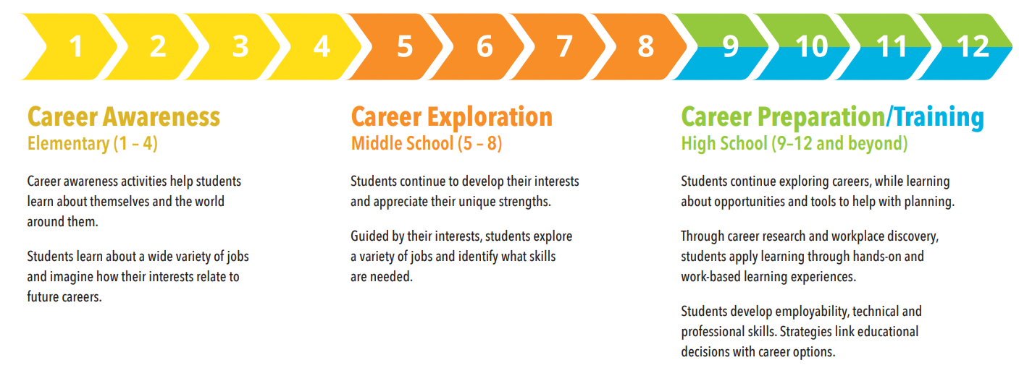
Figure 2: Oregon Career Connected Learning Framework
What this looks like:
- Each and every learner has the opportunity to engage in cohesive, flexible, and responsive career awareness, exploration, preparation, and training
- Each and every learner has opportunities to explore future careers and connect learning in the classroom to their communities and/or future careers
- Each and every learner is empowered with information to skillfully navigate their own career journey
Strategies to Achieve Outcome 1:
Strategy 1 - Align education and workforce systems to ensure equitable access to career connected learning and elevate effective resources and assets to foster seamless transitions from and between education, training programs, and careers.
Strategy 2 - Prioritize middle-grades career awareness and exploration to intentionally diversify and expand interest and opportunity for participation in CTE Programs of Study leading to high-wage, in-demand careers.
Strategy 3 - Empower all Oregon educators and community partners to support students' awareness and navigation of pathways to careers through learning and experiences.

“Career and Technical Education is the bridge that connects students to the careers of the future, equipping Oregonians with the skills, knowledge, and real-world experience essential for success in high-skill, high-wage, high-demand professions. In collaboration with industry, community colleges play a pivotal role in shaping a robust workforce that not only fortifies our economy but also offers a pathway to economic mobility for all Oregonians, with a particular focus on historically underserved communities.”

~ Dr. Adrien Bennings | President, Portland Community College
Career Awareness and Exploration can happen at any age and any stage for an individual. The pace and flow of career preparation and training may vary depending on student readiness, district programming, and community partnerships. The Career Connected Learning (CCL) domains in Figure 2 are organized by recommended grade levels to provide districts an example of a K-12 Scope and Sequence for career development. Work-based learning (WBL) is a focus area for CCL in Oregon, and since the 2020 plan, Oregon has grown WBL in CTE Programs of Study, with now over 50% of concentrators having high-value connections to business and industry partners.

Outcome 2: Increased equitable participation in high-quality CTE and career connected learning.
Creating inclusive, high-quality CTE and CCL that provides equitable access to all Oregonians is fundamental to the state’s vision for CTE. This outcome most directly ties to the work of Oregon’s CTE leaders and educators and our partners in the Career Connected Learning community. Oregon has invested state funds to incentivize persistence in CTE Programs of Study and provided schools with additional resources to develop strong high school programs, including CTE.
What this looks like:
- Each and every learner feels welcome in, is supported by, and has access to career exploration and awareness and the means to succeed in career preparation and training with a particular focus on all dimensions of diversity, equity, and access, including educational, racial, Tribal sovereignty, socioeconomic, gender, and geographic
- Removal of barriers (cultural, financial, physical, structural) that prevent learner participation
- All CTE Educators are given the tools, training, and supports necessary to provide equitable, inclusive, and high-quality CTE programs
- Each learner’s strengths and skills are counted, valued, and portable
- Student Leadership (CTSO) opportunities and engagement that reflect real-life business and industry experiences and expectations
- Each learner can access CTE Without Borders, expand learners’ access to high-quality CTE and work-based learning opportunities within and across state lines

“CTE offerings at RCC play a critical role in our local economy. Many programs provide tracks for stacked credentialing so students can fill high-demand jobs sooner and continue to earn while they learn as advanced credentials are obtained.”

~ Randy Weber, Ed.D. | President, Rogue Community College

Strategies to Achieve Outcome 2:
Strategy 1 - Center equity and learner experience in decision-making, resource distribution, policies, and practices.
Strategy 2 - Strengthen the quality and consistency of CTE Programs of Study by developing resources and training educators, administrators, and partners to improve instruction.
Strategy 3 - Create clear CTE educator retention and recruitment systems, resources, and supportive spaces.
Strategy 4 - Develop innovative policies and models to ensure CTE programs have the flexibility needed to provide access for all students while meeting the demands of today and tomorrow.
The State Plan includes action steps to provide many resources and strategies that will help build and maintain high-quality CTE Programs of Study.
Alignment to labor needs and state priorities:
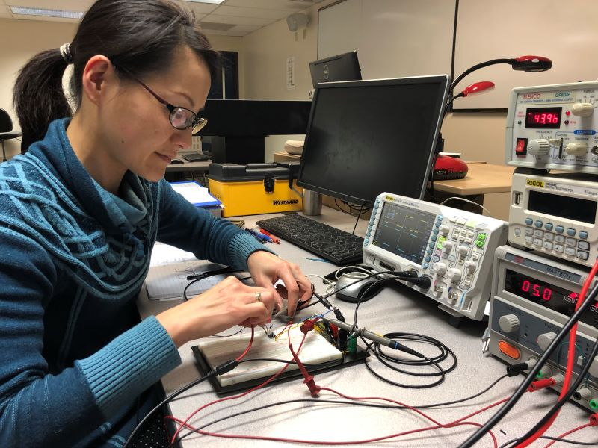
Approved CTE Programs of Study must lead to occupations in high-skill, high-wage, in-demand career areas. Additionally, Oregon requires community colleges to develop and submit a Labor Market Analysis when submitting new programs for state approval. In order to ensure districts and community colleges have the most up-to-date information when designing new CTE Programs or updating their existing CTE Programs of Study, CTE Regional Coordinators participate in a Labor Market Information (LMI) training with the Oregon Employment Department, meet with their Local Workforce Analysts, and collaborate with postsecondary and workforce partners to prepare LMI materials for districts and local community colleges. These materials are then used by eligible recipients as they engage their communities through the needs assessment process and through engagement with CTE Advisory Committees, regional sector partnerships, and statewide Industry Consortia.
Photo Courtesy of Clackamas Community College
Through coordinated community engagement, aligned CTE Programs of Study, a shared understanding of regional needs and priorities, and pertinent labor market information, districts, and community colleges are able to build robust pathways for students’ continued success after graduation. It is recommended that districts and community colleges coordinate their partner engagement around CTE Programs of Study and regional labor market needs and priorities to further the required alignment between secondary and postsecondary CTE Programs of Study and strengthen the connection to high-skill, high-wage, in-demand careers. This intentional collaboration helps ensure the entire region and all partners are working towards providing a well-rounded education, building rigorous, relevant, and authentic learning experiences for students along with connections, networks, and pathways for each individual’s successful transition into a career of their choice.
Quality Program Support:
The size, scope, and quality definition creates the foundation for a CTE Program of Study. This definition will be used jointly by secondary and postsecondary institutions to demonstrate that a newly proposed CTE Program of Study has the fundamental requirements. This minimum definition will be maintained at all times and reviewed every three years during the CTE Program of Study renewal process.
The CTE Program of Study Quality Rubric is a tool designed to help secondary and postsecondary institutions explore a CTE Program of Study more deeply and create a plan for continuous improvement. Secondary and postsecondary institutions and CTE regional leaders will be expected to develop and document continuous improvement goals related to each CTE Program of Study and submit those as part of the CTE Program of Study renewal. CTE Programs of Study will be evaluated during the initial and renewal phases to ensure they meet state requirements and are supporting continuous improvement in academic, technical, and employability skill attainment Approved CTE Programs of Study must have a purposeful alignment between the high school courses and a community college certificate or degree that leads to a high-wage, high-skill, and in-demand career (as defined in Appendix J: CTE State Plan Glossary) and progress in specificity of content to avoid duplication (See Appendix E: CTE Program Approval Process). The alignment can result in an opportunity for high school students to earn college credit and increase Oregon’s achievement of goals for postsecondary credential attainment.
The size, scope, and quality definition and the CTE Program of Study Quality Rubric guide continuous improvement. The local and regional needs assessment provides the focus and evidence.
Consistency and Support Statewide:
The development of the statewide CTE Program of Study Frameworks has been identified by partners as an important new direction for Oregon. Oregon will complete the creation of Statewide CTE Programs of Study in each career area in 2024. The process was improved each year, and there is still a lot of work to be done to strengthen the Statewide Programs of Study and use the statewide frameworks to build better connections between industry, college, and K-12. The state will continue to provide support for the Statewide CTE Programs of Study.
Photo Courtesy of Central Oregon Community
College VetTech Program
Our CTE State Plan will allow students to learn from a range of knowledgeable experts who contextualize learning and create robust integration of academic and technical content. At the heart of every CTE program are the educators. Without quality educators who build relationships with our learners and support the journey from education to career, all the systems in the world will not achieve improved outcomes across our population of diverse students.
The recruitment and support of our educators, mentors, counselors, and business and industry partners is essential to achieving Oregon’s vision for CTE. Therefore, we are committed to building a diverse educator workforce in both secondary and postsecondary education, but we recognize that educator shortages and mismatch in systems of compensation for educators from traditional pathways and those who enter the profession from business and industry continue to be barriers.
Flexibility to ensure CTE without limits:
Our CTE State Plan will focus on flexible learning systems that allow Oregonians to gain necessary skills where and how they best meet their needs. Flexible learning helps achieve equity goals by acknowledging learners’ diverse needs and competing priorities while providing the tools and techniques that are critical to the success of a range of learners. CTE Program of Study choices vary by school and college location; the differences are often substantial and inequitable. Rural communities often have fewer CTE opportunities due to resource constraints, greater distances to population centers, and the nature and assortment of industries found in these areas. Supporting flexible learning is a way to explore creative solutions to bolster program offerings for rural communities.

“At Clackamas Community College, we believe that CTE not only provides valuable skills and knowledge but also serves as a driving force for economic development. By equipping students with practical, hands-on training, we are not just educating individuals, we are preparing a skilled workforce that contributes to the growth and prosperity of our community.”

~ David Plotkin | Vice President of Instruction and Student Services Clackamas Community College

Outcome 3: Expanded communication, transparency, and diversity of voices and contributors connected to education and workforce development partnerships.
A critical component is to ensure students, parents, and communities are informed about career pathway options and resources. ODE maintains a website of approved Programs of Study in each high school and college. HECC maintains an expanded list of all approved postsecondary CTE programs at each college. Additionally, this plan outlines resource development for Career Exploration and Work-Based Learning Opportunities.
What this looks like:
- Meaningful partnerships with students, families, educators, Tribes, community-based organizations, workforce development, state agencies, and industry partners deeply invested and involved in the design, delivery, and success of the CTE system
- Continuous improvement, collaboration, and alignment by leaders at all levels within our education and workforce development systems
- Actionable, transparent, and trustworthy data that addresses the demographic questions, the inclusion and equity aspects, and the longitudinal outcomes of our CTE Programs of Study
Strategies to Achieve Outcome 3:
Strategy 1- Pursue meaningful collaboration with communities, Tribes, families, and students to provide comprehensive outreach and communication for those who are impacted by decisions regarding career connected learning and CTE systems.
Strategy 2 - Create structures to achieve transparent sharing of data to support well-rounded, equitable approaches to preparing learners for life after secondary education.
Strategy 3 - Enhance the use and accuracy of data, reporting, and information systems to drive data-informed decision-making, monitoring state-identified performance targets, local implementation of CTE Programs of Study, and use of funds.
Access to State Leadership funds via ESSERIII has allowed ODE to work collaboratively with a wide array of educational leaders to develop and populate a Career Connected Learning Resource Hub. The Resource Hub is available statewide and houses tools and resources to support practitioners, students, and families in the four domains of Career Connected Learning. A team of Career Connected Learning System Navigators, located at all 17 Oregon Community Colleges, along with a statewide Career Connected Learning Coordinator and a CTE Tribal Liaison, collaboratively support the dissemination of the CCL Resource Hub throughout the state. Their work focuses on supporting and aligning systems that provide career awareness, exploration, preparation, and training for learners down to middle grades and across the transitions into high school, career, and postsecondary opportunities. Additionally, the Tribal Liaison plays a pivotal role in facilitating collaboration among Tribes, the Oregon Department of Education, the Higher Education Coordinating Commission, local education agencies, community colleges, CCL Network, STEM Hubs, and local workforce development boards. This collaboration aims to expand opportunities for Tribal youth to access Career Connected Learning and CTE opportunities within their communities.
Our CTE State Plan will support seamless transitions, including those between technical and academic learning in education and the workplace and between secondary or Adult Basic Skills and postsecondary education. Additionally, our statewide partner engagements have clearly identified a need for additional CTE courses and teachers, career information and exposure to CTE, particularly for students in the middle grades and underserved populations, and targeted resources for rural communities.
Accelerated Learning
The Oregon Department of Education and the Higher Education Coordinating Commission have created a joint state team that manages approval, support, and guidance for accelerated learning programs. The state team tracks accelerated learning participation, including CTE, and coordinates opportunities for collaboration between partners, including research and evaluation, and tracking student outcomes such as education and training beyond high school, including college enrollment, persistence, and transfer of credit. Oregon’s CTE State Plan will create Statewide CTE Programs of Study—resources associated with these programs will communicate opportunities for earning college credit while in high school and how those credits fit into career pathways. The focus of accelerated learning in Oregon centers on educational equity and increasing equitable access, participation, and advancement for historically underrepresented students in postsecondary education. Recent trends indicate a significant drop in the percentage of college credits earned by high school students that is CTE credit. In 2017-18, 25% of these credits were considered CTE, which dropped to 12% during the pandemic-impacted 2020-21 school year and rebounded slightly to 17% in 2021-22. The joint state team has launched a research effort to identify the root causes of this decrease in CTE college credit earning that engages national, state, and regional partners, including K-12 and community college educators.

Accountability
Oregon will continue to focus on accountability through monitoring state-identified performance targets and local implementation of CTE Programs of Study and use of funds. Oregon convened a partner group, including K-12 and postsecondary partners, to analyze the past two years of available statewide CTE data and set our state-determined performance levels. See Appendix I: Performance Targets for a full description of our state-determined performance targets and the process for arriving at these levels.
Photo Courtesy of Central Oregon Community College Apprenticeship program
Oregon continues its commitment to engage partners throughout the development and implementation of Oregon’s CTE State Plan and to inform the in-depth use of data and feedback. Part of that process includes the implementation of a comprehensive local needs assessment by each Perkins grant recipient to ensure that spending matches needs (see Appendix B: CTE Needs Assessment). In Oregon, Perkins and CTE have been included in an Integrated Application that integrates several education initiatives that all focus on well-rounded education, advancing equity, engaging community, and strengthening systems and capacity. All public K-12 districts go through the needs assessment and community engagement process outlined in the integrated guidance every two years. Post-secondary institutions and consortia complete a parallel needs assessment process. Grantees are not required to submit their needs assessment but must share a high-level summary of the results as part of their Perkins Application and retain the complete needs assessment results for monitoring. The results of these needs assessments are used by local partners to determine priorities for resource allocation, collaboration, and engagement.

Fiscal Guidance and Support
We will continue to support local education entities (school districts, regional recipients, and colleges) receiving federal and state sources of CTE funding to ensure proper stewardship of those funds. Federal CTE funds are allocated according to federal guidelines.
Our federal funds are split evenly between secondary and postsecondary recipients (see Appendix H: Perkins Budget). This is based on our long history of equitable sharing of funds, and was reaffirmed during partner discussions in 2019.
Beginning with the 2023-2024 needs assessment, application, and budget submission, Perkins for K-12 recipients are included in an integrated application process called Aligning for Student Success, which integrates application and reporting requirements for multiple ODE grant programs in order to promote cohesion between programs, reduce duplication of effort, and leverage expertise and resources across programs to produce better results and more equitable outcomes. The integrated application process includes all Perkins requirements for engagement needs assessment, application, and budget. Consortium and postsecondary direct application processes are aligned with the integrated application process.
Perkins Basic Grant recipients will submit an application to the state to receive their federal Perkins funds. The proposal will include a four-year strategic plan for CTE based on their local CTE needs assessment, which will be informed by their partner engagement process. The proposal will tie the local needs to academic and technical skill attainment activities that will lead to a recognized postsecondary credential. Prior to approval, ODE and HECC will review and approve the proposals to ensure that they align with the identified needs. There will be a bi-annual submission of a budget to ODE that demonstrates a tight connection to improving equitable access to and benefit from CTE and meeting needs identified in the local CTE needs assessment. Recipients will provide quarterly reports on grant expenditures, changes to the budget, and progress on activities. We are committed to ensuring that CTE works for Oregon and that the use of public funds supports the vision and goals of our state. Oregon will monitor local recipients based on the process outlined in our CTE Policy Guidebook (Appendix K).

Leadership Set Asides
The state is also committed to focusing resources on areas of identified needs. Each year, Oregon reserves 10% of the federal funding for CTE (Perkins funds) for use by state leadership. Oregon meets the required use of these funds through programs including:
- Supporting the recruitment of special populations into CTE programs by creating resources and best practices.
- Supporting CTE programs and opportunities for students in state institutions by focusing 2% of its 10% of leadership funds on youth and adult correctional facilities and the Oregon School for the Deaf.
- Ensuring equitable access to high-quality CTE programming by participating in a professional learning community with the National Association for Partners in Education (NAPE) and other states to further understanding and inclusion of student input to CTE programs.
- Ensuring better communication tools, including creating greater awareness of the CTE teacher licensure process and program development, focused communication on the value of CTE for focal populations, support and guidance for education administrators on how to build and support strong CCL and CTE programs, and guidance for business and industry on how to become involved in CTE.
- Creating and implementing an onboarding program to support new CTE educators during their first three years that includes a robust orientation; intentional mentorship; resource support; professional development in content, pedagogy, and working with partners in business, industry, and education; professional learning communities; administrator engagement; and opportunities to network with other CTE teachers across the state.
- Supporting educators through professional learning communities and training opportunities tied to industry changes, culturally sustaining pedagogy, and academic, employability, and technical skills integration in their CTE instruction.
Photo Courtesy of Southwestern Oregon
Community College Agroecology
Instructional program
The remaining leadership funds will be focused on achieving our vision for CTE by addressing the following needs identified through the statewide needs assessment process, including:
- Supporting statewide CTE Programs of Study Frameworks and the partnership between secondary and postsecondary institutions.
- Expanding career awareness and exploration opportunities into the middle grades.
- Supporting the domains of career connected learning by providing scope and sequence with multiple entry points for learners and training for practitioners on implementing quality career advising and development.
- Growing capacity to offer equitable quality work-based learning opportunities in secondary CTE programs.
- Piloting ways to support flexible CTE Programs to encourage more opportunities for students, particularly rural students.

Perkins Reserve Fund Use
Oregon has a rich history and strong belief in the value of regional coordination of CTE programs and supporting partnerships between colleges, school districts, education service districts, workforce development, and regional employers. Oregon already has a regional CTE structure in place, which is supported by 14 CTE Regional Coordinators.
Oregon sets aside 15% of its Perkins Reserve Fund to build regional support for CTE Program of Study implementation and partnerships. The Perkins Reserve’s priority focus is the development and implementation of Work-Based Learning (WBL), Career Connected Learning (CCL), and career technical education (CTE) within the context of CTE Programs of Study (POS), especially in small/rural/remote areas of Oregon.
In response to a Regional Education Laboratory Northwest study showing a decline in programs and access in small/rural schools, a Small/Rural Regional Funding Supplement was provided to qualifying regions that includes a baseline leadership supplement, travel to support on-site support and an equalization supplement to equalize the cost of supports in a rural setting. The supplement was first provided during the 2021-2022 school year and continued to the 2023-2024 school year. A workgroup has been formed to explore longer-term strategies.
Regional Coordinators submit a WBL and CTE Project Plan that describes how the region will develop innovative approaches to creating multiple on-ramps and off-ramps to CTE Programs. Regional Reserve Grant Applications are reviewed to ensure applicants promote academic achievement and technical skill attainment leading to a postsecondary credential and that the local needs assessment takes into consideration local and regional labor market and education needs. Particular attention will be paid to rural CTE providers by focusing on developing, implementing, and adopting quality CTE POS and supporting regional coordination of promising CTE practices. Funds will support the implementation and expansion of career exploration and guidance and the implementation of equitable work-based learning, particularly in rural communities.
Funding allocations are calculated using the funding formulas found in Section 131 and Section 132 of the Perkins Act. Approved applications must demonstrate—among other things—how recipients will provide students with the skills needed to succeed in the workplace.
For compliance purposes, the following statements are offered:
- The data used to calculate allocations takes into account all current data reflecting school district boundaries.
- The agency does not seek a waiver to the secondary allocation formula.
- The agency does not seek a waiver to the postsecondary allocation formula.
- Oregon intends to maintain the current level of effort.

Appendices

APPENDIX A: COMMUNITY ENGAGEMENT SUMMARY (Under construction)
APPENDIX B: CTE NEEDS ASSESSMENT TEMPLATES (Under construction)
APPENDIX C: IMPLEMENTING THE PLAN – PROPOSED PARTNER ACTIONS (Under construction)
APPENDIX D: CTE WITHOUT LIMITS ACTION PLAN (Under construction)
APPENDIX E: CTE PROGRAM APPROVAL PROCESS (Under construction)
APPENDIX F: CTE PROGRAM SIZE, SCOPE, AND QUALITY (Under construction)
APPENDIX G: HIGH-QUALITY PROGRAM OF STUDY RUBRIC (Under construction)
APPENDIX H: PERKINS BUDGET (Under construction)
APPENDIX I: PERFORMANCE TARGETS (Under construction)
APPENDIX J: CTE STATE PLAN GLOSSARY (Under construction)
APPENDIX K: CTE POLICY GUIDEBOOK

Oregon Workforce and Talent Development Board - Final Report, Essential Employability Skills Task Force. December 2020
Defined in Glossary, Appendix J: CTE State Plan Glossary.
Aligning for Student Success: Integrated Guidance for Six ODE Initiatives.
Representing ODE, HECC, Bureau of Labor and Industries, Workforce and Talent Development Board, Oregon Youth Works, High School Success, STEM Network, Future Ready Oregon, Career Connected Learning, and Work-based Learning.
According to the US Census, 85% of Oregonians identify as White.
HECC Equity Lens, ODE Education Equity Stance: Education equity is the equitable implementation of policy, practices, procedures, and legislation that translates into resource allocation, education rigor, and opportunities for historically and currently marginalized youth, students, and families including civil rights-protected classes. This means the restructuring and dismantling of systems and institutions that create the dichotomy of beneficiaries and the oppressed and marginalized.
Advance CTE - CTE Without Limits https://careertech.org/our-vision/cte-without-limits/
Multiple partners, including business partners and educators, cited a need to reexamine Oregon’s graduation requirements to ensure that all students are gaining the skills necessary to be successful in the rapidly changing world. A reexamination of Essential Skills, career-related learning experiences, and requirements were all cited as possibly needing an update.
Secondary eligible recipients that do not qualify for the $15,000 minimum or postsecondary that does not qualify for the $50,000 minimum; or eligible recipients that cannot sustain a program of sufficient size, scope and quality will be encouraged to form or join a consortium with another eligible recipient. The funds generated by all eligible recipients within will be awarded to the fiscal agent of the consortium and shall be used only for purposes and programs that are mutually beneficial to all members of the consortium and can be used only for Programs authorized under Perkins V.
Oregon requires each Basic grant recipient to set aside a minimum of 15% for professional development needs identified. Additionally, there is a maximum cap of 30% of the Basic grant allocation that can be used for staffing costs associated with program leadership.
Arneson, A., Hodara, M., & Klein, S. (2020). Career and technical education in Oregon: Exploring who participates in high school and the outcomes they achieve. Portland, OR: Education Northwest, Regional Educational Laboratory Northwest.

