Career Awareness and Exposure Workgroup Meeting Notes
July 10, 2019

Workgroup Objectives
- Develop overall recommendations for how to improve career awareness and career advising activities in Oregon.
- Develop recommendations for how to specifically use the Perkins V state plan to improve career awareness and expose students to career information earlier.
- Develop suggestions for state technical assistance and professional development related to career advising and expanding career advising to middle grades.
- Develop a recommendation around use of Perkins funds for the middle grades.

Discussion: What stands out to you from the briefing document?
- Concerns about a lack of connectivity across systems due to the emphasis on the word “meaningful” in the needs assessment
- Don’t see industry as being emphasized in the document
  - Critical that industry is integrated into the education system
- Need to focus on systems alignment, but career awareness seems to be focused solely on K-12
- Adults that have a “low level” of education that end up back at school for basic skills also need to be supported
- Concerns from industry that the education system has failed to expose learners to career options

What we know from the Needs Assessment
- Stakeholders think career guidance is an important equity strategy but needs significant improvement
- More alignment is needed across systems to develop a comprehensive career guidance system
- More guidance is needed for programs, counselors and educators providing career development
- Younger students need more career exploration opportunities
- The Career Information System is not as effective as it could be
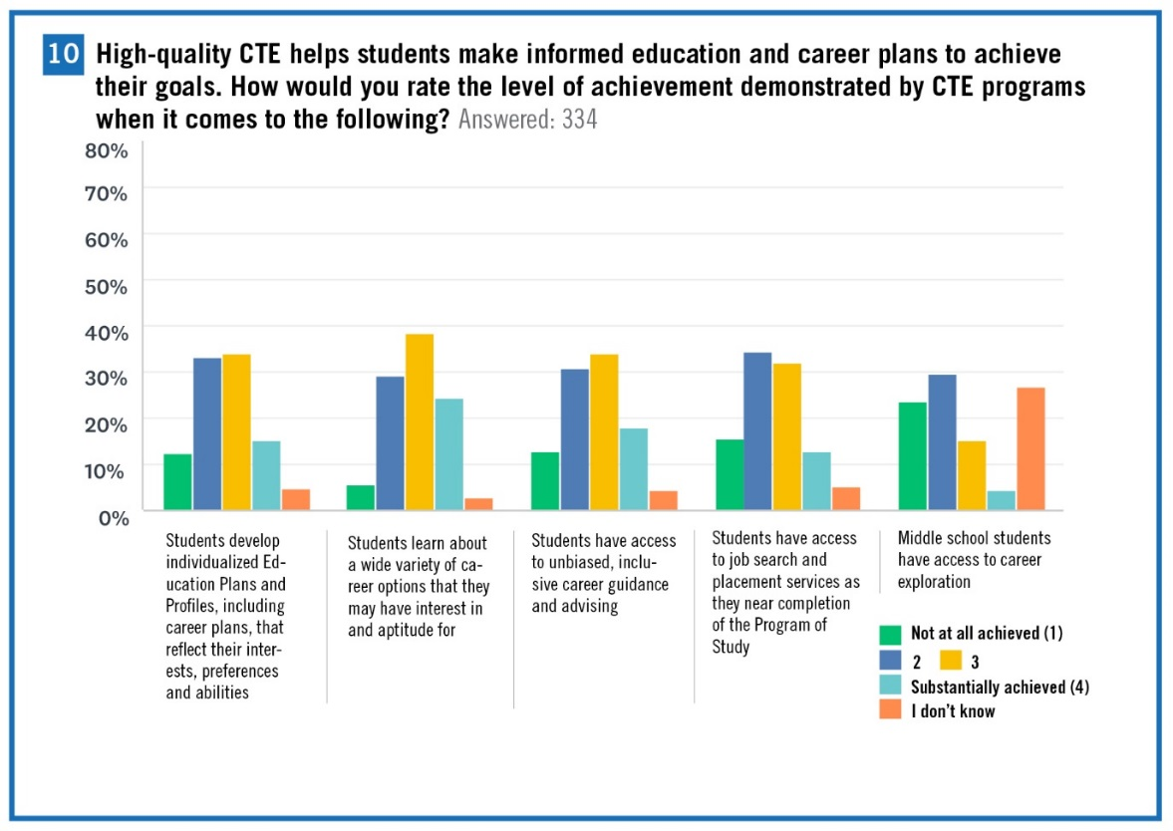

Needs Assessment Recommendations
- Engage stakeholders to review state policies and initiatives around career development, and determine areas of greater alignment and investment.
- Provide greater specificity around standards for career development within POS application and program quality review processes.
- Provide professional development for school counselors and other educators on career development.
  - Leverage EPP requirements and connections to other state and federal policies to deliver more professional development.
  - Ensure that professional development includes an equity focus so that guidance is inclusive and unbiased.
- Support the development or expansion of middle school career exploration opportunities.
  - Consider piloting promising middle school career exploration models or scaling current, isolated efforts.
  - Consider the use of the reserve fund to explore and incentivize middle school career exploration models.
- Improve the CIS to make it more interactive and user friendly.

Career Awareness and Exposure in Oregon: Strengths
Write strengths/what should we keep doing with regard to career advisement and exposure in Oregon?
- Growing CTE programs
- New ways to connect learners to career awareness opportunities: career fairs, virtual mentors, virtual field trips, mock interviews etc.
- College and career coaches at community colleges
- Convening of regional STEM Hubs
- Dual credit and early college CTE programs
- Pockets of success and promising practices
- Partnerships/ collaboration between institutions and groups
- Pre-apprenticeship programs and internships
- Educator externships
- Oregon Career Information System (CIS) has a new platform

Career Awareness and Exposure in Oregon: Challenges
Write Challenges/what should we stop doing with regard to career awareness and exposure in Oregon?
- Terminology shift needed: careers and college, not college and career
- Need to connect career experiences to education plan/profile
- Need more dual credit opportunities
- Need to provide training and awareness to counselors- high school counselors often direct learners to 4-year institutions
- Access/ equity is a challenge
  - Difficult to link learners in rural Oregon to career mentors
  - Providing transportation to career experiences can be difficult, especially in rural areas
  - Need role models of diversity, inclusion and opportunities
- Need to shift the culture at institutions so that there is less of a stigma associated with CTE
- Priority Challenges:
  - Disconnected system
  - Communicating with stakeholders
  - Stakeholders not recognizing its College AND Career (Stigma)
  - Building clear pathways
  - CTE Teacher/other educator prep
  - Lack of knowledge/”recognizing that it’s everyone’s job”
  - Education plan/profile

Addressing the Challenges
For the top three (based on a vote) priority challenges, answer the following questions:
- What is the compelling interest/reason for this challenge to be addressed?
- Does this (or should this) challenge apply to all learner levels?
- Are there policy changes at the state level that could address this challenge statewide?
- How could additional resources help to address this challenge statewide?
- How could technical assistance or professional development help to address this challenge statewide?
- How could business and industry partners help to address this challenge statewide?

Priority Challenge: Communicating with Stakeholders
- What is our shared vision of CTE, career awareness and career opportunities?
- 1. What is the compelling interest/reason for this challenge to be addressed?
  - Sharing common language across the entire spectrum and all stakeholders.
    - -Technical -Cultural -Other than English language
  - Helps set expectations amongst partners and stakeholders
    - Shared ownership for outcomes
    - Community issue, not K-12 issue
    - (California- “Career Education”)
  - A common conduit at division to state and broadcast out
- 2. Does this (or should this) challenge apply to all learner levels?
  - Implied that it should
- 3. Are there policy changes at the state level that could address this challenge statewide?
  - Challenge: lack of work experience prior to arriving at postsecondary
  - Need to expel myths
  - Need to improve knowledge of rules/regulations- labor law change?
  - Data complexities can be barriers to equity/access
  - Common across agencies:
    - System /structure at the state to create a multi-structured communication system
      - How is it brought together? If it’s not a policy, will a multi-structured communication system ever happen?
    - Policy around system...not just pockets of system (i.e. Measure 98)
  - Need incentives for business to come to table
    - Workforce development boards
      - Clarify connection to education/community/business
    - Create stakeholder asset map, by region, and financial asset/resource map
  - Collective impact approach (model)
- 4. How could additional resources help to address this challenge statewide?
  - Incentives, convenings, changing culture, develop skill sets, develop structures (state positions to support)
  - A system that allows K-5/6-8/9-12/Train/CC/ 4 year/ Job-Emp alignment
    - Track learners
    - Respond to data
    - Data agreements
  - Need people at the state-level who will support the communication system development and provide support to local regions
  - Equity-minded approach in building systems
  - Funding around STEM and CTE statewide (marketing and PSAs)
  - “What’s the first thing you think of when you hear CTE?”
- 5. How could technical assistance or professional development help to address this challenge statewide?
  - Technical assistance to translate/common messages
    - Different languages and formats to promote accessibility
  - Professional development around the “how to” communicate what is CTE/STEM/Career
  - Professional development to address implicit biases associated with CTE/pathways vs. college bound
  - Complete system development around a career awareness/ exposure approach
- 6. How could business and industry partners help to address this challenge statewide?
  - Business/industry as part of all processes
    - Discussion/debate
    - Planning
    - Implementation

Priority Challenge: Disconnected System
- 1. What is the compelling interest/reason for this challenge to be addressed?
  - Cohesive and everyone benefits
  - Better outcomes and equity
  - Common understanding and language
- Includes students, admin, educators, parents, business/industry
- Support policies
  - Include accountability and equity
- Create new policy or rewrite old policy with focus on accountability and equity
- Hold CTE advisory boards accountable
  - Guidelines tied to resources
  - Revamp structure (local and statewide)
- Create guidance and share effective practices and resources
- Identify skills/knowledge for workforce readiness
  - Embed in all content areas/connect to core content
  - Align with standards already adopted
- Addresses biases and lack of knowledge
- Provide regional support/networks beyond CTE (for Career Learning)
- Expand funding to ALL educators and others beyond CTE folks (core teachers/counselors) to help with professional development, resources and supports

Priority Challenge: Lack of knowledge
- Suggestion to look at what other states are doing, but important to remember that Oregon may not have the same resources as other states
- 1. What is the compelling interest/reason for this challenge to be addressed?
  - Lack of knowledge
  - Traditional mindsets still at play
  - Fear factor: Workforce concerns
  - Teachers have large influence
  - Making connections
- 2. Does this (or should this) challenge apply to all learner levels?
  - Yes. To varying degrees- need to see connections from classes (i.e. math)
- 3. Are there policy changes at the state level that could address this challenge statewide?
  - Skills assessment
  - Increased CTE funding
    - Measure 98 funds to sustain coordinated efforts for advising/counseling
    - Fund “transition programs (career to education)
- 4. How could additional resources help to address this challenge statewide?
  - From “practitioner” to “educator”
  - Take best practices
    - Classroom activities to real-world experiences
- 5. How could technical assistance or professional development help to address this challenge statewide?
  - Better, consistent sharing of information
  - Better communication
  - Address inequities
  - Teacher access to information
- 6. How could business and industry partners help to address this challenge statewide?
  - Take “mystic” out of it
  - Make more connections
  - “Virtual online career learning” - (i.e. Nike)
  - Developing a catalog of people to engage in the sharing of skills and competencies
  - Tech skills

Discussion: Is expansion of career advisement and exposure the same as expansion to middle grades CTE?
- At the middle school level, students should be taught applied learning and the soft skills
- Programs of study should not be implemented in middle schools
- Middle school courses should focus on exposure and project-based learning so that students can build work-ready skills
- What is the funding solution for middle grade CTE? Do you have to have CTE programs in the middle grades to ensure that funding is provided?
- Career tie needs to be specific in middle grades
- Access/equity concerns
  - Concerns about the accessibility of middle school career awareness and exposure in rural school districts
  - Concerns about transportation for students
    - Even when transportation is provided, there are communication issues that prevent students from participating in opportunities such as STEM camps
  - Underserved students who may need additional support sometimes don’t have the opportunity to participate in electives and therefore may not be able to participate in middle school CTE/career awareness elective courses
- Suggestion: Develop CTE programs for the summer between middle school and high school
- Middle school CTE could be a way to help address “summer melt”
- Oregon is piloting an exploration wheel in some schools

Middle Grades: Funding
Perkins V allows states to use Perkins funding to support CTE as early as fifth grade

“For” expansion of CTE to middle grades
- If CTE programs of study exist at the high school level, can middle school be leveraged to develop “feeder” CTE opportunities?
- Are 9th grade explorations too late?
- Can leverage middle school CTE to prioritize local needs
- Can provide choices that resonate with students in 6th, 7th and 8th grade
- Exploration includes and connects to career opportunities
- Provides learners with hands-on, real world application, and career exploration experiences
- Because of Measure 98 funding we can now expand CTE
- May increase student retention and success rates
- Students will be more ready for high school electives
- Can increase student confidence, self-confidence and curiosity
- Can provide additional diversity and variety in instructional methods, applied learning
- Can teach learners about opportunities to learn while you earn and obtain a livable wage
- Focus on career awareness
- Learners will develop life skills/work readiness skills
- Can implement the Wheel model
  - Exposure
  - Choice by Career Learning Areas

“Against” expansion of CTE to the middle grades
- Is funding truly available to feed and support middle school opportunities?
- Who can teach it?
- Concerns about funding, time and alignment
- Need to convince high school that this would benefit middle school

What else do you need to know?
- Best approach: exposure to have broad understanding vs. wheel/mini-class model
- What would be the broad spectrum?

