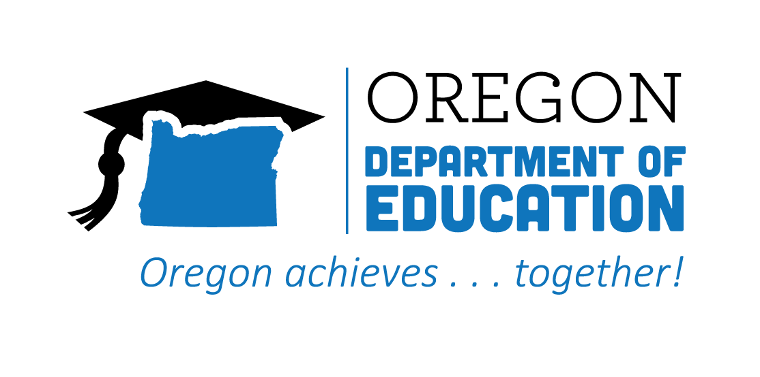
CTE State Plan
ACCOMPLISHMENTS 2022-2023

The Oregon CTE State Plan is a high level, four-year strategic plan that integrates state and federal priorities to implement the "Strengthening Career and Technical Education for the 21st Century Act" (commonly known as Perkins V). The following are two accomplishments from each action team made during the third year, along with their respective goals for 2022-2023.
2022-2023 ACCOMPLISHMENT HIGHLIGHTS
Provided every new teacher with an instructional mentor, focusing on teachers coming from industry, ensuring that each one is paired with an experienced educator.
Provided the New CTE Teacher’s Guide to Success (available acte.com) as a reference and book study for new teachers.
Provided program-level demographic data to each program and school to help identify where programs were not meeting student needs; followed up with guidance to help districts build capacity in equity work.
Worked with a cross-agency team to create the document, Supporting Gender Expansive Students: Guidance for Schools in support of schools, families, and the community.

Released the first 6 modules in the WBL Canvas course to provide a consistent way to share resources and offer asynchronous professional development around the planning and implementation of WBL experiences.
Hosted Oregon Employability Skills training at the regional level, promoting to districts throughout the region to provide rigorous, relevant, and approved curriculum for students.
Utilized CTE Participation Explorer, a data visualization dashboard, to address gaps in access and achievement, and to ensure equitably achievable goals within CTE Participant and CTE Concentrator statuses.
Provided timely professional development and technical assistance for local data preparers and submitters on reporting for the CTE System and the secondary CTE spring collections.

Overcame barriers resulting from COVID, fires, and teacher shortages by supporting virtual schools when traditional, bricks-n-mortar approaches presented accessibility issues.
Provided multiple options to obtain work experience placements, internships, or work-based learning opportunities, building diverse kinds of partnerships within the community.
Presented the HQPOS rubric to teachers during professional development–many of whom have not previously seen the rubric–providing an opportunity for teacher learning, goal setting, and overall program improvement.
Gathered CTE teachers by career cluster as they were renewing for the Statewide cycle and invited community college faculty and industry partners, creating focused professional development and networking opportunities.
Assisted youth explore career options, especially prior to high school, through the CCL Navigator, who collaborated with key personnel in all schools within the region.
Created resources to support early career awareness– including Career Journeys Videos, YouScience, eDynamic–for rural, remote and frontier schools.

VISION FOR CTE

Building on CTE’s past vision and based on input from CTE partners and agency staff,
Oregon has identified the following vision for CTE that will guide Oregon’s State Plan:

Oregon will reimagine and transform learner experiences to enhance learners’ future
prospects; empower their communities; and ensure equity in an inclusive, sustainable,
innovation-based economy.

CTE OUTCOMES BY 2027

Integrated career connected learning systematically in Oregon;

Increased equitable access, inclusion, and participation in
high quality CTE career connected learning; and

Expanded communication, transparency, and the voices contributing
to our education and workforce development partnerships.

