Archive A

Formerly Appendix B: Community Partner Engagement * - Part of Original Submission and included for Archival Purposes

Process for Engagement
Broader engagement of Community Partners is a key theme for CTE under Perkins V. Our goals for engagement included:
- Creating a plan for CTE in Oregon that is informed by the voices of all our Community Partners;
- Building sustained momentum and informed support for CTE in Oregon;
- Addressing systemic barriers that have prevented equitable outcomes for Oregonians; and
- Facilitating opportunities for families, communities, business and industry, and education leaders alike to share input that informs the crafting and implementation of the State Plan.
The state created a CTE Core Team consisting of ODE and HECC CTE and High School Success staff. The CTE Core Team met weekly starting in December 2018. The Core Team managed the creation of the CTE State Plan and Community Partner engagement. During the development of the CTE State Plan, ODE and the Office of CCWD engaged all the required Community Partners.
In addition, we partnered with leaders of the Workforce and Talent Development Board, STEM Council, Youth Development Division, Title II Adult Basic Skills, and Every Student Succeeds Act to align the CTE State
Plan with their ongoing efforts focused on work-based learning. Our creation of statewide CTE Programs of Study will align with our workforce sector strategies.

Phase 1: Creating a Vision
(October 2018 - February 2019)
Oregon started engagement activities before drafting the State Plan. We started by listening to what Community Partners wanted in CTE (December 2018-March 2019). Community Partners included ODE; CCWD; and leaders of the Workforce and Talent Development Board, STEM Council, Youth Development Division, Title II Adult Basic Skills, and Oregon’s Every Student Succeeds Act plan. We also consulted with our nine federally recognized tribes and engaged the following Community Partners for input:
Representatives of secondary and postsecondary CTE programs, teachers, faculty, school leaders, specialized instructional support personnel, career and academic counselors and advisors, parents, mentors, students and community organizations (e.g., In 4 All, STAND for
Children, Native American Youth Organization, Immigrant and Refugee Community Organization), local government and chambers, members and representatives of special populations, representatives of business and industry (e.g., Oregon Business and Industry, Oregon Business Council, Homebuilders Association, Oregon Restaurant and Lodging Association), small business representatives, Youth Development Division, representatives and reengagement hub grant recipients, the state coordinator of the McKinney-Vento Homeless Assistance Act, representatives of federally recognized Indian tribes and tribal organizations located in or providing services in the state and individuals with disabilities and representatives from special education.
We incorporated information gathered by the Committee on Student Success (a legislative committee seeking education funding that engaged communities, families, students, education leaders, and business partners across the state). The state’s Every Student Succeeds Act also informed our vision, as did interactions with CTE Regional Coordinators, STEM Hubs, workforce investment, and business and industry partners including trade associations.
Through these engagements, we heard some common themes:
- Equitable opportunities to benefit from high-quality CTE leading to high-skill, in-demand careers that provide a living wage;
- No tracking into dead-end careers or classes that are not relevant to a student’s future;
- Opportunities for youth to gain experience and apply their knowledge and skills in work-based learning;
- Career exploration for younger students to learn about career opportunities; and
- Multiple pathways into and out of CTE that accommodate individual needs;
- More skilled educators, advisors, and mentors to guide CTE for youth and adults; and
- Strong alignment to business and industry and strong partnerships between schools, colleges, and communities.

Phase 2: Identifying Focus Areas
(March 2019-June 2019):
We targeted communication about the enactment of Perkins V to Community Partner groups interested in CTE, such as the CTE Regional Coordinators, K-12 administrators, CTE deans, CTE teachers and faculty, school counselors, business and industry partners on the CTE Revitalization Advisory Committee, STAND for Children, Oregon tribes, the Chronic Absenteeism Advisory Committee, the Youth Development Division, the state homeless coordinator, the Student Services Office, and leadership at ODE and HECC to hear about their hopes for a new CTE State Plan. As part of the discussion with our key Community Partners, we framed the shifts in the new federal law and shared the need for equity to be at the center of the work we do. We conducted a statewide needs assessment with the support of Advance CTE/Association for Career and Technical Education (ACTE) from mid-March to late April 2019. The needs assessment used multiple research methods to identify focus areas for our State Plan:
- An online survey (513 respondents) distributed via email to CTE networks around the state;
- Interviews with 12 individuals identified by the State CTE Director and state CTE staff, including individuals representing state, regional and local secondary and postsecondary CTE as well as individuals representing community colleges and one person representing the business community;
- A literature review of online and print CTE, education and workforce development documents produced by ODE, CCWD, and other Oregon state agencies, and resources by third-party organizations addressing Oregon CTE and the broader economic and social context in Oregon; and
- Recommendations gleaned from an in-person Community Partner meeting of CTE leaders, business representatives, educators, tribes, special population representatives, workforce development, Adult Basic Skills providers, homeless education coordinators, and state agency staff facilitated by ACTE and Advance CTE staff.
The statewide needs assessment helped define the vision and focus of our work in developing our CTE State Plan. (Oregon Perkins V Planning Appendix M: CTE Needs Assessment).

Phase 3: Identifying Recommended Goals and Actions
(June 2019-October 2019)
During the third phase of Community Partner engagement, we began connecting with Community Partners about how to flesh out a plan to build a CTE system in the state that works for Oregon based on the results of the statewide needs assessment. CTE federal funding is meant to address equity issues, and our CTE State Plan needs to address these issues and be consistent with our value of creating inclusive systems. To help meet this goal, we placed a significant priority on engaging historically and currently marginalized groups in the process. We began the formal process of tribal consultation with follow-up meetings with our Office of Indian Education to plan our presentation at our government-to-government convening. We listened to the nine federally recognized tribes about the needs and hopes of our tribal communities and developed an engagement strategy based how they wished to be involved in the CTE State Plan development. Some tribes asked to be members of the workgroup or to join the group by providing feedback virtually. They asked that we become a regular agenda item on the Government-to-Government meetings. We connected with our homeless student liaison, Office of Student Support Services, Equity Diversity and Inclusion Office, directors in the Office of Teaching Learning and Assessment, our postsecondary WIOA Title II director, Office Workforce Investment Office, community advisory group working on reducing chronic absenteeism, and Oregon business and industry groups.
During this phase, we recruited members to serve on four workgroups facilitated by Advance CTE/ACTE. The workgroups consisted of key CTE Community Partners, including CTE Regional Coordinators, STEM Hub directors, community college leaders, CTE administrators, CTE teachers, data and research staff from K-12 and higher education, community members, employers, virtual schools, business and industry partners, tribal members, equity staff, and state agency staff. We shared Oregon’s equity lens with all workgroup members and emphasized the importance of examining our decisions and recommendations around the context of our historically and currently underserved groups. The workgroups explored key issues of CTE in the state and developed recommendations to improve Oregon’s work-based learning; data and accountability; program of study application, review, and approval quality; and career awareness and advisement structures. These topics were chosen because of the focus that emerged on these issues during earlier Community Partner engagement activities.
A broader group of Community Partners, which included 440 interested individuals, also had the opportunity to give input over the summer through additional short surveys administered online to help inform the workgroups as they drafted their recommendations. A summary of the workgroups’ recommendations and their influence on our CTE State Plan is included in our Workgroup Summary. Throughout this process, CTE Core Team staff continued to engage with other key agency staff from within ODE and HECC to maintain alignment and connection with our WIOA Plan and our Every Student Succeeds Act (ESSA) plan.

Phase 4: Refining Our Goals and Actions and Building Our Plan
(October 2019-January 2020)
After creating draft components of the CTE State Plan, the CTE Core Team solicited further public input to validate, refine, and hone the draft CTE State Plan. This engagement included in-person presentations to groups such as: Oregon Business and Industry Education Committee, Oregon State Board of Education, HECC, School Counselor Association Annual Meeting, APRIRE Mentor annual training, American Indian Education Advisory Group, CTE deans meeting, Working Together (a local workforce investment board), Regional CTE Educators Professional Learning Committees, HR Professional Association, the Confederation of School Administrators Conference, and the Students with Disabilities Conference. In addition to in-person feedback opportunities, draft documents were posted online, and invitations to provide comments were sent to target Community Partners such as CTE educators, student leadership organization members, tribal education coordinators, English learner coordinators, homeless liaisons, school counselors, recipients of youth reengagement grants, recipients of African American/Black Student Success grants, dual credit coordinators, business and industry associations, Parent Teacher Association members, and student associations. The state team offered webinars for the public highlighting draft plan goals and actions and held our 60-day formal public comment around the CTE performance targets. The Governor’s Office was also apprised of the plan and planning process. The state convened a CTE Summit for our communities of color to allow participants to voice their concerns and hopes for how CTE in Oregon will engage with people of color and meets their needs. All of these engagements helped refine and hone the CTE State Plan.
Representatives of these diverse advisory groups will be asked to participate in our CTE advisory group and engage as we implement our CTE State Plan.
Our State Determined Performance Targets were open for public comment October 10, 2019 through December 9, 2019. The proposed targets were shared with all Community Partner workgroups, sent through the Department of Education and Community College and Workforce Development’s communications team to all Community Partners.

Phase 5: Public Comment
ODE presented the CTE State Plan to the State Board of Education for a first read on February 20, 2020. The plan became available for public comment on January 21, 2020. ODE also sent a Notice of Public Comment to all Community Partners who had been involved in the plan development, and ODE announced public opportunities to provide comment via our listservs, Twitter, Facebook, and education partners. ODE also provided notice through ODE’s listservs, Twitter feed, State Board announcements, and formal public hearing processes, and through HECC’s listservs and newsfeeds. ODE submitted the amended CTE State Plan to the governor for signature in February 2020. ODE staff summarized and addressed public comments in the final CTE State Plan adopted by the Oregon State Board of Education on March 19, 2020.
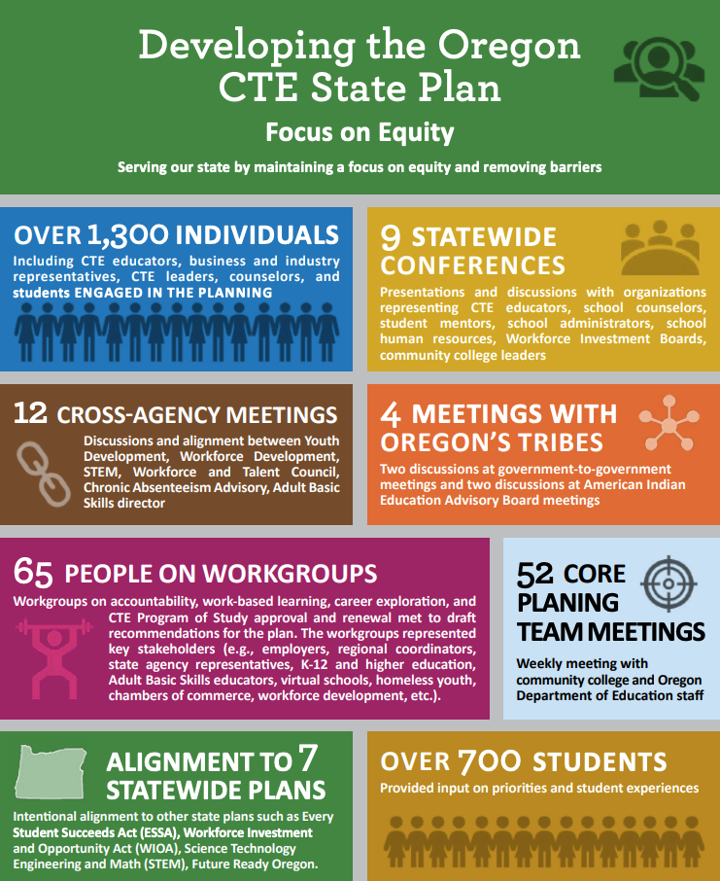

Oregon Public Comment Overview
Comments from 20 individuals were received through the online form submission option. In addition, nine individuals or groups submitted comments via email. While the majority of those submitting comments were educators, there were several business and industry representatives, including both Adobe and Oregon Business and Industry which both submitted substantial written responses. In addition, seven of those submitting online comments identified as parents, and nine as workforce development professionals. However, it is important to recognize that this is a very limited group of respondents, many with similar perspectives, and should be considered as just one piece of the broad Community Partner engagement that has been conducted throughout the state plan development cycle.
Most of the comments were either relatively minor in the scope of the entire plan, or about very specific issues (such as open educational resources or mechatronics). Many concerns raised, such as those about regional consortia or state initiatives, represent valid points but are likely outside the scope of the state Perkins plan to affect. Aside from those issues, there were several themes that were reoccurring within the comments:
- Work-based learning: A number of commenters raised concerns about work-based learning, particularly related to how it will be measured and supported. This has continued to be a priority among Community Partners and was the subject of one of the state’s working groups. There was also concern on how the required “sustained interactions” can occur within work-based learning.
  - Response: The state will include technical assistance to support Community Partners in implementing work-based learning systems and to acknowledge that guidance and support will not be fully available upon adoption of the CTE State Plan the performance targets were lowered for the first few years. This will allow for fidelity of measurement of work-based learning as we support development of quality systems and partnerships to expand work-based learning for Oregon Students.

- Business and industry engagement: Relatedly, several commenters recognized the need for robust employer engagement, both related to program quality and work-based learning more specifically.
  - Response: There have been plans to develop advisory committee for the CTE state plan. Language has been added to the plan to make this intention more explicit. State staff will be partnering with business and industry organizations to develop the process for Statewide Program of Study development as well as for the development of the programs. State staff will also work with those organization and our regional CTE coordinators to develop regional relationships between CTE programs and employers.

- Regional activities: Several commenters commented on the importance of regional activities or consortia in implementing CTE programs across the state.
  - Response: Many of the initiatives outlined in the state plan rely heavily on our regional structure more emphasis was placed on the role of regional structures in the state plan implementation. Oregon’s CTE regional coordinators play an essential role in successfully achieving our state’s vision.

- Ongoing Community Partner engagement: A number of commenters expressed a desire either to continue involvement themselves as future decisions were made (such as defining the work-based learning measures) or for key Community Partners to have formal collaboration mechanisms, such as statewide advisory committees moving forward.
  - Response: Oregon that Community Partners want to be involved in improving CTE. State staff will develop mechanisms to engage a broader range of Community Partners as well as a communications plan for providing information and receiving feedback on the progress of CTE implementation in the state.

- Statewide program alignment: Programs of study, secondary-postsecondary alignment, alignment of courses across the state within each learner level (such as from one high school to another) and labor market alignment were all topics raised in the comments.
  - Response: The statewide program of study initiative is one way to address these issues. An overview of how the statewide program of study can address alignment issues in posted on the Oregon Department of Education webpage.

* PLEASE NOTE: As originally published, this document was called “Stakeholder Engagement.” In this version, that phrase has been updated to the more currently accepted “Community Partner Engagement.”

