Algae Machine Setup Instructions for

Biofuel from Algae

**Notes:**

1. Refer to the Materials List in the Lesson Plan for items referred to below.
2. To assure that your first batch of algae is reasonably mature by the time you begin the lesson, we recommend you order your algae three weeks in advance and follow steps 2, etc. at least two weeks in advance.
3. To shorten the time it takes for your students to successfully grow algae, you can provide them more than 5 ml of algae per team. You may want to provide as much as 100 ml per student team. The following steps will provide you with a good supply of algae as well as a demonstration vehicle for the lesson.

**Figure 1.** Algae Machine using 20 oz. plastic beverage bottles; ideally these would be identical bottles.

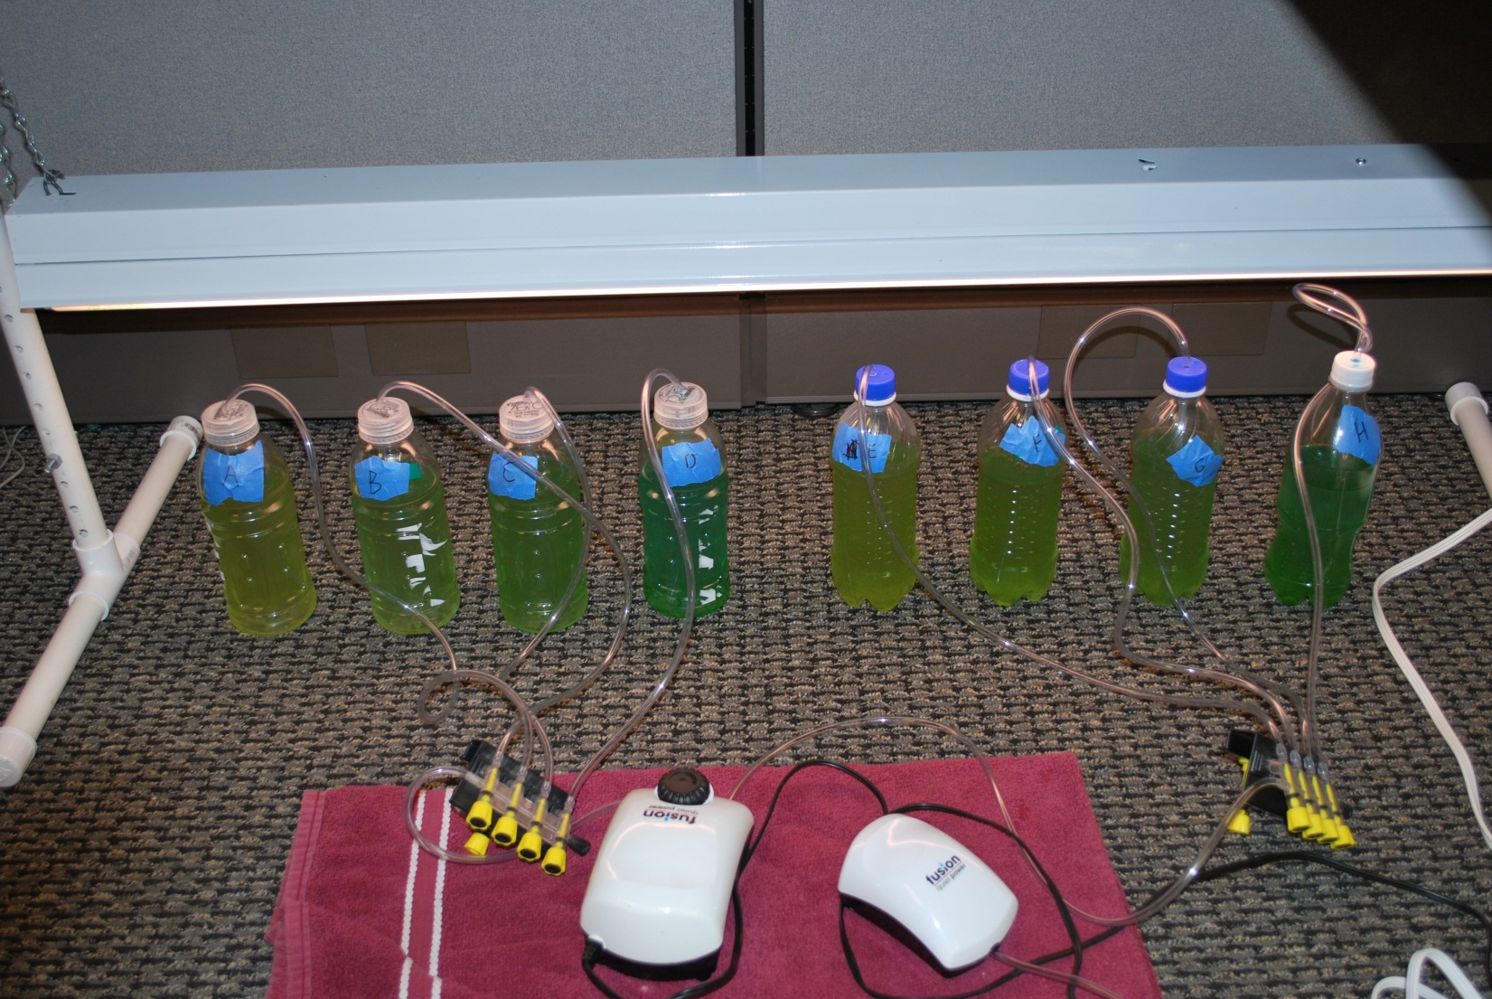

**Materials:**

Quantities are given for a 16-bottle set up with information on re-sizing the set up.

* One 100 gallon aquarium air pump, aerates up to 16 500 ml – 1.5 liter containers
* Four 4-way aquarium gang valves; each 4-way gang valve supports four containers plus either one additional container or another gang valve in series; we recommend connecting no more than two gang valves in series
* One T-connector for standard airline tubing; depending on the number of gang valves and the number of air outlets on the air pump, T-connectors may be needed to connect all the gang valves to the air pump.
* Aquarium tubing. We recommend you use “standard” 3/16” outer diameter tubing. Purchase at least 50’
* Transparent growth containers with sealing lids, 500 ml – 1.5 liters. The number of containers you can support depends on your airpump,gang valves, and the amount of algae needed to supply to your students. We recommend 12 to 16 identical containers per set up.
  + Plastic beverage bottles, clean, labels removed, flatter bottoms preferable, **or**
  + Erlenmeyer flasks with 2-hole stoppers
* Live green algae culture, enough for at least 5ml for each container you are starting. Purchase from a reputable source. Recommended species are *Scenedesmus* and/or *Selenastrum* and/or *Spirogyra*, in that order of preference. Some vendors have axenic, or single-species cultures without detectable contaminants. This degree of purity is not necessary for this activity. Collecting samples from local bodies of water is also not recommended, because a multi-species array that includes algivores is likely, as are cyanophytes and bacteria capable of producing toxins. Some companies require a signature for shipment, so the package is not left out in hot conditions. Refrigerate upon receipt, as the growth medium will not have enough nutrients to support an expanding population.
  + Niles Biological ships from California, sells in units of 2 oz for 30 students. Buy “For a class of 60 students” to inoculate 16 containers.
  + Carolina Biological supply ships from North Carolina, sells in units of 25 ml vials with a live materials shipping surcharge. Buy four vials to inoculate 16 containers.
* Plant fertilizer, such as Miracle-Gro. One without dye would be preferable; we were not able to find one. The higher the proportion of nitrogen, the better. Lower NPK ratios may favor undesirable species.
* Dechlorinated water. We used bottled spring water. Alternates include distilled or reverse osmosis water. Some water supplies are treated with chloramine, which is non-volatile. If your tap water is treated with chlorine rather than chloramine, it can be dechlorinated by letting it stand overnight in a bucket or pan with a large surface area. The chlorine will evaporate.

**Steps:**

1. Purchase a vial of *Scenedesmus* and/or *Selenastrum* live green algae from a reputable source.
2. If you are using 500 ml Erlenmeyer flasks with 2-hole rubber stoppers skip this step. If you are using plastic bottles, using a manual or power drill, drill holes into each cap. Having two holes in the caps/stoppers allows greater air exchange in the containers. For standard 3/16” airline tubing, one hole should be made with a ¼” drill bit; the second hole can be the same or a different size, depending on what works for your bottle caps and equipment. Smaller holes minimize the risk of spillage. Uniform holes speed up set up.
3. Clean all of your algae machine equipment (container, tubing, gang valves, etc.) with hot water and soap. If you are using lab-grade glassware, cleaning with an autoclave may be appropriate.A dilute solution of household bleach or hydrogen peroxide may also be used. Thoroughly rinse off any soap, bleach, or peroxide and dry completely.   
   Safety **Note:** Don’t use an autoclave for plastic components. Let the water cool down well below 100 degrees C before you put in the plastic containers since heat can warp their shape. When using bleach or peroxide, work in a well ventilated area, protecting eyes, skin, and clothing.
4. Make a fertilizer solution/growth medium by mixing 1 tbsp or less of fertilizer with 1 gallon of water. The students’ designs may change this formula in an attempt to optimize growth or reduce costs. Note that more fertilizer may reduce growth rates or even kill the algae.
5. Pour at least 500 ml of fertilizer solution/growth medium into each container.
6. Transfer at least 5 ml of live algae by pouring, pipette or dropper from the purchased culture into each of the containers. If you have enough algae available you may want to use more initial algae in order to get a faster start.
7. Thread a piece of tubing through each cap/stopper and screw/insert the cap/stopper onto a container. Be sure the tubing reaches far enough into the container to promote thorough aeration and mixing. Some bottles have hills and valleys at their base. An airline trapped in a valley may not adequately aerate and mix the rest of the bottle contents.
8. Connect the other side of the tubing from step #7 into completely shut-off gang valves. Divide the gang valves so that they have similar number of bottles attached to each set of valves.
9. Connect all gang valves to the air pump. If the gang valves have a main line outlet you can hook them is series. If they don’t have an outlet for the main line you will need T connectors to hook up several gang valves to the same pump unless the pump has several outputs.
10. Arrange the containers under a fluorescent lamp.
11. Plug the light into a timer and set to 8 hours off and 16 hours off to simulate daylight. The students designs may change this ratio. To maximize growth, leave the lights on 24/7.
12. Plug in the air pump and adjust the gang valves so that all bottles are bubbling at approximately the same rate.
13. Let algae grow for at least a week. Air valves may need to be re-balanced every few days. More likely it will take two or more weeks before most of the bottles are distinctly green because each bottle started with a very small amount of algae. Initially the bottles will remain blue because of the blue food coloring in the fertilizer. (If you can find similar fertilizer without food coloring, that would be better; we were not able to do so.) Gradually the color should turn turquoise and then green. It may help to shake the bottles occasionally but you should you should probably not describe shaking the bottles as part of the baseline design for which students should propose improvements. Leave ideas like shaking the bottles as improvements that they can propose.
14. The students’ designs may add accessories such as reflectors to increase the amount of light that reaches the bottles. If you are short on time to grow algae to demonstrate the result for your class you may want to add reflectors and then remove them before you show the baseline design to your class. Reflectors can be made from materials like white paper or aluminum foil and supported by corrugated cardboard or other means.